ARC Infruitec-Nietvoorbij
Private Bag X5026, Stellenbosch, 7599, South Africa
Tel: (021) 809 3172
Fax: (021) 809 3400/3592
OFFICE OF SUPPLY CHAIN MANAGEMENT
- DESCRIPTION OF SERVICE: SUPPLY & DELIVERY BALER TWINE

BALER TWINE |  | Quantity | If No, Please Indicate Deviation
1. Specific Description | Compliance to Specification (Yes/No)  *Describe If Specification Differs | Quantity | If No, Please Indicate Deviation
- Super strong polypropylene baler twine, RAM baler or similar, needed to tie grapevine shoots in a tight bundle (1 Roll) |  | 8
- Colour: Orange
- Mass: 5 kg
- 238m/kg
- +-1640m
- 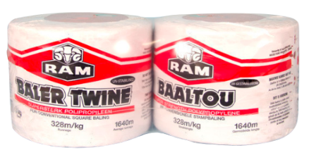
- 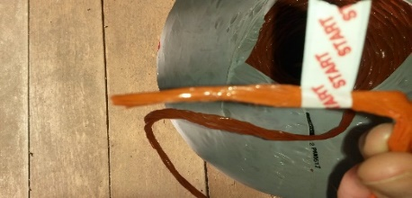
- Delivery must be at ARC Infruitec – Helshoogte Road - Stellenbosch
- Closing Date - 24/03/2022 @ 11:00

Contact: Janene Strydom - StrydomJ@arc.agric.za - 021 809 3159 / 084 506 7492 enquiries.

