REQUEST FOR QUOTATION: EXHIBITION STAND CONSTRUCTION
The Corporate & Marketing Communications team at the South African Medical Research Council (SAMRC) requests a quotation from suitably qualified service providers for the production, construction, installation and dismantling of an exhibition stand for the Nutrition Congress.

1. Event Details
Event: Nutrition Congress
Dates: 7–9 October 2026
Venue: Confirm: Wanderers Club, Johannesburg
Region: Gauteng
Build-up: Tuesday, 6 October 2026, 08:00–16:00
Breakdown: Friday, 9 October 2026, 12:00–18:00
The exhibition stand must be constructed in accordance with the supplied stand concept and artwork.

2. Stand Requirements
Graphics
- 2,000 mm × 2,000 mm fabric print sidewall – 1 unit (Sidewall 1)
- 2,000 mm × 2,000 mm fabric print sidewall – 1 unit (Sidewall 2)
- Front counter side graphic – supplier to advise on suitable dimensions
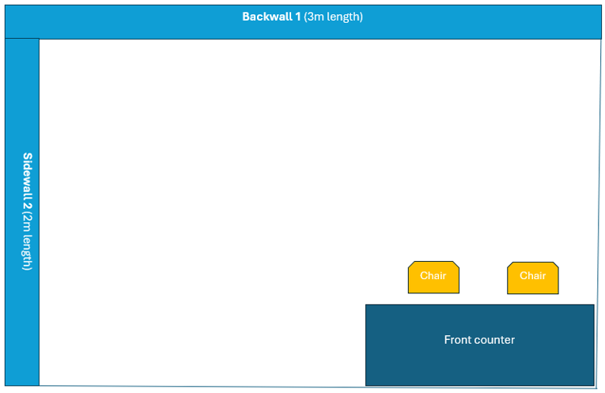
Furniture
4. Front counter (F028) – 1 unit
5. White Komora barstool (F017) – 2 units
Electrical
6. 30 Amp, 3-phase DB board – 1 unit
7. Lights directed onto Sidewalls 1 and 2 – 6 units

3. Supplier Scope
The successful service provider will be responsible for:
- Production and construction of the exhibition stand in accordance with the supplied concept and artwork.
- Supply and installation of all specified graphics, furniture and electrical requirements.
- Transportation and delivery to the confirmed venue.
- Complete stand setup within the specified build-up period.
- Dismantling and removal of the stand after the event.
- Compliance with the venue's exhibition, health and safety requirements.
- Advising SAMRC on any technical or dimensional requirements necessary for successful installation.

4. Quotation Requirements
Suppliers are requested to provide:
- Detailed quotation, inclusive of all applicable costs.
- Separate costs for construction, graphics, furniture, electrical requirements, transport, installation and dismantling, where applicable.
- Lead time for production.
- Confirmation of availability for the specified build-up and breakdown dates.
- Any assumptions, exclusions or additional requirements.
South African Medical Research Council
Francie van Zijl Drive, Parow Valley, Cape Town, Western Cape
Website: http://www.mrc.ac.za/

