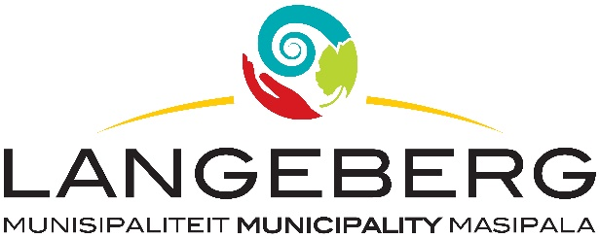

TENDER 05/2024

ERRATUM – TENDER 02/2024: PROVISION OF PROFESSIONAL SERVICES: COMPILATION OF INTEGRATED WASTE MANAGEMENT ANNUAL REPORT AND LANDFILL CLOSURE PROVISIONS ANNUAL REPORT, OVER A PERIOD OF THREE YEARS ENDING 30 JUNE 2026.

ERRATUM – BID NUMBER 02/2024: PROVISION OF PROFESSIONAL SERVICES: COMPILATION OF INTEGRATED WASTE MANAGEMENT ANNUAL REPORT AND LANDFILL CLOSURE PROVISIONS ANNUAL REPORT, OVER A PERIOD OF THREE YEARS ENDING 30 JUNE 2026.
LANGEBERG MUNICIPALITY WISHES TO INFORM ALL PROSPECTIVE BIDDERS THAT THE FOLLOWING SPECIFICATIONS HAS BEEN REMOVED FROM THE ABOVE-MENTIONED TENDER DOCUMENT.
- Bidders must be registered with the Consulting Engineers South Africa (CESA).
- Bidders that are not registered with CESA will be considered to be non-responsive.
The rest of the contents remain unchanged.
We apologize for the inconvenience that this may have caused to the Prospective Bidders.

