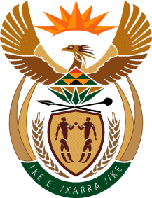
Water & Sanitation
Department: Construction East
Water & Sanitation
REPUBLIC OF SOUTH AFRICA

Request for Quotation

Item | Description | QTY
Ref: CTC 27

Provide Training for Confined Space, Working with Heights and Ladder Safety Training at IBTC in Roodeplaat in the Guteng Province.

Items description:

 | Working with Heights and Ladders Safety Training | 4 Each

Closing Date and Time:

31st August @ 11am

Contact Person: End-user:

Maria Maluleka – 060 980 5798

