SPECIFICATIONS

Maintenance to Nursery, net house structure, at ARC, Addo.
Size of structure – (40m x 32m x ±3.5m)
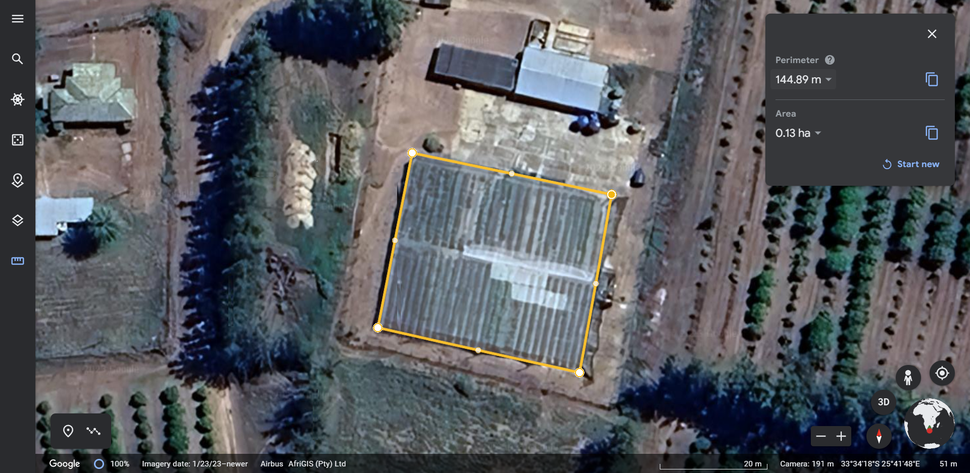
Scope of work to be done;
Structure;
- Plant and secure inside and outside poles.
- Plant and secure anchors.
- Putting up cable to secure structure and level poles.
- Securing of cable with grips.
Netting;
- Covering of pole heads.
- Threading of net on steel wire.
- Pulling up roof and securing wire and net.
- Putting up side net and securing net.

Material needed;

DESCRIPTION | AMOUNT
Outside poles, Creosote poles, 4.2 meter (125x150mm) | 22
Inside poles, Creosote poles, 3.6 meter (100 125mm) | 22
Stayrods, galvanised, 1.5m x 20mm | 18
Concrete anchors 690mm (diameter) x 150mm (Middle thickness) | 18
Oval steel wire 2.31mm x 1500 meter | 1
Grip VDWG 240 (150 x 175mm) PLP GRIPS | 76
Grip VBT 240 (100 x 125mm) PLP GRIPS | 54
Shade net, 3m wide (40% black) | 100 meters
Hog rings HR 23 (10 000 pieces) | 10 000 pieces

