

South African Airways
RFQ GSM013/2023
Request for Quotation for Gunsafe at SAA Premises

Written Quote Form

RFQ NUMBER: GSM013/23
ISSUE DATE: 04 April 2023
SITE VISIT: 18 April 2023 (32 Jones Rd, SAA Airways Park) (11:00am) https://goo.gl/maps/PNfNK96GBjXU37XU6
CLOSING DATE: 25 April 2023 at 16:00pm
VALIDITY OF RFQ: 90 days

RFQ DOCUMENTS TO BE E-MAILED TO: | tracyvelbroek@flysaa.com - limit 2MB (send in part or via downloadable link)
Vendors should ensure that quotations are returned before the closing date and time.
If the quotation is late, it will not be accepted for consideration.

SAA requests your quotation on the goods and/or services listed on the attached form.
Please furnish all information as requested and return your quote on/before the date stipulated.
Late and incomplete submissions may invalidate the quote submitted.

NAME OF VENDOR:

POSTAL ADDRESS:

TELEPHONE NO.:

CELL NO:

E MAIL ADDRESS:

CONTACT PERSON:

This RFQ will be evaluated on pricing, BEE and functionality.
Required Documentation to be attached;
- SAA Vendor Document. Refer to Annexure 1
- SBD 1 Document. Refer to Annexure 2
- SBD 2 Document. Refer to Annexure 3
- General Conditions of Contract. Refer to Annexure 4
- Pricing Schedule. Refer to Annexure 5
CONDITIONS
- All goods or services purchased will be subject to SAA General Conditions of Contract. A copy of said conditions is available from the local Procurement office.
- It is the responsibility of the Vendor to ensure that SAA is in possession of a valid Original Tax Clearance Certificate.
- The onus therefore rests on the vendor to ensure SAA receives a valid Tax Clearance Certificate, as soon as the validity of the said certificate expires.
- Where SAA does not have a valid Tax Clearance Certificate, an Original Tax Clearance Certificate must be submitted with this RFQ. Failure to do so may invalidate the quote submitted in terms of the RFQ.
- All purchases will be made through an official purchase order. Therefore, no goods must be delivered or services rendered before an official order/contract has been received.
- I certify that the information supplied is correct and I have read and understand SAA General Conditions of Contract and accept SAA General Conditions of Contract.
- I further certify that all the required information has been furnished and the relevant forms completed and are herewith submitted as part of the bid.

SIGNATURE OF VENDOR: ____________________________ CAPACITY: _______________________________

RFQ NUMBER GSM013/2022
SAA Business Unit: Global Supply Management

- BACKGROUND

  - Service Providers are requested to provide Prices with their quotation to SAA for all the services to be provided as per specification. Service providers are expected to submit a costing that is fair and reasonable.
  - SAA has the right to enter into negotiation with a prospective Service Provider regarding any terms and conditions, including price(s), of a proposed contract.

- SCOPE OF WORK

  - Total number of safes (Johannesburg – ORTIA)

SAA GUN SAFE CHECK-LIST
AREAS | TOTAL NO: | NOT OPENING | NOT LOCKING
Airways park (AWP) | 10 | 03 | 07
Inflight-Services (IFS) | 20 | 05 | 15
SAA Cargo JNB (SAAC) | 06 | 02 | 04

BRAND NAME: MAC SAFE
SAFE MODEL NO: M002 (SAMPLE OF CURRENT SAFES)
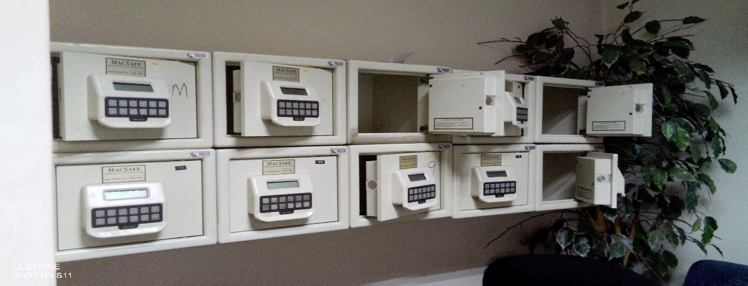

2.2 Requirements
- Repair
- Restore
- Maintenance

2.3 Maintenance plan (specify the period)
- Adhoc
- Call out
- Periodic
- Annual

2.4 SAA premises coverage
Current scope: AWP/IFS/SAAC

CONTRACT: One year with potential to scope increase

- EVALUATION PROCESS & CRITERIA

Responses will be evaluated on the functional criteria, where after qualifying responses will be evaluated on the Price and Preference Points:

  - EVALUATION PROCESS

    - COMPLIANCE WITH MINIMUM REQUIREMENTS

All quotations duly lodged will be examined to determine compliance with bidding requirements and conditions. Quotations with obvious deviations from the requirements/conditions will be eliminated from further adjudication.

    - EVALUATION OF QUOTATION

The contract shall be awarded at the sole and absolute discretion of SAA.

SAA hereby represents that it is not obliged to award this quotation to any bidder. SAA is entitled to retract this quotation at any time as from the date of issue.

SAA shall not be obliged to accept the lowest of any quotation, offer or proposal.

All quotation will be evaluated according to the criteria, weightings and threshold scores as Indicated in 3.2 below:

  - EVALUATION CRITERIA

The criteria and weights referred to in paragraph 3.1 above are as follows:

Functional Criteria
PHASE 1: FUNCTIONAL CRITERIA FOR SAA GUNSAFE |  | WEIGHTINGS
Bidder to conform to the minimum requirements indicated in Scope of Work:  - Conformance to specification per applicable legislation - 25%  - Partial conformance to specifications -15%  - Non-compliance to specifications - 0% | 25%
Delivery timelines once PO is received:  - 5 days = 20 %  - 6 days or more = 0 % | 20%
Ability to deliver service to Johannesburg SAA premises (AWP/IFS/SAAC) | 15%
Ability to deliver maintenance within agreed times | 20%
Bidder to provide a warranty and guarantee period on workmanship in line with the scope of work  Note: Bidder to provide in writing the warranty and guarantee information. | 20%
Total | 100%
Threshold | 70%

Threshold: The minimum qualifying score for Functionality is 70%. All tenders that do not comply with all the Mandatory Requirements for Functionality and that fail to achieve the minimum qualifying score of 70% on Functionality shall not be considered for further evaluation against Price and B-BBEE.

  - PHASE 2 - Preference Point System

All tenders that comply with the mandatory requirements for Functionality and that have achieved the minimum qualifying score of 70% (Acceptable tenders) will be evaluated further in terms of the applicable preference point system as follows:

Criteria | Points
Price | 80
BBBEE | 20
Total | 100 points

- STANDARD CONDITIONS FOR REQUEST FOR QUOTATION

Conditions:

4.1 All prices quoted must be exclusive of Value Added Tax (VAT).
  - All goods/services purchased will be subject to SAA Conditions of Contract and Order, available when requested.
  - All prices submitted must be firm. “Firm” prices are deemed to be fixed prices, which are only subject to the following statutory changes, namely VAT.
  - Note: Although SAA would prefer to award this contract to one service provider, it remains at our discretion to award the functions of the manufacturing of this product to the company that will provide us with excellent & prompt service. SAA is thus not obligated to award this quote to any bidder. SAA is entitled to retract this quote at any time as from date of issue, without any refunds whatsoever. SAA is not obligated to award this quote to the bidder that quotes the lowest.
  - Service, pricing and availability will be taken into consideration.
  - Pricing should be given based an individual component that would make up the solution based on technical and functional requirements.

THE FOLLOWING MUST ACCOMPANY YOUR QUOTE
SAA Vendor application and supporting documents. Refer to Annexure 1
- SBD 1 Document. Refer to Annexure 2
- SBD 2 Document. Refer to Annexure 3
- Pricing Schedule. Refer to Annexure 5.
- Applicable compliance documentation in line with legislation

IF NOT QUOTING, INDICATE SO AND RETURN EMAIL TO THE RELEVANT PROCUREMENT OFFICIAL

