List of desired items for the boardroom refurbishments
PICTURES | DESCRIPTION
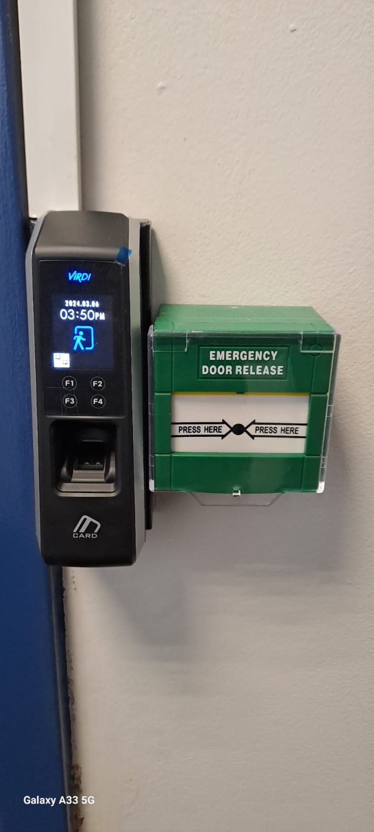 | ACCESS CONTROL  biometric reader
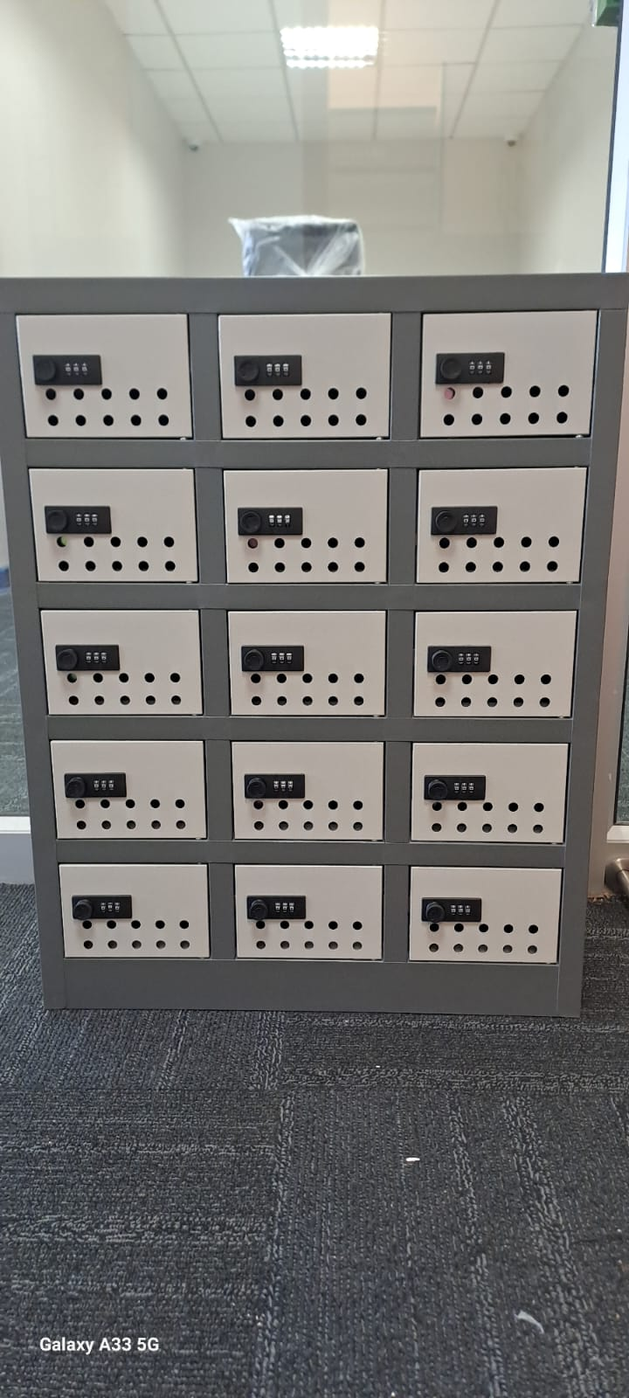 | 15 compartment steel cellphone lockers comprising of combination locks for each compartment therein
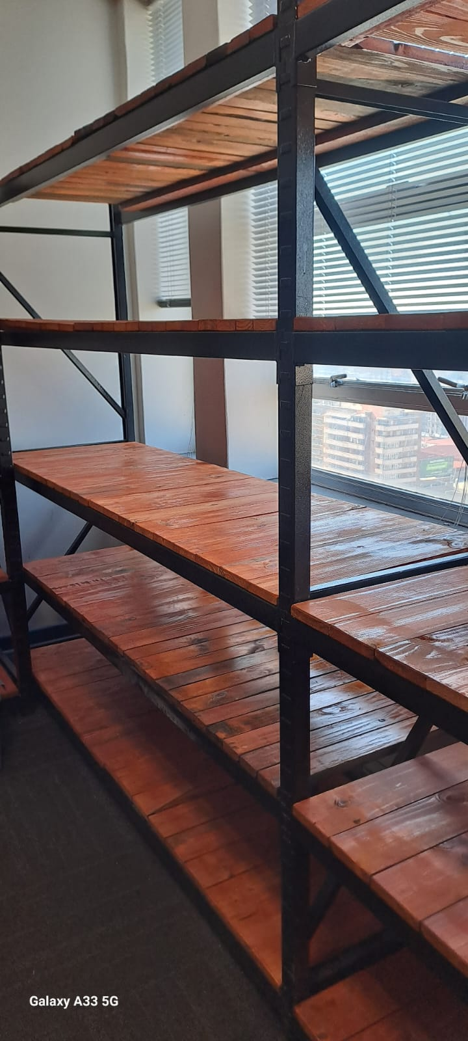 | Bolted heavy-duty shelving, with solid pine decking. (2000mm H x 2000mm W x 600mm D)
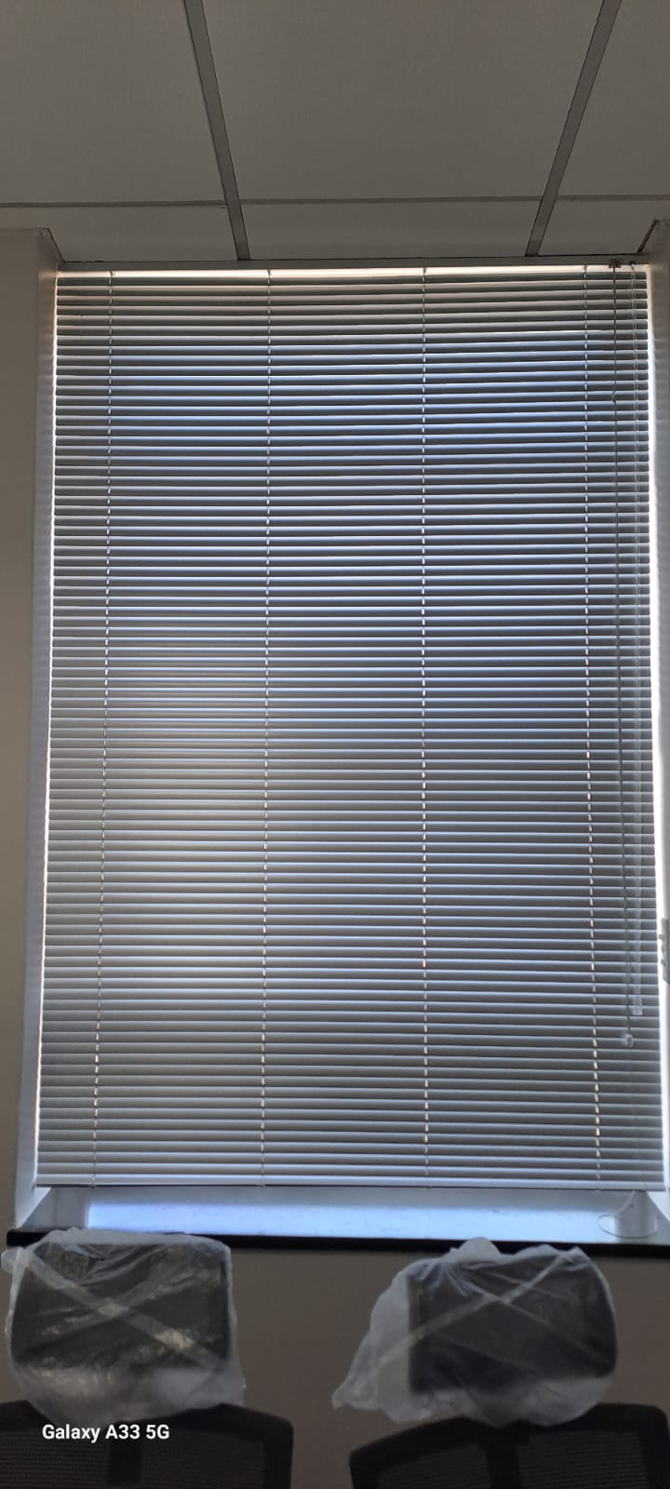 | Aluminum venetian blind, size to fit window with 25 x 0.21mm thick slats including 25 x 25mm high matching aluminum powder coated top and bottom tracks with stainless steel separator pins, cord locks and roller pins, blinds to be fitted inside reveal to lintel
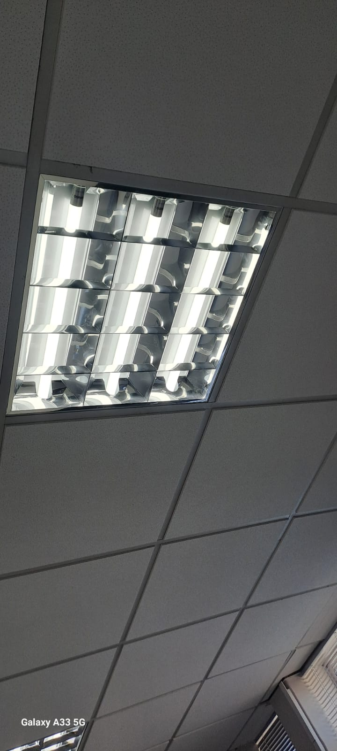 | Recessed low brightness luminaires with double parabolic louvres. Output to be min 3x14W T5 for 600x600mm fittings.
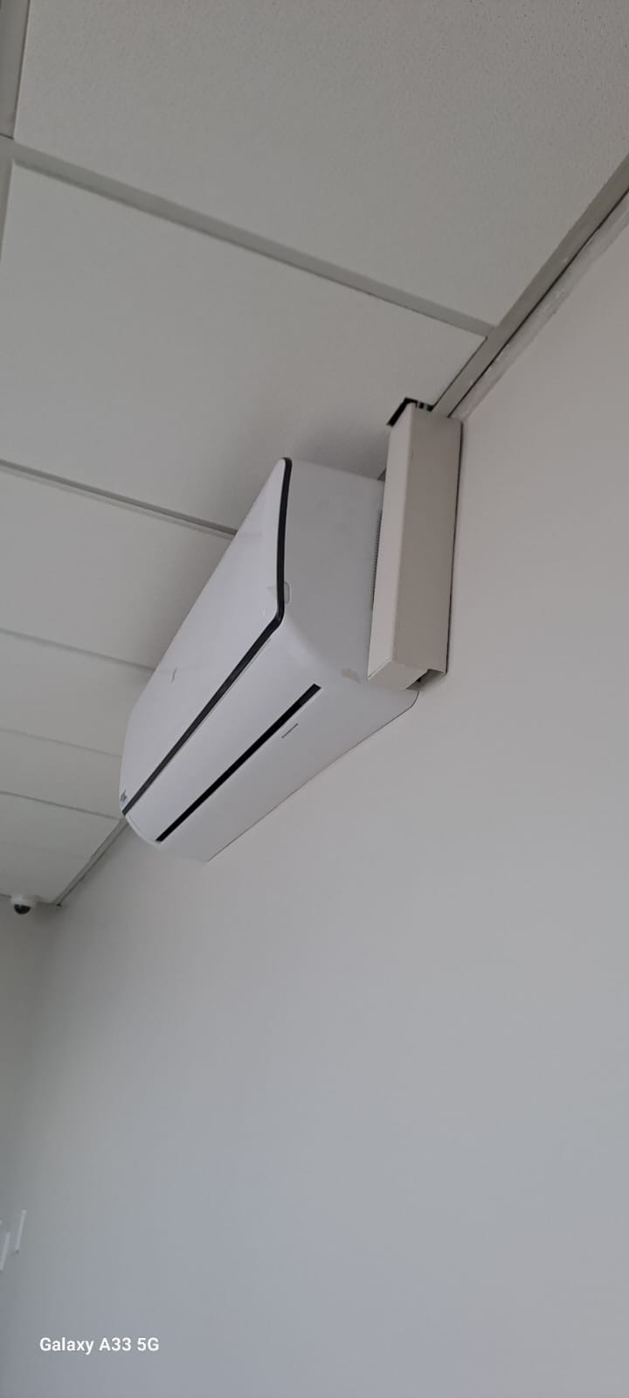 | Wall mounted air conditioner
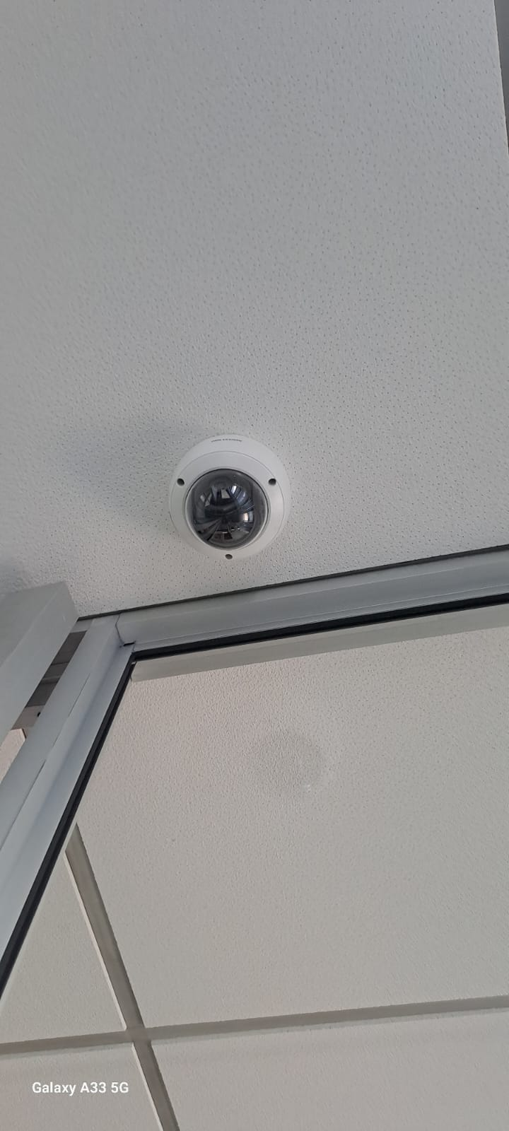 | IP Dome Camera. To be monitored at the control room
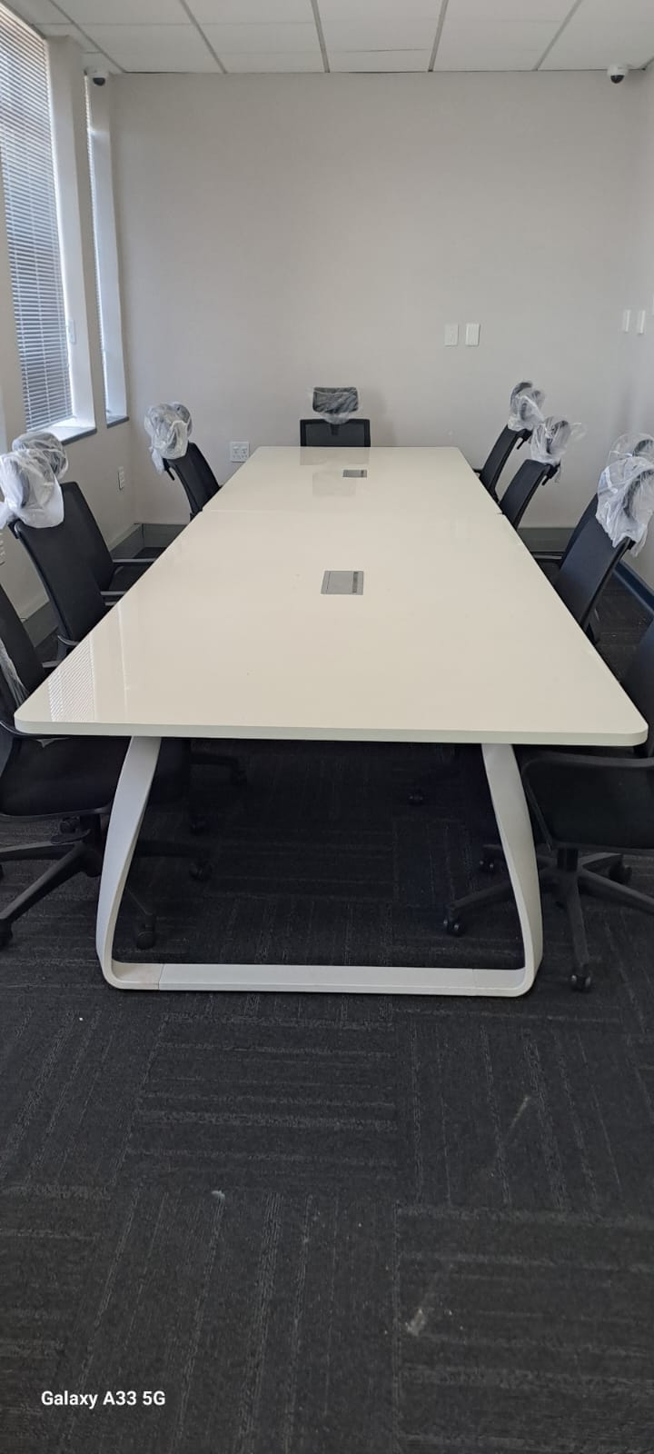 | Meeting room tables:  Work top finish: 22mm particle board with Iceberg White Deacon  Edging: Matching PVC flat edge 2mm  Leg Frame: Metal
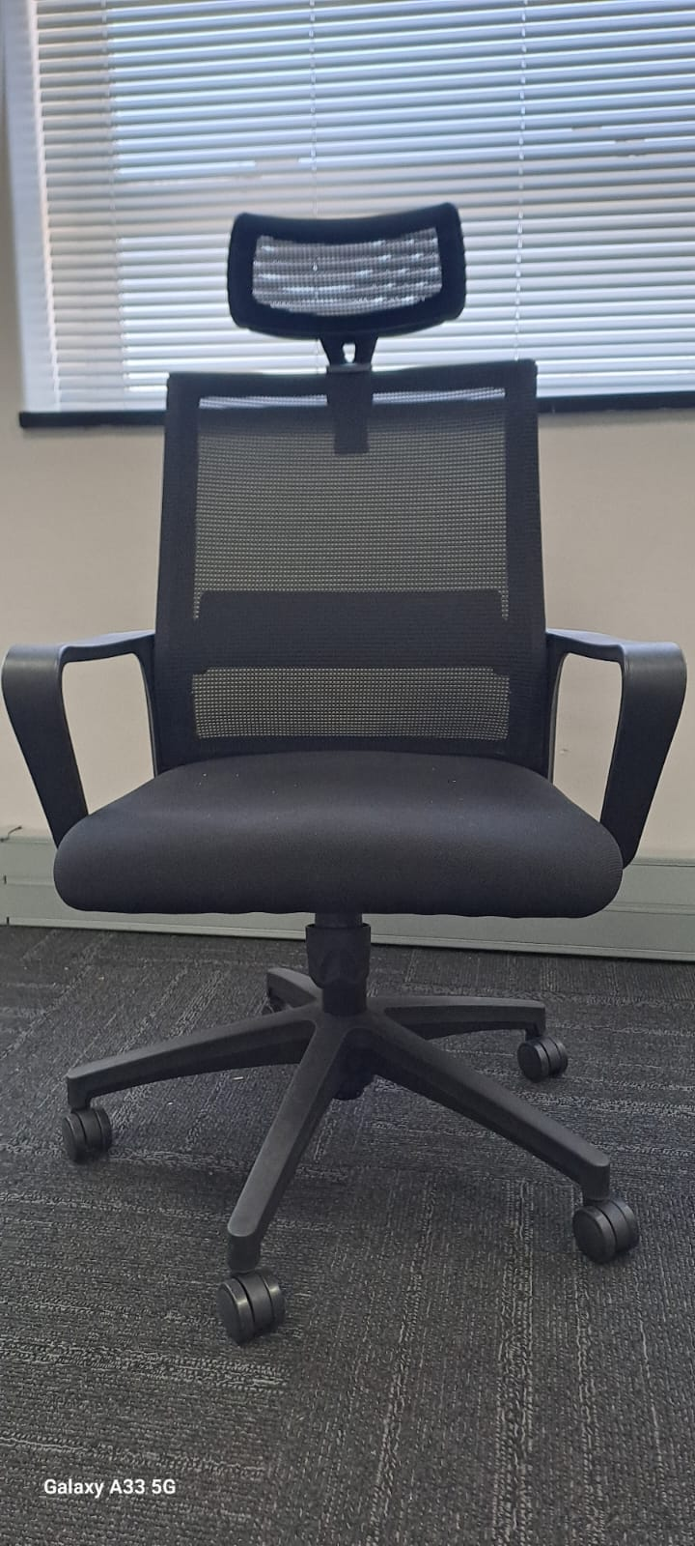 | High back-office chairs:  Back: Black netting
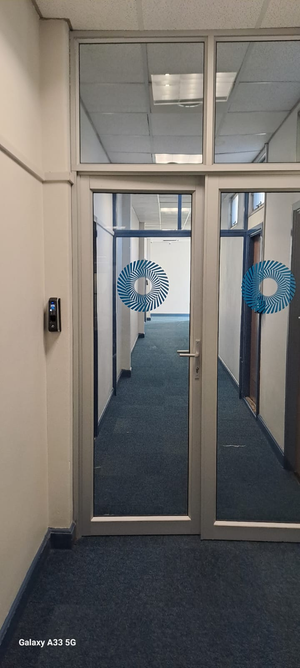 | Aluminum shopfront at 1700mm wide passage inclusive of glazed and frosted Double door size 1200mm x 2850mm
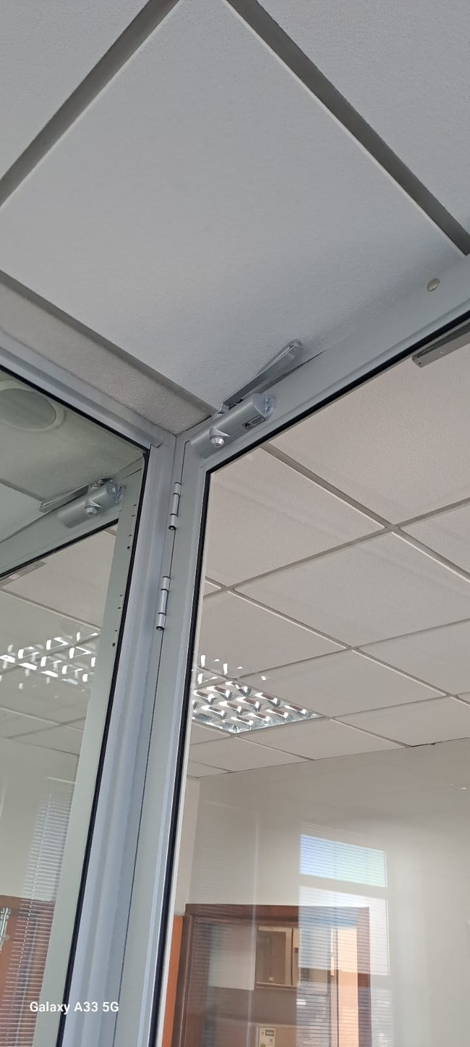 | Grade 304 stainless steel Rack and Cam pinion door closer with sliding track arm. Non handed with a maximum 180 degree non hold opening as standard. Power adjustable by spring, latching and damping action.
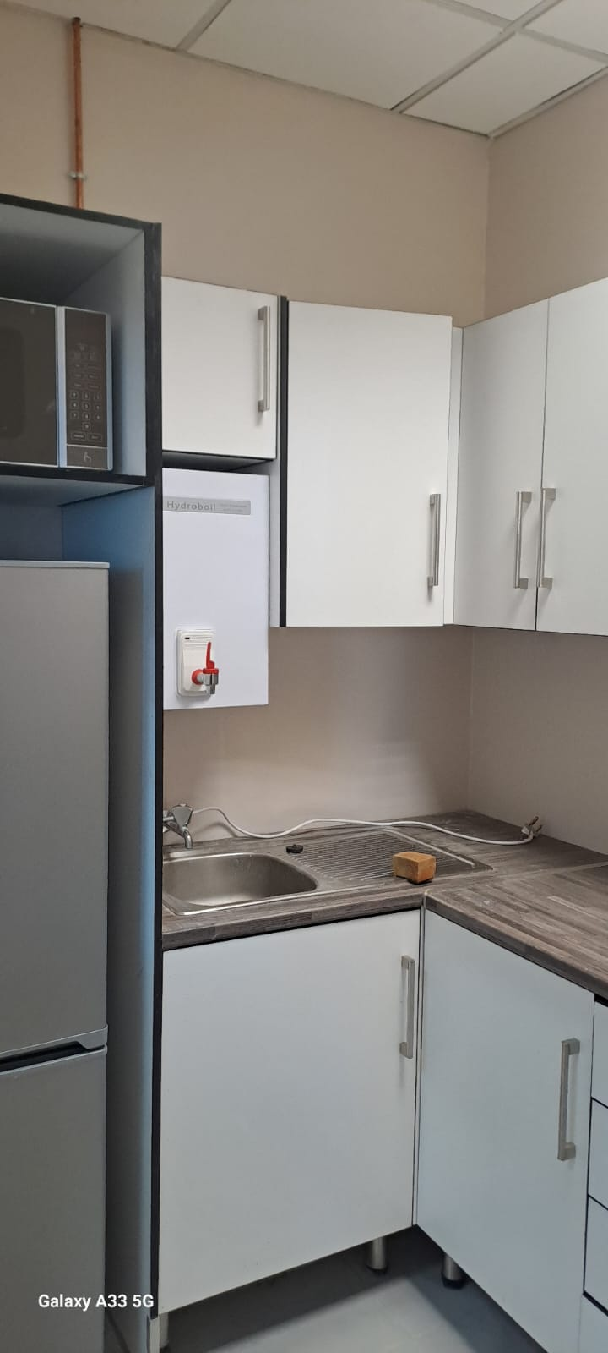 | Kitchen space at the SCM Evaluation rooms (cupboards, sink, microwave, and boiler)
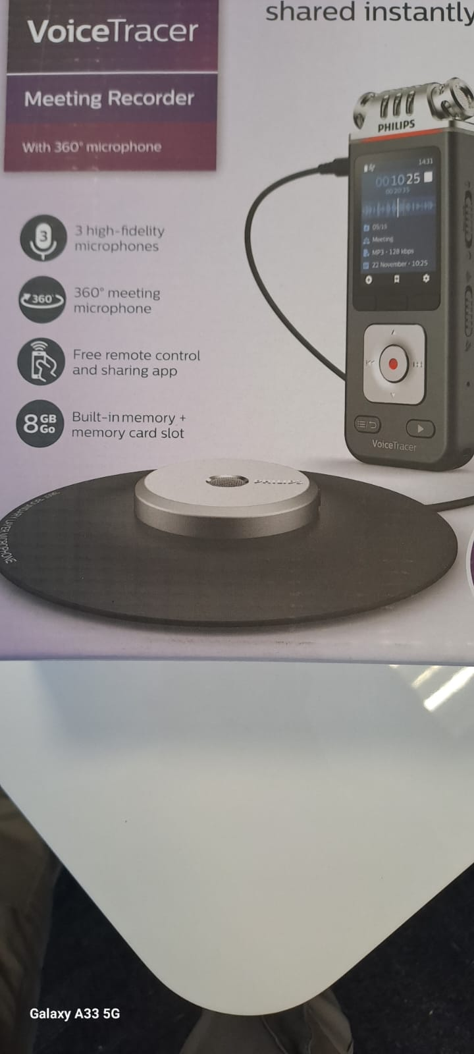 | Noise reduction voice activated voice recorders

