Requirement for crew will be 13 rooms per night, 3 Pilots and 10 Cabin Crew.

Flight Deck Crew
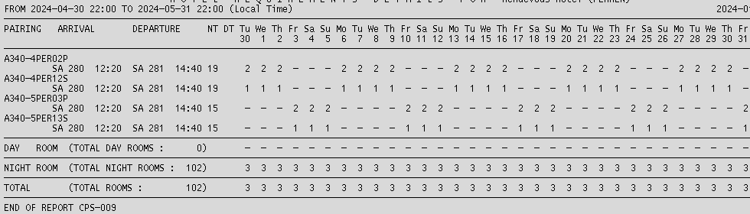
Cabin Crew
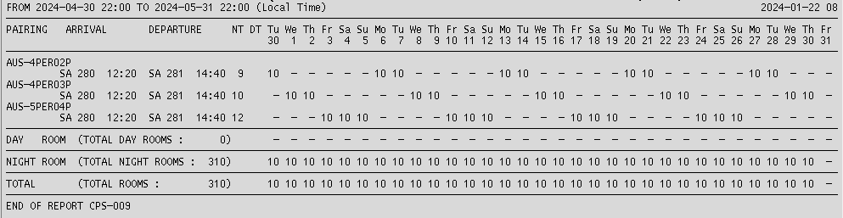

END.

