ENOCH MGIJIMA LOCAL MUNICIPALITY
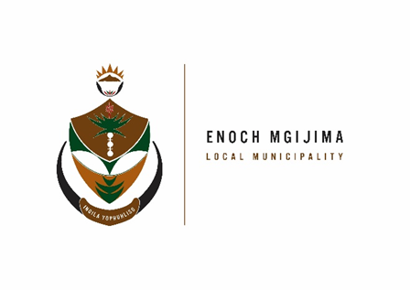
TENDER NOTICES

PROJECT NAME | NOTICE NUMBER | CIDB | DOCUMENT PRICE | PPPFA | COMPULSORY BRIEFING MEETING | ENQURIES | CLOSING DATE
CONSTRUCTION OF MOLTENO CEMETERY | SCM51/08/2022 | 3CE OR HIGHER | R500.00 | 80/20 | Venue: No. 20 Brewery Lane; Technical Service department @ 10h00  Date: 14 September 2022 | Mr. Gemadala 0458076001 | 29 September 2022 at 12h00pm  Register will be uploaded on the municipal website.
CONSTRUCTION OF STERKSTROOM CEMETERY | SCM52/08/2022 | 3CE OR HIGHER | R500.00 | 80/20 | Venue: No. 20 Brewery Lane; Technical Service department @ 10h00  Date: 14 September 2022 | Mr. Gamedala  0458076001 | 30 September 2022 at 12h00pm Register will be uploaded on the municipal website
RENOVATIONS OF THE HUMAN SETTLEMENT OFFICE BUILDING | SCM53/08/2022 | 2GB OR HIGHER | R300.00 | 80/20 | Venue: No. 2C Komani Street; Komani  Time: 11h00  Date: 14 September 2022 | Mrs N Makwethu  045 807 6400 | 23 September 2022 at 12h00pm Register will be uploaded on the municipal website
PROVISION OF BANKING SERVICE FOR A PERIOD 5 YEARS | SCM54/08/2022 | N/A | R1000.00 | 90/10 | N/A | Mr. T Abofra 045 807 2009 | 07 November 2022 at 12h00pm Register will be uploaded on the municipal website
SUPPLY AND DELIVERY OF GEL FUEL AND STOVES FOR 36 MONTHS | SCM55/08/2022 | N/A | R300.00 | 80/20 | N/A | Mr. T Ngwane 045 807 2021 | 22 September 2022 at 12h00pm Register will be uploaded on the municipal website

Bids are hereby invited from suitably qualified service providers for the projects listed above and must also take note of the following.
Bid documents containing detailed terms of reference will be available as from Wednesday 07 September 2022 ; 08h00 - 16h00 week days, from the Supply Chain Management offices: Budget and treasury offices at No. 25-27 Owen Street; Queenstown upon payment of a non–refundable fee (either in cash or by means of an EFT made payable to the Enoch Mgijima Local Municipality) . Completed bid documents are to be place in a sealed envelope clearly marked the Bid number and Project Name and must be deposited in a bid Box situated at Budget and treasury offices at No. 25-27 Owen Street; Queenstown no later than 12h00pm on the closing date at which all bids will be opened in public. Banking details: Acc Name: Enoch Mgijima Local Municipality
Bank :FNB
Acc No :62438159809
Acc Type :Cheque
Branch Code: 250655 (internet Banking)
Ref : 3010142551022
More details about the adverts phone Mr. A Hoko on 045 807 2000

Issued By

N C ZONDANI TOWN HALL
MUNICIPAL MANAGER CATHCART ROAD
KOMANI

