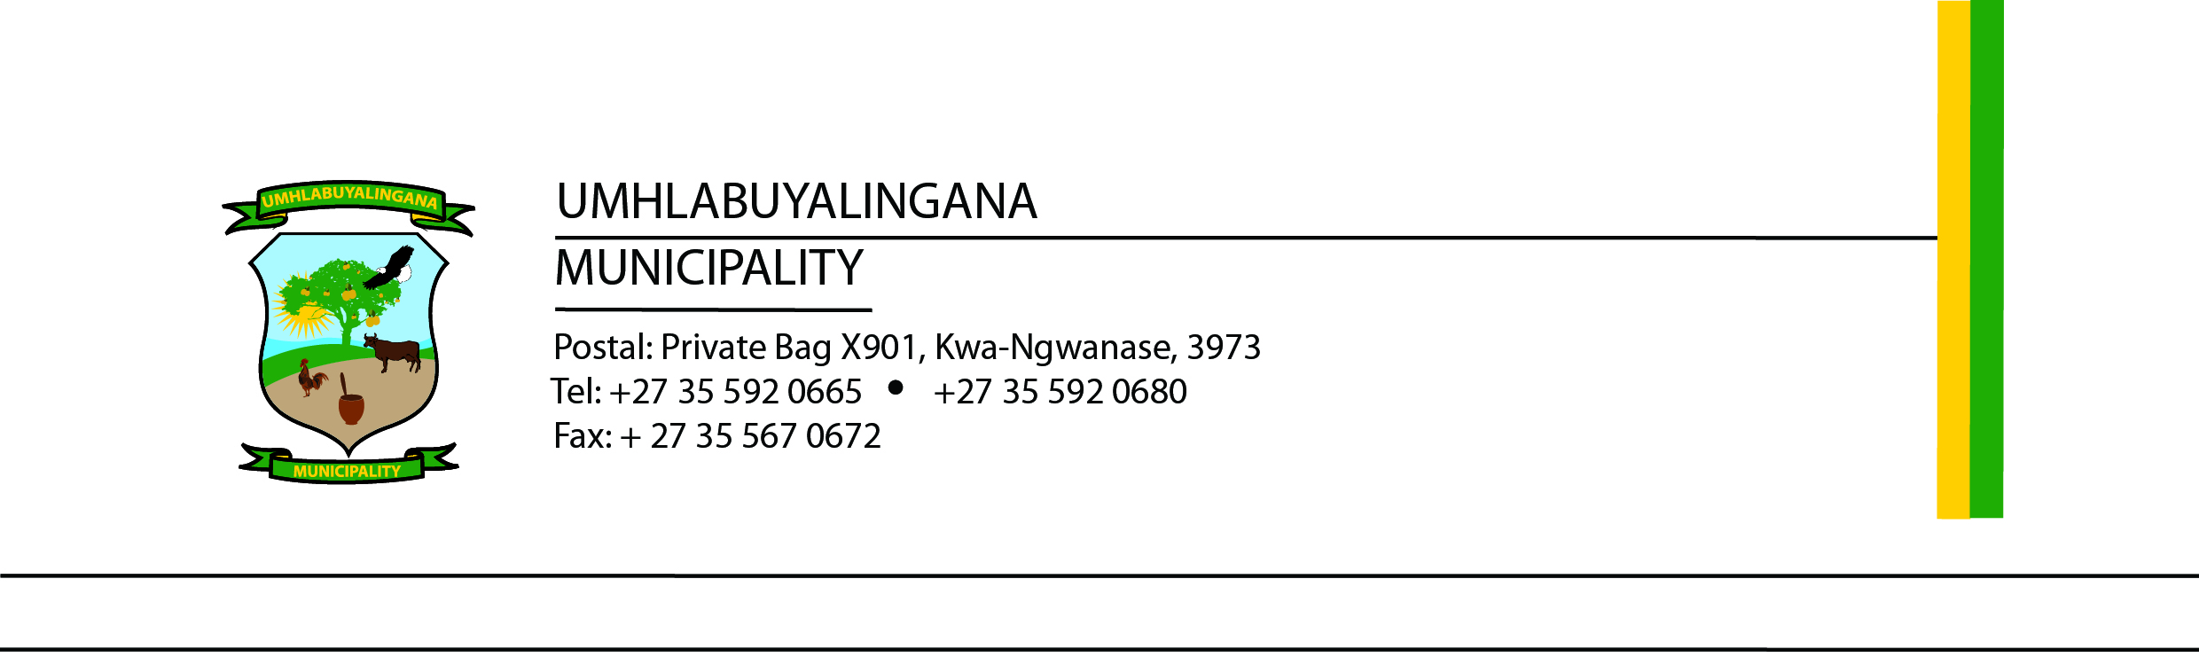

TENDER NUMBER: UMHL35/2025/2026
SUPPLY, DELIVERY, AND INSTALLATION OF FURNITURE FOR MUNICIPAL COUNCIL CHAMBER
The uMhlabuyalingana Local Municipality invites suitably qualified and experienced service providers to submit tenders for the supply, delivery, and installation of council chamber furniture. Tender documents are available for free download from the eTenders portal and the uMhlabuyalingana Municipality website.

Scope of Work
- Supply council chamber furniture of high quality and durability.
- Deliver furniture to the uMhlabuyalingana Municipality offices.
- Install and arrange furniture in the council chamber.
- Ensure compliance with ergonomic, safety, and design standards.

Tender Requirements
- Valid company registration documents.
- Valid SARS Tax Pin.
- Proof of relevant experience in similar projects.
- Detailed proposal including specifications, timelines, and costs.
- Warranty and after-sales support.
- MBD 1, 4, 6.1, 8 and 9,
- Certified ID document of director(s)
- Certificate of warrant of the furniture
- Municipal Rates not in arrears for more than 90 days

Evaluation Criteria
Tenders will be evaluated in line with SCM Regulations and the uMhlabuyalingana Municipality SCM Policy.
- Functionality assessment: minimum 70% required to proceed.
- 80/20 preference point system: 80 points for price, 20 points for specific goals.

Compulsory Briefing Session
- Date: 26 June 2026 at 10h00
- Venue: uMhlabuyalingana Municipality, Council Chamber, R22 Manguzi Main Road, KwaNgwanase, 3973

Closing Date
Completed tender documents must be submitted by 03 July 2026 at 12h00 at the uMhlabuyalingana Local Municipality offices. Late submissions will not be considered.

Enquiries
For further information, please contact: Mr. N.M. Mthembu Email: BafanaM@mhlabuyalingana.gov.za
The Municipality reserves the right not to accept the lowest or any tender received.

Mr. N.P.E. Myeni
Municipal Manager

