

Mini Prof Repair and Calibration

The following mini-profilers need to be repaired as guided by (but not limited to) the outlined observations from the engineering team. The service provider is appointed to make the mini-profilers functional. The serial numbers of the profilers and specific observations are noted below:

Serial No: 131-1319
- Assess and refurbish as necessary:
- Digital Encoder (inner)
- Digital Encoder (outer)
- Litton brush block
- Litton slip ring with V-groove
- Litton extension for MiniProf wheel
- MiniProf printed circuit board
- Reference pins
- MiniProf Service & Calibration
- Additional repairs:

Serial No: 131-1393
- Assess and refurbish as necessary:
- Digital Encoder (inner)
- Digital Encoder (outer)
- Litton brush block
- Litton slip ring with V-groove
- Litton extension for MiniProf wheel
- MiniProf printed circuit board
- Reference pins
- MiniProf Service & Calibration
- Additional repairs:
  - Cable connector previously damaged and repaired –USB power short circuit

Serial No: 131-1395
- Assess and refurbish as necessary:
- Digital Encoder (inner)
- Digital Encoder (outer)
- Litton brush block
- Litton slip ring with V-groove
- Litton extension for MiniProf wheel
- MiniProf printed circuit board
- Reference pins
- MiniProf Service & Calibration
- Additional repairs:
  - N/A

Serial No: 131-1706
- Assess and refurbish as necessary:
- Digital Encoder (inner)
- Digital Encoder (outer)
- Litton brush block
- Litton slip ring with V-groove
- Litton extension for MiniProf wheel
- MiniProf printed circuit board
- Reference pins
- MiniProf Service & Calibration
- Additional repairs:
  - N/A

Serial No: 162-2138
- Assess and refurbish as necessary:
- Digital Encoder (inner)
- Digital Encoder (outer)
- Litton brush block
- Litton slip ring with V-groove
- Litton extension for MiniProf wheel
- MiniProf printed circuit board
- Reference pins
- Battery
- MiniProf Service & Calibration
- Additional repairs:
  - N/A

Pictorials

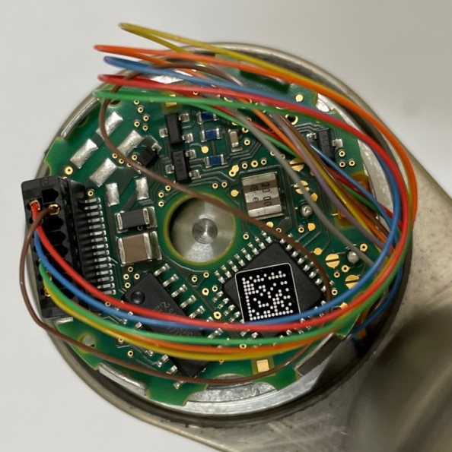 | Digital encoder and printed circuit board
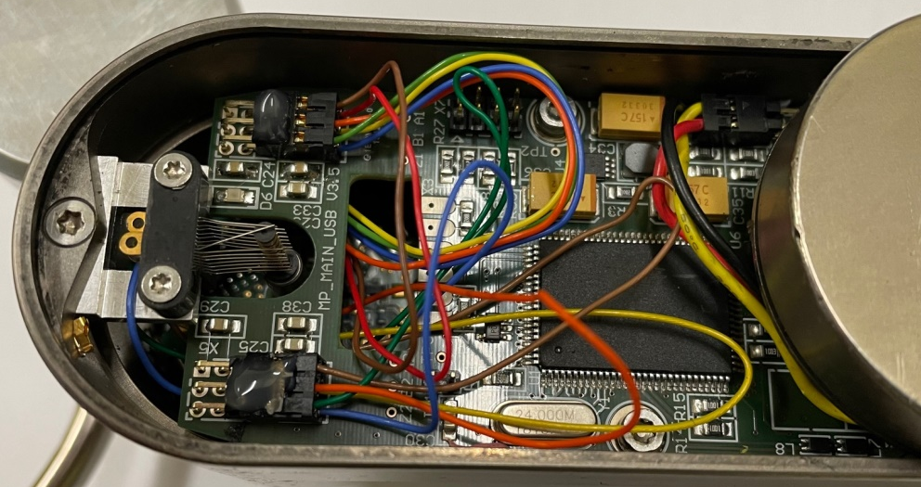 | MiniProf printed circuit board
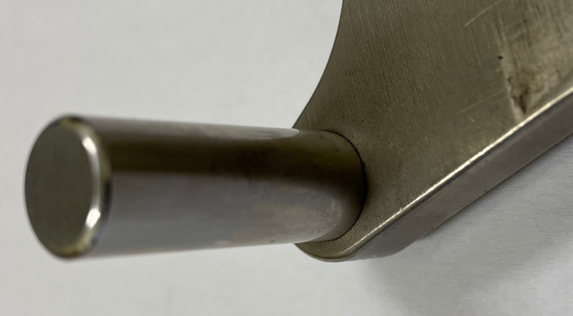 | Reference pin
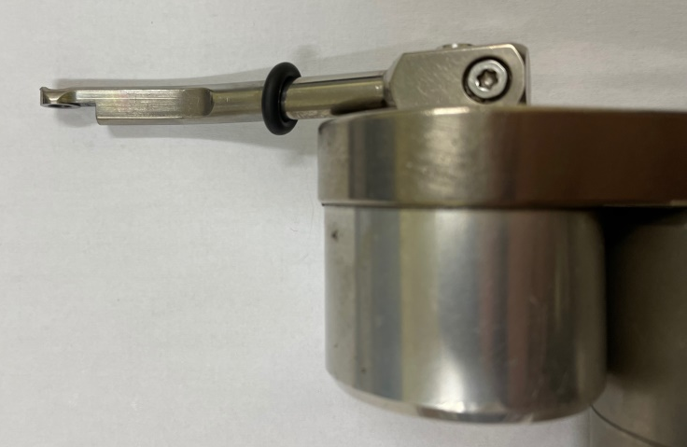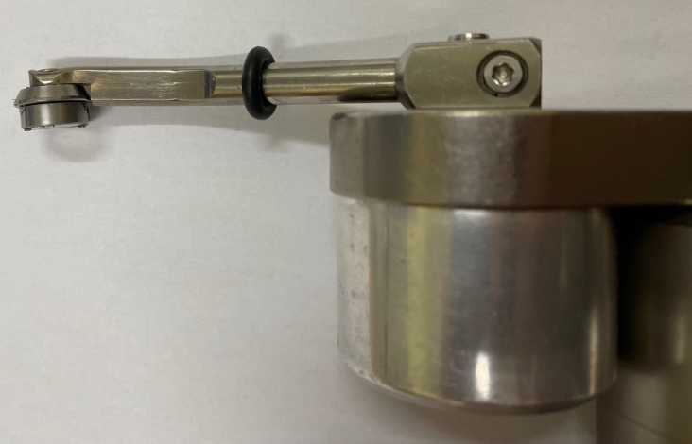 | Magnetic wheel
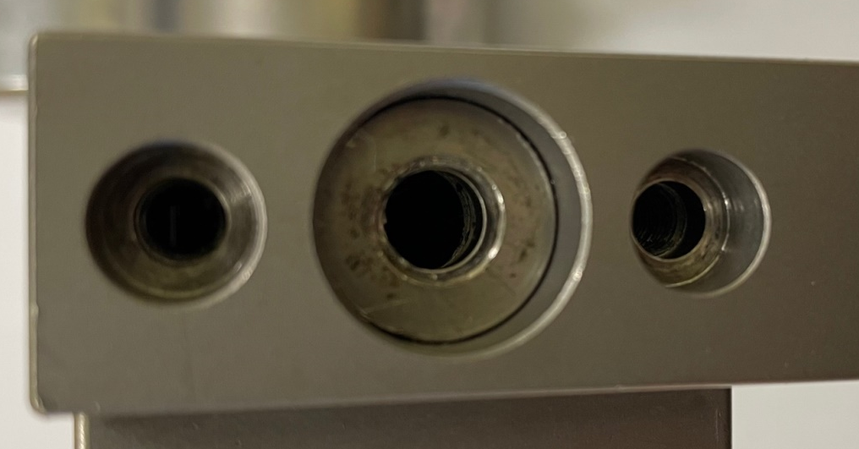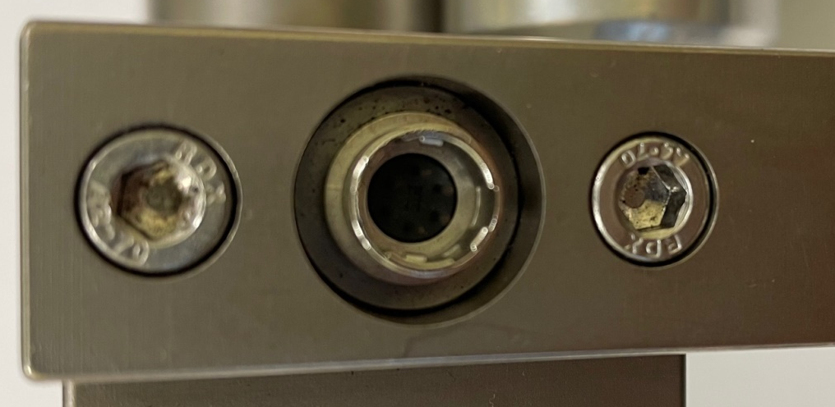 | Missing connector and screws

