Scope of Work:

For the construction and installation of a 4.8 Meter Vertex RSI KPC antenna.

Sentech requires a contactor to install a Vertex RSi KPC 4.8-meter C-Band Satellite antenna and 2 LMR 400 cables at the Cape Town Sentech offices at Silverboom Avenue, Plattekloof (GPS coordinates -33.8664035, 18.5726582). The project objectives are:

- The installation of a Vertex 4.8 meter C-Band earth station antenna: The antenna is available at the Sentech offices in Cape town
- The components of the antenna must be thoroughly cleaned before assembly and inspected for corrosion damage.
- A complete, Vertex supplied, relocation kit is to be provided by the contractor for installation.
- The antenna will be installed and aligned, according to the installation manuals, on the roof of the building. The antenna will be positioned on a prepared base supplied by Sentech. A crane with a lifting capacity of at least 60 Tons is required to erect the antenna. Lightning protection rods as well as antenna structure earthing needs to be installed and connected.
- The current circular polarization configuration on the two-port feed will have to be checked and changed to RHCP for reception if required.
- The antenna will be optimized on the AMOS 17 satellite at 17° east. The qualification of the antenna. The antenna is to be qualified by providing a G/T measurement. The G/T methodology will be left to the discretion of the contractor. A signed As-built handover document must be provided to SENTECH as proof of completion of work.
- The supply of 150Meters LMR-400 cable (50 Ohm), 4 x N-type male connectors for LMR-400 cable and 4 x earth kits for LMR-400 cable

- The installation and termination of the cable and connectors from the antennas to the equipment cabinet. The cables are to be strapped to the antenna structure and cable trays with cable-ties supplied by the contractor. All external connections are to be weather-proofed with self-vulcanizing tape. An earth kit is to be installed at the base of the antenna and an earth kit the cable at the point where the cable enters the building.

- The installers must include an OHS file in their bid submission. The file must contain all the relevant information as indicated an annexure-1. A copy of the file are to be available for inspection duration of the disassembly. All personal working on the antennas will be required to have a valid mast climbing certificate as well as a valid medical fitness certificate. All work to be carried out in accordance with the OHSE act as applicable in South Africa.
- Site clean-up: All excess installation, packaging and waste material will be removed from site and disposed of by the installer.

- There are two similar antennas at the Cape Town OC. Only one will be installed. The other will be relocated to an area, identified by the OC, at ground level. Parts can be interchanged between the two antennas in the event of missing components.

Google Earth view of the Sentech office site.
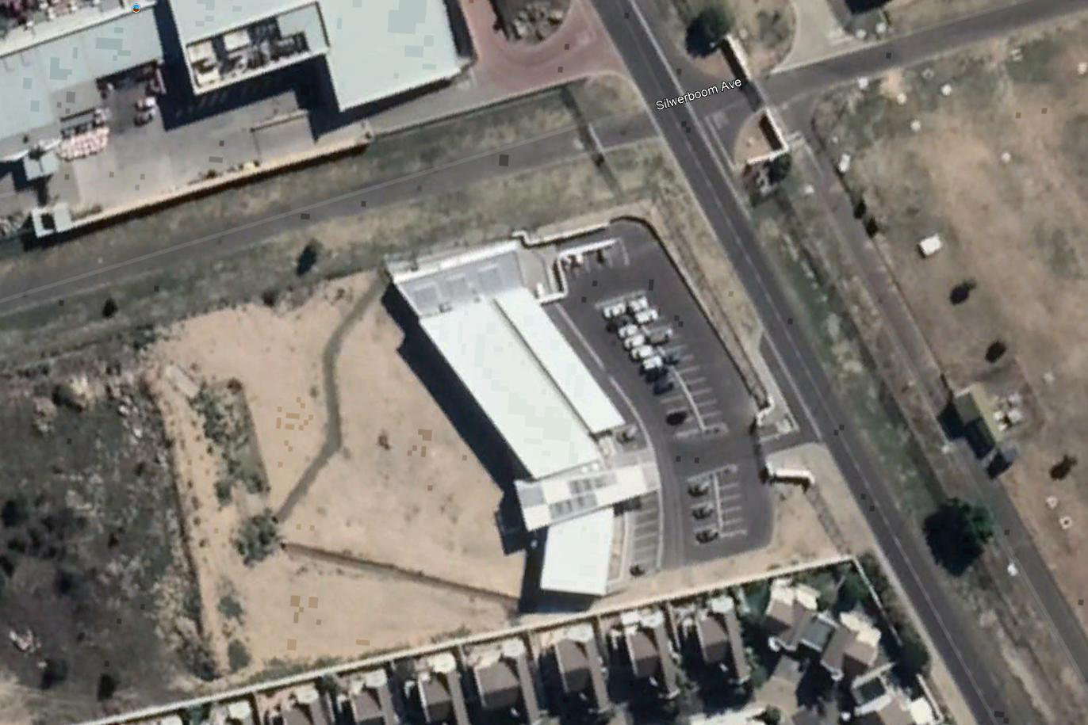

Street view of offices
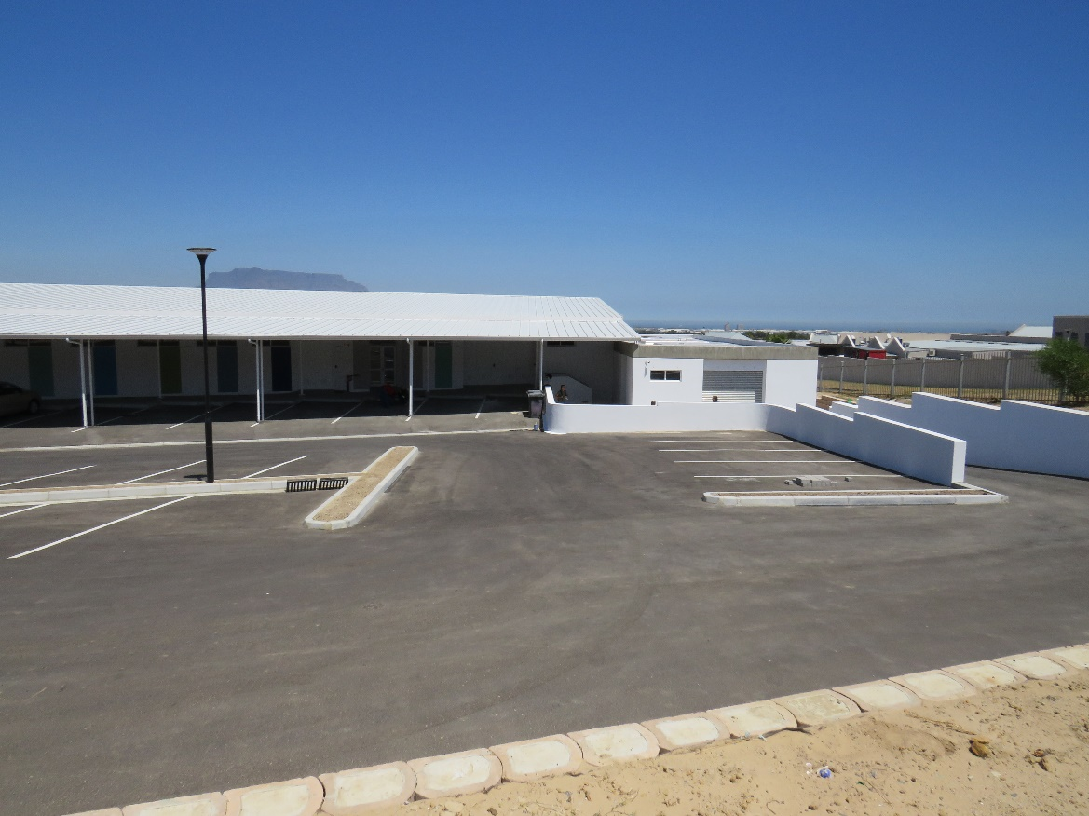

Street view of offices
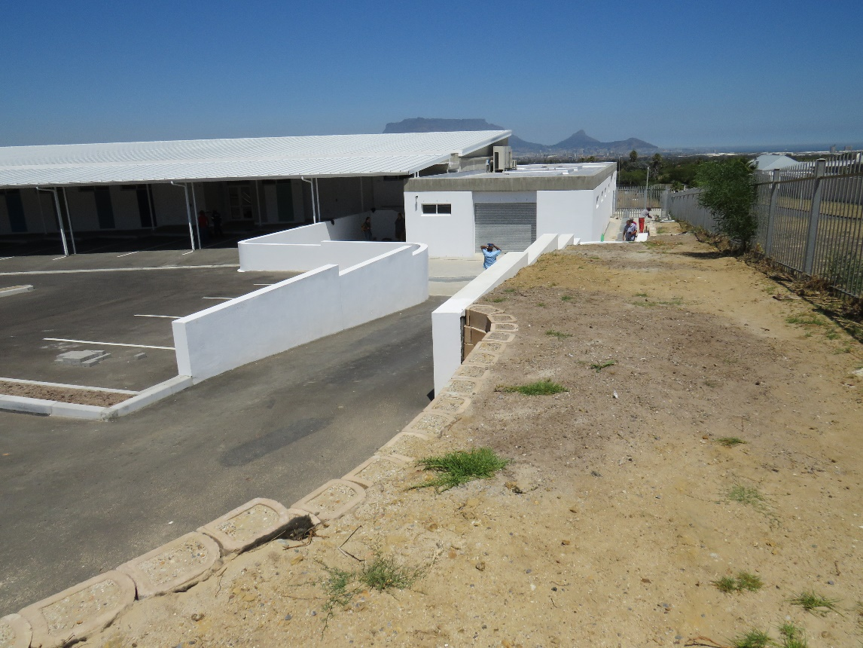

Annexure1

OCCUPATIONAL HEALTH SAFETY AND ENVIRONMENTAL PROJECT FILE

PROJECT NAME:

The installation of a 4.8 Meter Vertex antenna.

INDEX

- Occupational Health Safety Environmental Policy
- Legal appointments
  - 16 1 Appointee – CEO/MD/GM
  - 16 2 Appointee/ CR6.1 – Snr Rigger/Antenna Technician onsite
  - CR20(f) - Crane Operator
  - GSR 14 – Scaffold Inspector or Cherry picker
  - CR 7.1 – Risk Assessor
  - GAR 9.2 – Incident Investigator
  - EMR 9.4 –Electrical portable tools inspector
  - SEC. 17.2 - H & S Rep
  - GSR 3.4 – First Aider
  - CR 27 – Fire Fighter & equipment’s Inspector
- Training Records supporting most Legal Appointments above
- Medical Fitness Certificate of Crane Operator
- Scope of Operation
- Section 37.2 agreement
- Public Liability Insurance
- Notification of construction work to Provincial Director (Annexure A) of Reg 3
- Letter of Good Standing
- Safety plan including the following:
  - Risk Assessment – indicate assessment criteria
  - Fall Protection Plan
  - Checklist
    - Portable Electrical Tools
    - Crane load testing certificate
    - Slings(DMR 18)
    - Safety Harness
    - Scaffold
    - Hand tools
    - Mobile Crane etc.
    - PPE
- Emergency plan including:
  - First Aid box with standard contents
  - IOD reporting procedure or routing diagram
  - IOD forms WCL1 or 2 or Annexure 1
  - Incident Investigation procedure and forms
  - Emergency numbers
- Induction & Toolbox Talks with registers and minutes
- Waste disposal plan e.g. wooden drum, cable wires etc.

Annexure 2

Report on state of antenna at the time of decommissioning.

