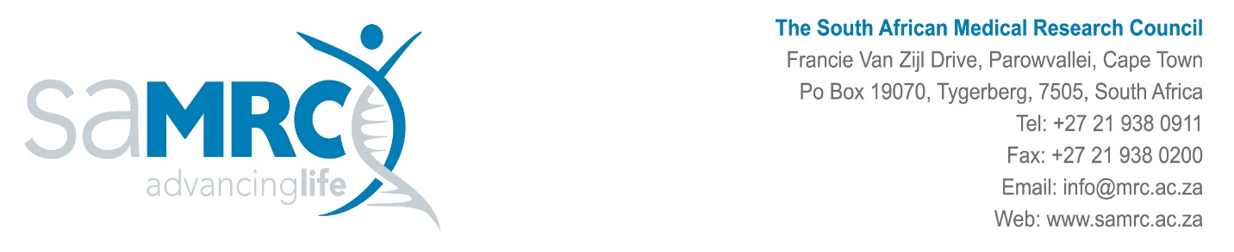

29 June 2026
Medicines Patent Pool:

Scope of Audit Work:

We require the services of a Registered Auditor/Audit Firm to complete the agreed upon procedures as outlined by Medicines Patent Pool (MPP) for grants issued to the SAMRC the following period:
- 1st January 2025 to 31st December 2025

The total value grants income received/claimed over the above-mentioned period amounted to: R8.2million

Please contact Peter Mwewa (contact details below) for the following audit documents to assist you with the providing an informed quotation:

- Questionnaire
- Income and Expenditure Statement
- GL

Contact Details:
Peter Mwewa
Project & Management Accounting Office
Peter.mwewa@mrc.ac.za

Additional Information and timeline.

The audit will take place at our offices in Francie van Zijl Drive, Parow Valley, Cape Town.
The audit deadline is 31st July 2026.

