

BREEDE-OLIFANTS CATCHMENT MANAGEMENT AGENCY
TERMS OF REFERENCE
Water Resources Assessment H30A-E

DOCUMENT INFORMATION SHEET
Title of Document | REQUEST FOR PROPOSAL (RFP)
Type of Document | Request for Proposal
Document Number | RFP 2024/06
Technical Specifications Prepared | Bid Specification Committee
Department | WATER RESOURCE MANAGEMENT
Prepared for | Breede- Olifants Catchment Management Agency
Date of Issue (Available) | 13 November 2024
Closing Date | 05 December 2024

NAME OF THE BIDDER

……………………………………………………………………………….

Total Tender Price R…………………………………………………….
(For the period of five years )

CNR Mountain Mill and East Lake Road, Worcester, 6850
Private Bag X3055,Worcester, 6849
ABBREVIATIONS AND ACRONYMS
APP | Annual Performance Plan
BEE | Black Economic Empowerment
BBBEE | Broad-Based Black Economic Empowerment
BGCMA | Breede-Gouritz Catchment Management Agency
BOCMA | Breede-Olifants Catchment Management Agency
BOWMA | Breede-Olifants Water Management Area
BGWMA | Breede-Gouritz Water Management Area
CEO | Chief Executive Officer
CFO | Chief Financial Officer
CMA | Catchment Management Agency
CMF | Catchment Management Forum
CMS | Catchment Management Strategy
DWS | Department of Water and Sanitation
EE | Employment Equity
ELU | Existing Lawful Use
EME | Exempted Micro Enterprises
FE | Financial Enterprise
GIS | Geographical Information System
GRAP | Generally Recognized Accounting Practice
HDI | Historically Disadvantaged Individual
HR | Human Resources
IT | Information Technology
ISPs | Internal Strategic Perspectives
IB | Irrigation Board
MOU | Memorandum of Understanding
MTEF | Medium Term Expenditure Framework
MTSF | Medium Term Strategic Framework
NCIMS | National Compliance Information Management System
NDP | National Development Plan
NEMA | National Environmental Management Act
NRF | National Research Foundation
NWA | National Water Act, 1998 (Act 36 of 1998 as amended)
NWRS | National Water Resource Management Strategy
PDMS | Performance and Development Management System
NWRS | National Water Resources Strategy
PSP | Professional Service Provider
PFMA | Public Finance Management Act
QSE | Qualifying Small Enterprises
RORs | Record of Recommendations
RPF | Resource Poor Farmers
RQOs | Resource Quality Objectives
SLA | Service Level Agreement
TMG | Table Mountain Group
V&V | Validation and Verification
WMIs | Water Management Institutions
WARMS | Water Authorisations and Registration Management System
WRM | Water Resource Management
WSA | Water Services Act, 1997 (Act 108 of 1997)
WSA | Water Services Authority
WSDPs | Water Services Development Plans
WUA | Water User Association

Introduction
The Breede-Olifants Catchment Management Agency requires the services of a suitably qualified and experienced professional service provider to conduct a comprehensive water resources assessment in the H30 tertiary catchment. This is to fully understand and document the catchment challenges and opportunities in the context of water resources management, use and development.

The purpose of the study is to conduct a water resources situation analysis, determine water balances, explore options to augment supply and research options and priorities for water resource protection. This should include the identifying of future water resources development options and resource management priorities for the catchment. The study also aims to update and verify existing Reserve and Resource Quality Objectives information, identify and rank activities to support implementation of the Reserve and RQO’s in the catchment/s.

The overarching aim of the study is to add to the decision support information in the catchment and also to identify key activities in the catchment that can benefit water users and improve the water availability. This will assist with future water resources management decisions, while contributing to the protection, use and development of water resources in the catchment.

The study is initiated in line with the existing Catchment Management Strategy (CMS) of the then Breede-Gouritz CMA which identifies the updating of water resources information and water balances progressively throughout the WMA following the completion of the Validation and Verification (V&V) studies. This will assist BOCMA to have up-to-date information to enable future water resources management decisions like licensing and the planning of additional water infrastructure. The selection and extent of the study areas are guided by budget availability and level of water stress in the catchment.

The study area is located primarily upstream of Montagu town, comprising of four quartenary catchments H30A, H30B, H30C and H30D, drained by the Kogmanskloof River, the main tributaries are the Kigna River to the east and the Keisie River to the west, see Figure 1. The Quartenary Catchment H30E drains the downstream portion of the river, located south of the Kogmanskloof pass up to the confluence with the Breede River. Major towns in the study area include Montagu in the upper catchment and Ashton in the lower reaches.

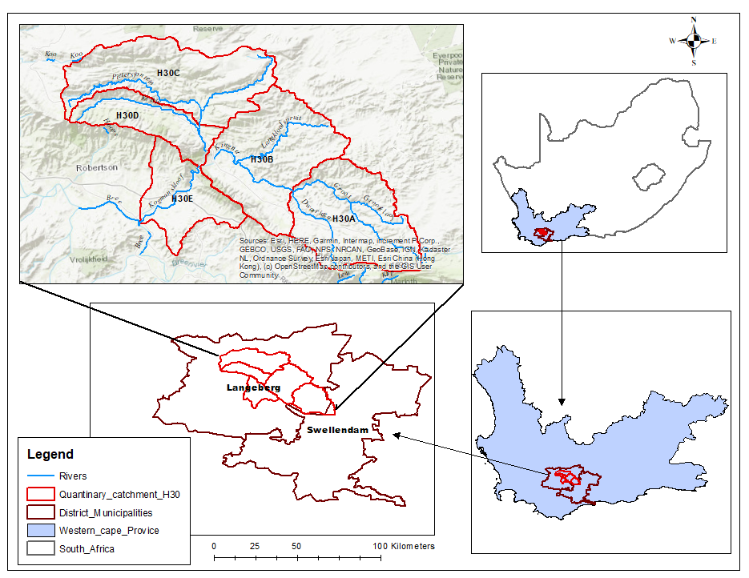
Figure 1 Showing location of the study area and focus catchments

This study area is known to be in local water deficit and have historically imported water from the Breede River for both irrigation and municipal use. A detailed understanding of the catchment, including future options, will assist BOCMA and stakeholders in the catchment by providing a baseline and consolidated information for future planning and management.

OBJECTIVES OF THE study
The objective of the study is to conduct a water resources catchment analysis of the H30 tertiary catchment with the aim of updating water balances and to aid future water resource management decisions. A supplementary aim is to identify future water resources development options and to explore resource management priorities for the small sub-catchment/s in the context of the reserve and RQO’s. It is anticipated that the exercise will be fulfilled by the following activities:-

- Set up a Surface water resources assessment model for the catchment, update hydrology and quantify yields of existing bulk water infrastructure. Source and update existing models as required, hydrology to be updated to include recent drought.
- Conduct a high level ground water resources assessment in the catchment and identify potential for possible future use. The expected approach is to conduct a hydrocensus survey and mini Reserve analysis within the study area to understand baseflow support to the streams in the area.
- Assessment of current and future water requirements in the catchment, focusing on the agricultural water use. Future requirements to be done in consultation with the Western Cape Department of agriculture and local stakeholders to identify future development potential.
- Document existing and identify possible additional water supply infrastructure options and conduct high level prioritization. In the study area it is anticipated that the focus will be on bulk water infrastructure supplying Agricultural use and options for increasing assurance of supply in existing schemes.
- Update and verify existing Reserve and RQO information, identify and rank activities to support implementation of the Reserve and RQO’s in the catchment/s.

In conducting the study, the following should be considered:-
    - Consider the management class of water resources and resource quality objectives contemplated in Chapter 3, (NWA 1998) and the requirements of the Reserve;
    - Consider the existing reconciliation strategy for the Breede Gouritz WMA;
    - Take into account the geology, demography, land use, groundwater recharge, climate, vegetation and waterworks within its water management area;
    - Consider the then ground- and surface water government control area/s;
    - Validation and Verification information including irrigation boards and water users association schedules;
    - Considering any relevant national or regional plans prepared in terms of any other law, including any development plan adopted in terms of the water ;
    - Enable the public to participate in managing the water resources within its water management area;
    - Consider the water needs and expectations of existing and potential water users;
    - Consider the impacts of climate change.

Study area

The study area is the is located within the H30 tertiary catchment, includes the quartenary catchments H30A, H30B, H30C, H30D and H30E. Approximately 85% the drainage area is located in the Little Karoo and includes the scenic Kogmanskloof Pass and Montagu Town. Major dams in the area include the Poortjieskloof Dam to the east and Pietersfontein Dam to the west. The area is drained by the Kogmanskloof River up to the confluence with the Breede River.

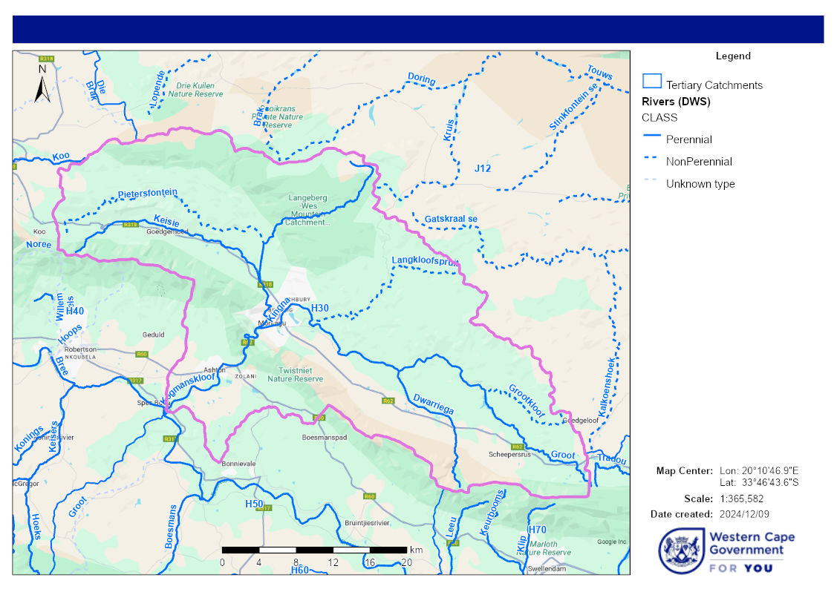
Figure 2 Map showing extent of H30 study area (Source, CFM)

Major Water Users
The major water user in the catchment is agriculture for irrigation purposes, there are two water users associations, the Kogmanskloof WUA and Dwaringa WUA and Two Irrigation boards, the Kingna and Baden Irrigation boards.

The major town in the study area is Montagu and Ashton.

CONSULTING SERVICES REQUIRED
The successful bidder has to perform and provide the following tasks and services:

4.1 Administration and project management:
- Project contract administration,
- Project secretariate services, preparing of agendas and keeping minutes of meetings,
- Stakeholder coordination and communication,
- Bi-monthly reporting and presentations (Minimum of 3 meetings).

4.2 Technical tasks, reports and presentations
The deliverables should be in line with the main study objectives, The following is the anticipated minimum set of deliverables for this assignment:
- Inception report;
- Situational assessment;
- Stakeholder Engagement
The stakeholder participation envisaged in this study include consultation with organisations involved in the water resources management and major water users like water users associations, irrigation boards and municipalities, government departments and local farmer representation groups/organisations. The identification of stakeholders to be consulted should be done in consultation with BOCMA. A complete stakeholder list and updated information should be compiled.
- Hydrological assessment and yield analysis of existing major water infrastructures and assessment of possible future water resources infrastructure developments;
- Current water requirements (Agriculture, Domestic, industrial);
- Hydrocensus survey and mini Reserve analysis to understand baseflow support to the streams in the area;
- Water balance and reconciliation options;
- Update Reserve, RQO’s and recommend activities to support Reserve and RQO implementation;
- Populate a database with all information used and generated including model setup.

SERVICE PROVIDER COMPETENCIES
5.1 Competencies of the Service Provider
The Professional Service Provider must be qualified with extensive knowledge of integrated water resources management. It is expected that the team and individual team members who are assigned to specific project tasks and activities have specialist subject knowledge and applied relevant experience in the area.
Suitable knowledge and experience competencies are required in:
- An extensive knowledge and understanding of all aspects of water resources, water resources management and water services provision in the Breede-Olifants water management area. Service providers should ideally have previous experience within the Breede River catchment;
- Catchment hydrology, yield assessment, operating rules, options analysis, and conducting studies of medium to large scale water resources projects;
- Experience in conducting Geohydrological studies at both local and regional scale, resource assessment and management. Including groundwater surface water interaction;
- Extensive knowledge and experience in water resource protection functions and ecological infrastructure. Ideally have experience in Reserve implementation and associated activities;
- In-depth knowledge of the Breede-Olifants water management area, its water resources issues, its main water uses, its stakeholders, and its institutions;
- Extensive understanding of the municipal environment within the Western Cape Province and more specifically within the Breede-Olifants water management area;
- Knowledge and experience of communication at strategic level as well as at local community level;
- The project leader shall have a minimum of 10 years’ experience in project management, of which 7 years shall be within the water sector, managing multi-disciplined teams in integrated water resources projects;
- Excellent inter-personal communication skills and the team members must demonstrate extensive experience at having worked with communities and or local institutions in the Western Cape province;
- Stakeholder engagement and various related processes.

PROJECT deliverables:

- Inception report: An inception report will be produced including a revised study plan, study design, detailed methodology, project programme, and outline of the structure of the content of the final report.

- Regular progress meetings (bi-monthly) comprising presentations and reports. The service provider will prepare agendas and concise Minutes for distribution. The meeting Minutes, reports and presentations should indicate progress, obstacles encountered as well as strategies to surmount obstacles.

- Draft reports for review / comments by steering committee and final reports for the various study deliverables.

- Final study report providing a project overview highlighting the key findings and recommendations: The report will be in a format and layout prescribed by BOCMA and must be print-ready. It must be provided in electronic format (both in Word and pdf).

- All datasets, metadata, minutes of discussions and other documentation will be provided to BOCMA in electronic and hardcopy format as appropriate.

- A PowerPoint presentation of the results and final research report in the prescribed format.

DURATION AND LOCATION
7.1 DURATION
The maximum duration of the project is six (6) months.
The time frame for the study needs to be stated by the Tenderer in their proposal, however the BOCMA has allowed for maximum of six (6) months for the completion of the assignment. The study will commence on the date of signing a Service Level Agreement and run for maximum six (6) months till completion.

Table 2: Outline of the project plan
DELIVERABLE | MILESTONE | DATE
Project commencement | Appointment contract, Service Level Agreement Signed and inception meeting. | TBC
Inception report | Report submitted approved by BOCMA after being circulated to the relevant parties for comments | TBC
Situation assessment | Report submitted approved by BOCMA after being circulated to the relevant parties for comments | TBC
Hydrological assessment and yield analysis | Report submitted approved by BOCMA after being circulated to the relevant parties for comments | TBC
Groundwater Assessment Report | Report submitted approved by BOCMA after being circulated to the relevant parties for comments | TBC
Water Requirements report | Report submitted approved by BOCMA after being circulated to the relevant parties for comments
Water Balance and reconciliation options | Report submitted approved by BOCMA after being circulated to the relevant parties for comments
Reserve and RQO verification and implementation | Report submitted approved by BOCMA after being circulated to the relevant parties for comments
Draft final study report | Final integrated draft report and PowerPoint presentation completed and circulated to relevant parties for comments. | TBC
Provision of and finalisation of all other tasks and information: Project completion | Final reports and presentations provided in correct format and approved by BOCMA, including project data: Project completion. | TBC
*Deliverables can be combined, the reporting schedule proposed by service provider to be finalised and agreed between service provider and BOCMA on inception.

7.2 LOCATION OF ASSIGNMENT
The project is being implemented by BOCMA as the Contracting Authority with its head office in Worcester.

7.3 WORKING LANGUAGES
The working languages for the assignment are English, Afrikaans and Xhosa, however the final reports must be in English.

ORGANISATIONAL MATTERS
8.1 CLIENT AND STUDY NAME
The Chief Executive Officer representing the Breede-Olifants Catchment Management Agency is the client and the study shall be called “Water Resources assessment, H30A-E”.

PROPOSAL SUBMISSION
- The proposal must provide a detailed work plan including activities, timeframe, deliverables, costs, and rates of consultants.
- A clear and concise description must be provided of how the proposed activities will be carried out and how key deliverables will be achieved together with a Gantt chart indicating activities and timeframes.
- Identify possible risks and problem areas which may impact on performance and explain how to possibly avoid or overcome such problems.
- Describe how the original support service will be managed, including providing an organisation chart indicating the lines of reporting within the team as well as intended lines of reporting between the tenderer and the CMA.

TEAM CAPABILITY AND DETAILS INCLUDING CuRRIculum VITAE FOR INTENDED STAFF
Tenderers must clearly list the proposed delivery team whilst describing each member’s intended involvement and responsibility. CV’s to be provided for each team member, which will include the following information:
- Name, age, nationality;
- Current position;
- HDI status (describing population group, gender, and disabilities);
- Qualifications and professional registrations;
- Years experience as well as relevant experience.
The evaluation of proposals will place considerable importance on the experience of the proposed staff to perform duties as listed in the TOR.

EVALUATION CRITERIA AND METHODOLOGY

11.1 Phase 1: Administrative mandatory requirements

The information contained in the Table below is mandatory and will be used in assessing the responsiveness of bidders. Failure to submit and complete all mandatory information will result in submissions being deemed null and void and shall be considered “non – responsive” and therefore not considered.

DESCRIPTION | MINIMUM PROOF REQUIRED | TICK SUPPLIED
DESCRIPTION | MINIMUM PROOF REQUIRED | YES | No
Tax Compliance Status | CSD Tax Compliance  Proof of CSD registration number
SBD1 | Completed, signed and submitted
SBD 3.3 | Completed, signed and submitted
SBD 4 | Completed, signed and submitted
SBD 6.1 | Completed, signed and submitted
SBD 7.2 | Completed , signed and submitted
SBD 8 | Completed, signed and submitted
SBD 9 | Completed, signed and submitted
Company registration certificate CIPRO / CIPC | Company registration documents / certificate from CIPRO / CIPC
Company profile | Detailed company profile

N.B: Failure of bidders to meet all the above mandatory requirements will result in submissions being deemed null and void and shall be considered “non – responsive” and therefore not considered.

Phase 2: Technical Evaluation
The evaluation of the technical part of the proposal will be on the basis of the candidate’s responsiveness to the terms of reference, as well as the application of the evaluation criteria and points system as indicated below. Each responsive proposal will be given a technical score. The proposals will receive further consideration if they score at least 70% minimum points out of the 100% for functionality

Phase 3: Pricing and Specific goals evaluation

The value of this tender is not expected to exceed R50 000 000 therefore:
The following 80/20 preferential point system will be used for the evaluation of the proposals:

Pricing : 80 points
Specific Goals : 20 points

In terms of the Preferential Procurement Regulations 2022, a maximum of 20 points may be awarded to a tenderer for the specific goals specified for the tender and a maximum of 80 points will be allocated to tenderer for pricing. Points scored for specific goals will be added to points scored for price and the total will be rounded off to the nearest two decimal places. Services providers are required to complete SBD 6.1 , Table 1 in order to claim specific goals points under the column named 80/20 number of points allocated. Failure to complete table 1 of SBD 6.1 will mean that no points for specific goals will be allocated to a bidder and a service provider will only receive points for price only. The documents to verify specific goals are mandatory when the tenderers are claiming specific goals.

11.2 Phase 2 : Functionality Evaluation
1 = poor, 2 = average, 3 = good, 4 = very good, and 5 = excellent
A bidder must meet 70 out of 100 on technical mandatory requirements.
Functionality evaluation will be based on the following criteria:

No. | Functionality | Criteria/ Guide |  | Max Weight | Score Claimed
1 | Company Experience |  |  | 15
1 | Company profile including demonstrated experience in conducting medium to large scale integrated water resources management studies, strategies, and plans in the water sector and/or public sector. Project list including start and end date with accompanying traceable appointment and/or reference letters confirming project scope and completion. | 0 to 2years relevant experience | 1 | 15
1 |  | 3 to 5 years relevant experience | 2 | 15
1 |  | 6 to 8 years relevant experience | 3 | 15
1 |  | 9 to 10 years relevant experience | 4 | 15
1 |  | >10 years relevant experience | 5 | 15
2 | Team Capabilities: |  |  | 15
2 | 2.1 Project Director |  |  | 15
2 | 2.1Project Director:  The project leader shall have a minimum of 10 years’ experience in project management, of which 7 years shall be within the water sector, managing multi-disciplined teams in integrated water resources projects.  SACNASP/ECSA Registered | 10- relevant experience | 1 | 15
2 |  | 11-15 years relevant experience | 2 | 15
2 |  | 16-20 years relevant experience | 3 | 15
2 |  | 21 to 25 years relevant experience | 4 | 15
2 |  | >25 years relevant experience | 5 | 15
2 | 2.2 Hydrologist, |  |  | 10
2 | Hydrologist/ Water resources modelling  Experience and extensive knowledge in undertaking surface water investigations, water balance modelling, drainage modelling, water quality modelling and associated reporting;  Experience on collection, compilation, presentation, and evaluation/analysis of hydrological and water quality data;  Ability to integrate water demands with other research areas such as ecology and water quality;  Applying water resources management models under a range of climate change scenarios;  Ability to model water quality and reconcile present and future water quality demands and impacts on Resource Quality Objectives,  Developing tools to manipulate/analyse large datasets; and  Working knowledge of GIS software such as ArcGIS, Global Mapper and QGIS for pre- and post-processing of model data.  Reserve Determination studies and Implementation  (flows)  SACNASP/ECSA Registered | 1-year relevant experience | 1 | 10
2 |  | 2 to 3 years relevant experience | 2 | 10
2 |  | 4 to 5 years relevant experience | 3 | 10
2 |  | 6 to 9 years relevant experience | 4 | 10
2 |  | >10 years relevant experience | 5 | 10
2 | 2.3 Geohydrologist, |  |  | 10
2 | Geohydrologist:  Knowledge and vast experience on large scale geohydrological assessments; Hydrogeological Characteristics, Groundwater resource assessment, Groundwater data and information management, Integrated Water Resources Management (IWRM), aquifer management, Groundwater resource planning, Groundwater geophysics, Borehole and aquifer testing, Groundwater mapping and Groundwater water quality.  SACNASP Registered | 1 year relevant experience | 1 | 10
2 |  | 2 to 3 years relevant experience | 2 | 10
2 |  | 4 to 5 years relevant experience | 3 | 10
2 |  | 6 to 9 years relevant experience | 4 | 10
2 |  | >10 years relevant experience | 5 | 10
2 | 2.4 Stakeholder empowerment and public participation expert |  |  | 10
2 | Stakeholder empowerment and public participation expert  Experience and extensive knowledge of stakeholder engagement and empowerment.  Excellent inter-personal communication skills  The team members must demonstrate extensive experience at having worked with communities and or local institutions. | 1 year relevant experience | 1 | 10
2 |  | 2 to 3 years relevant experience | 2 | 10
2 |  | 4 to 5 years relevant experience | 3 | 10
2 |  | 6 to 9 years relevant experience | 4 | 10
2 |  | >10 years relevant experience | 5 | 10
2 | 2.5 Freshwater Ecologist
2 | Freshwater Ecologist:  Extensive experience in water resource protection functions and ecological infrastructure including:  Water quality  Reserve and RQO Implementation  Wetlands assessment  SACNASP Registered | 1 year relevant experience | 1 | 10
2 |  | 2 to 3 years relevant experience | 2 | 10
2 |  | 4 to 5 years relevant experience | 3 | 10
2 |  | 6 to 9 years relevant experience | 4 | 10
2 |  | >10 years relevant experience | 5 | 10
2 | Attach an organogram which clearly outlines the role of the team and the indication staff that will be allocated to BOCMA. Bidders to include comprehensive CVs.
3 | Project plan and methodology |  |  | 30
3 | - The proposal must provide a detailed work plan including activities, timeframe, deliverables, costs, and rates of consultants.  - A clear and concise description must be provided of how the proposed activities will be carried out and how key deliverables will be achieved together with a Gantt chart indicating activities and timeframes.  - Identify possible risks and problem areas which may impact on performance and explain how to possibly avoid or overcome such problems.  - Describe how the original support service will be managed, including providing an organisation chart indicating the lines of reporting within the team as well as intended lines of reporting between the tenderer and the CMA. |  |  | 30
3 | No project plan and methodology | 0 |  | 30
3 | Project Plan with no methodology or methodology only with no project plan | 1 |  | 30
3 | Project plan provided with no clear deliverables, methodology & timeframes/milestones. | 2 |  | 30
3 | Project plan provided with clear deliverables, methodology & timeframes/milestones. | 3 |  | 30
3 | Project plan provided with methodology, deliverables, timeframe/milestone & management of the project. | 4 |  | 30
3 | Project plan well broken down with methodology, deliverables, timeframe/milestone, quality assurance & management of the project including staff deployment to each activity/ deliverables. | 5 |  | 30
 | All documents in support of the various sections above must be submitted in order to claim the maximum. Missing or incomplete documentation will result in a zero score for the relevant section.
 | TOTAL |  |  | 100

11.3 Phase 3: Price and Specific goals Evaluation.

11.3.1 Price:
A maximum of 80 points will be awarded to service providers in the following basis:

POINTS AWARDED FOR PRICE

A maximum of 80 points is allocated for price on the following basis:

80/20
$Ps=80\left(1+\frac{Pt-P\max{}}{P\max{}}\right)$
Where
Ps = Points scored for price of tender under consideration
Pt = Price of tender under consideration
Pmax = Price of highest acceptable tender

11.3.2 Specific Goals :
Evaluation Element | Weighting / Points Specific Goals
Enterprise is 51% or more Black Woman Owned | 10
Enterprise owned by people with disability or Youth | 5
Enterprise is 51 % or more Black owned | 5
Maximum points | 20

Please provide proof for specific goals.
Failure to submit proof for specific goals will not disqualify you but you will not score any points for specific goals.

The following documents will be used as verification documents

- BEE Certificate / Affidavit
- Certified Identity Document
- Letter from the Doctor confirming Disability

MANAGEMENT ARRANGEMENTS
The service provider will report to a committee chaired by the Professional Engineer: Water Resources Management. The members of the committee will include relevant internal and identified external stakeholders.

Enquiries
Mr. Mkhanyiseni G Zimu PrEng
Professional Engineer: Water Resources Management
Tel: (021) 808 5340
Cell: 082 345 3834
E-Mail: mzimu@bocma.co.za

For enquiries contact :Administrative requirements: Ms Noxolo Mafanya
Telephone number: (023) 346 – 8000
Email: nmafanya@bocma.co.za/

Disclaimer

14.1 BOCMA reserves the right not to appoint a service provider and is also not obliged to provide reasons for the rejection of any proposal.

14.2 BOCMA reserves the right to:

- Award contract to a service provider;
- Reject all bids;
- Decline to consider any bids that do not conform to any aspect of the bidding requirements;
- Cancel this tender or any part thereof at any time.

For enquiries contact : Administrative requirements: Ms Noxolo Mafanya
Telephone number: (023) 346 – 8000
Email: nmafanya@bocma.co.za/

SPECIFIC CONDITIONS

Respondents should complete all the returnable SCHEDULEs/SBD forms listed below.

RETURNABLE SCHEDULES

(All ANNEXUREs must be completed and returned by the Supplier(s) when submitting the bid.)
RETURNABLE SCHEDULE 1: Invitation to Bid (SBD 1)
RETURNABLE SCHEDULE 2: Pricing Schedule (SBD 3.3)
RETURNABLE SCHEDULE 3: Declaration of Interest (SBD 4)
RETURNABLE SCHEDULE 4: Preference Points Claim Form (SBD 6.1)
RETURNABLE SCHEDULE 5: Contract Form (SBD 7.2)
RETURNABLE SCHEDULE 6: Supplier(s)’s Past Supply Chain Management Practices (SBD 8)
RETURNABLE SCHEDULE 7: Certificate of Independent Bid Determination (SBD 9)

TERMS AND GENERAL CONDITIONS

- All submissions must be received by the Breede-Olifants Catchment Management Agency no later 05 December 2024 @ 14:00 . Respondents must submit their proposals before the closing date and time. No late submissions will be considered;
- All submissions and subsequent information received will become the property of the Breede-Olifants Catchment Management Agency and will not be returned;
- Failure to complete all supplementary information will result in submissions being deemed null and void and shall be considered “non-responsive” and therefore not considered;
- Telegraphic, telexed, faxed or e-mailed submissions will not be accepted;
- Service Providers should submit 5 Copies of proposals, one copy should be an original and clearly marked Original and the remaining can be the copies of the Original.

RFP 2024/06– Water Resources Assessment H30 FOR THE BREEDE-OLIFANTS CATCHMENT MANAGEMENT AGENCY at the Tender Box of BOCMA at Cnr Mountain Mill and East Lake road; Worcester; 6850.

Proposals may also be posted to: Attention: Acting: CHIEF EXECUTIVE OFFICER ; RFP 2024/06 Proposal for Water Resources Assessment H30: FOR THE BREEDE-OLIFANTS CATCHMENT MANAGEMENT AGENCY; Private Bag X3055, Worcester, 6850.

- Respondents or their representatives (including the courier services) must ensure that they register their submissions in the Lodging Sheet at the Reception Desk of the above-mentioned Breede-Olifants CMA Office, wherein they will indicate the name of the person delivering the submission, the number of copies submitted, the time and date of submission and sign the document;

- All enquiries and submissions regarding this Request for Tender (RFP) must be directed to: - Ms Noxolo Mafanya at Supply Chain Management Unit Number: 023 – 346- 8000; Email: nmafanya@bocma.co.za and all Technical related enquiries should be directed to Mr Mkhanyiseni Zimu. Email: mzimu@bocma.co.za. ;

- The contact persons reflected above shall be the only point of contact for this contract. Failure to observe this requirement might lead to immediate disqualification of the respondent;

- The Breede-Olifants CMA reserves the right not to accept any submission;

- Bidders must comply with Regulation 13(c) of the Public Service Regulations, 2016 which states that “an employee in the public service shall not conduct business with any organ of state or be a director of a public or private company conducting business with an organ of state, unless such employee is in an official capacity a director of a company listed in ANNEXURE 2 and 3 of the PFMA”;

- Submission of a Request for Proposal and its subsequent receipt by the Breede-Olifants CMA does not represent a commitment on the part of the Breede-Olifants CMA to proceed further with any Respondent or any project;

- No costs incurred by the Respondents in the preparation of their submission will be reimbursed;

- Public Liability - Breede-Olifants CMA shall not be liable in respect of any claims, damages, accidents, etc. to persons, properties, vehicle rights, etc. that may arise from the carrying out of this contract;

- Tender prices must remain valid for a period of one hundred and twenty (120) days (calculated from closing date of the bid).

DISQUALIFICATION
- It must be stressed that any queries relating to this request must be addressed only to nmafanya@bocma.co.za, who are identified as contact persons for this contract; Ms Noxolo Mafanya at Supply Chain Management Unit Contact Number: 023 – 346 8000. The queries must be in writing addressed to the above-mentioned officials. The queries must be sent to the above-mentioned officials before
29 November 2024

Respondents are not to communicate in any manner or form whatsoever with members of Breede-Olifants Catchment Management Agency’s personnel about the RFP until the preferred Supplier(s) has been selected and the procurement process completed;

- Respondents are advised that should there be any contact with Breede-Olifants Catchment Management Agency’s staff and the Adjudication Team which could in any way be seen or deemed to constitute a conflict of interest, bribe or otherwise influence the process and the outcome thereof, will result in immediate disqualification;

- Misrepresentation of information presented to the Breede-Olifants Catchment Management Agency, be it on capability statement or empowerment credentials will also lead to disqualification of the respondent.

RETURNABLE SCHEDULE 1: INVITATION TO BID AND THE TERMS AND CONDITIONS OF BIDDING (SBD 1)

PART A

INVITATION TO BID
YOU ARE HEREBY INVITED TO BID FOR REQUIREMENTS OF THE (NAME OF DEPARTMENT/ PUBLIC ENTITY)
BID NUMBER: | RFP 2024/06 |  |  | CLOSING DATE: |  | 05 December 2024 |  |  | CLOSING TIME: |  |  | 14:00
DESCRIPTION | REQUEST FOR PROPOSAL (RFP): WATER RESOURCES ASSESSMENT H30 (FOR THE BREEDE OLIFANTS CATCHMENT MANAGEMENT AGENCY
BID RESPONSE DOCUMENTS MAY BE DEPOSITED IN THE BID BOX SITUATED AT (STREET ADDRESS)
Breede-Olifants Catchment Management Agency
Cnr Mountain Mill & East Lake Roads
Worcester
6850
BIDDING PROCEDURE ENQUIRIES MAY BE DIRECTED TO |  |  |  |  | TECHNICAL ENQUIRIES MAY BE DIRECTED TO:
CONTACT PERSON |  |  | Noxolo Mafanya |  | CONTACT PERSON |  |  |  |  |  | Mkhanyiseni Zimu
TELEPHONE NUMBER |  |  | 023 346 8000 |  | TELEPHONE NUMBER |  |  |  |  |  | 023 346 8000
FACSIMILE NUMBER |  |  |  |  | FACSIMILE NUMBER
E-MAIL ADDRESS |  |  | nmafanya@bocma.co.za |  | E-MAIL ADDRESS |  |  |  |  |  | mzimu@bocma.co.za
SUPPLIER INFORMATION
NAME OF BIDDER
POSTAL ADDRESS
STREET ADDRESS
TELEPHONE NUMBER |  | CODE |  |  |  | NUMBER
CELLPHONE NUMBER
FACSIMILE NUMBER |  | CODE |  |  |  | NUMBER
E-MAIL ADDRESS
VAT REGISTRATION NUMBER
SUPPLIER COMPLIANCE STATUS |  | TAX COMPLIANCE SYSTEM PIN: |  |  | OR |  | CENTRAL SUPPLIER DATABASE No: | MAAA
ARE YOU THE ACCREDITED REPRESENTATIVE IN SOUTH AFRICA FOR THE GOODS /SERVICES OFFERED? |  | Yes No  [IF YES ENCLOSE PROOF] |  |  | ARE YOU A FOREIGN BASED SUPPLIER FOR THE GOODS /SERVICES OFFERED? |  |  |  |  | Yes No  [IF YES, ANSWER THE QUESTIONNAIRE BELOW]
QUESTIONNAIRE TO BIDDING FOREIGN SUPPLIERS
IS THE ENTITY A RESIDENT OF THE REPUBLIC OF SOUTH AFRICA (RSA)? YES NO
DOES THE ENTITY HAVE A BRANCH IN THE RSA? YES NO
DOES THE ENTITY HAVE A PERMANENT ESTABLISHMENT IN THE RSA? YES NO
DOES THE ENTITY HAVE ANY SOURCE OF INCOME IN THE RSA? YES NO
IS THE ENTITY LIABLE IN THE RSA FOR ANY FORM OF TAXATION? YES NO
IF THE ANSWER IS “NO” TO ALL OF THE ABOVE, THEN IT IS NOT A REQUIREMENT TO REGISTER FOR A TAX COMPLIANCE STATUS SYSTEM PIN CODE FROM THE SOUTH AFRICAN REVENUE SERVICE (SARS) AND IF NOT REGISTER AS PER 2.3 BELOW.

PART B

TERMS AND CONDITIONS FOR BIDDING

- BID SUBMISSION:
  - BIDS MUST BE DELIVERED BY THE STIPULATED TIME TO THE CORRECT ADDRESS. LATE BIDS WILL NOT BE ACCEPTED FOR CONSIDERATION.
  - ALL BIDS MUST BE SUBMITTED ON THE OFFICIAL FORMS PROVIDED (NOT TO BE RE-TYPED) OR IN THE MANNER PRESCRIBED IN THE BID DOCUMENT.
  - THIS BID IS SUBJECT TO THE PREFERENTIAL PROCUREMENT POLICY FRAMEWORK ACT, 2000 AND THE PREFERENTIAL PROCUREMENT REGULATIONS, THE GENERAL CONDITIONS OF CONTRACT (GCC) AND, IF APPLICABLE, ANY OTHER SPECIAL CONDITIONS OF CONTRACT.
  - THE SUCCESSFUL BIDDER WILL BE REQUIRED TO FILL IN AND SIGN A WRITTEN CONTRACT FORM (SBD7).

- TAX COMPLIANCE REQUIREMENTS
- BIDDERS MUST ENSURE COMPLIANCE WITH THEIR TAX OBLIGATIONS.
- BIDDERS ARE REQUIRED TO SUBMIT THEIR UNIQUE PERSONAL IDENTIFICATION NUMBER (PIN) ISSUED BY SARS TO ENABLE THE ORGAN OF STATE TO VERIFY THE TAXPAYER’S PROFILE AND TAX STATUS.
- APPLICATION FOR TAX COMPLIANCE STATUS (TCS) PIN MAY BE MADE VIA E-FILING THROUGH THE SARS WEBSITE WWW.SARS.GOV.ZA.
- BIDDERS MAY ALSO SUBMIT A PRINTED TCS CERTIFICATE TOGETHER WITH THE BID.
- IN BIDS WHERE CONSORTIA / JOINT VENTURES / SUB-CONTRACTORS ARE INVOLVED; EACH PARTY MUST SUBMIT A SEPARATE TCS CERTIFICATE / PIN / CSD NUMBER.
- WHERE NO TCS PIN IS AVAILABLE BUT THE BIDDER IS REGISTERED ON THE CENTRAL SUPPLIER DATABASE (CSD), A CSD NUMBER MUST BE PROVIDED.
- NO BIDS WILL BE CONSIDERED FROM PERSONS IN THE SERVICE OF THE STATE, COMPANIES WITH DIRECTORS WHO ARE PERSONS IN THE SERVICE OF THE STATE, OR CLOSE CORPORATIONS WITH MEMBERS PERSONS IN THE SERVICE OF THE STATE.”

NB: FAILURE TO PROVIDE / OR COMPLY WITH ANY OF THE ABOVE PARTICULARS MAY RENDER THE BID INVALID.

SIGNATURE OF BIDDER: ……………………………………………

CAPACITY UNDER WHICH THIS BID IS SIGNED: ……………………………………………
(Proof of authority must be submitted e.g. company resolution)

DATE: ……………………………

RETURNABLE SCHEDULE 2 – PRICE SCHEDULE

BIDDER: _________________________________

Price
Total Tender Price

This price must Include Vat (VAT INCLUSIVE)

Pricing Instructions:
By signing the Price Schedule, a bidder warrants that:
    - the relevant quotation is correct;
    - the rates(s) and prices(s) quoted cover all the work/item(s) specified in the quotation document;
    - the rate(s) and price(s) cover all the Supplier(s)’s obligations under a resulting contract, including all disbursements;
    - any mistakes and/or omissions regarding rate(s) and price(s) or errors in calculation shall be at the Supplier(s)’s risk.
    - Bidders must show VAT payable separately on the Price Schedule.

SIGNED at _____________________(place) on the ______ day of __________________ (month),
20_____
___________________________________ ___________________________________
Signature Date
Print name: _________________________
On behalf of the Supplier(s) (duly authorized

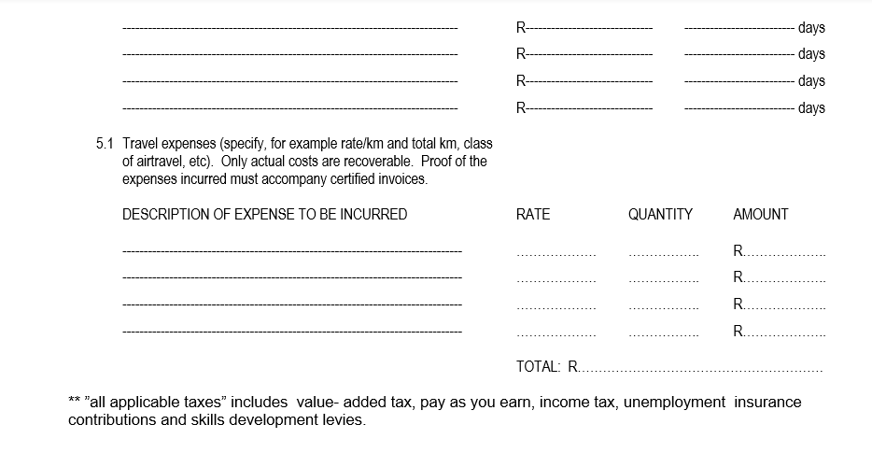
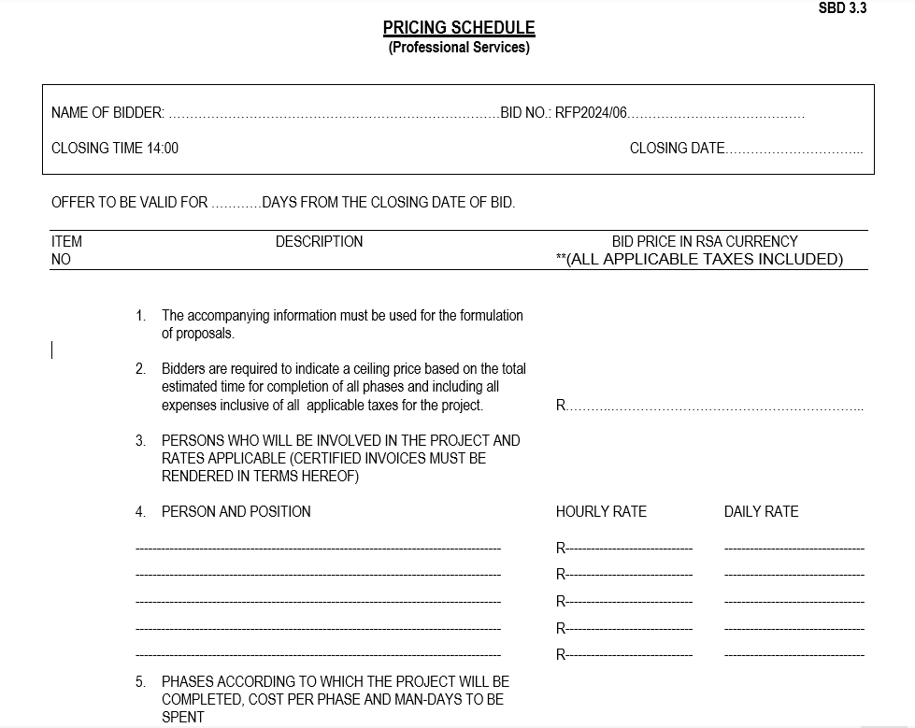

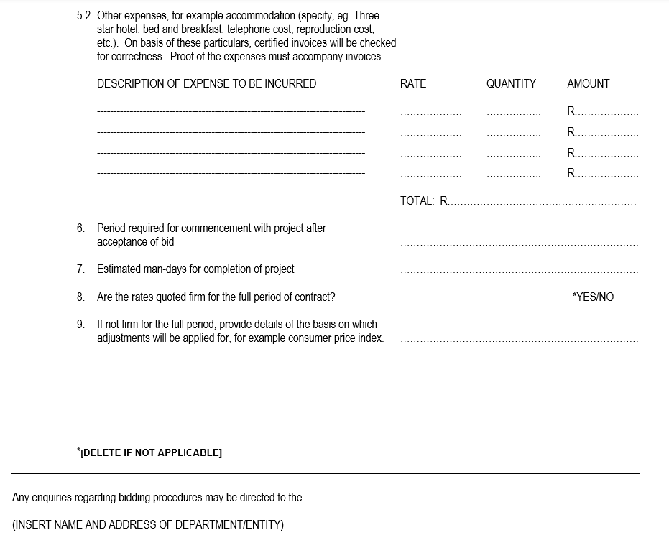

RETURNABLE SCHEDULE 3: DECLARATION OF INTEREST (SBD 4)
- Any legal person, including persons employed by the state¹, or persons having a kinship with persons employed by the state, including a blood relationship, may make an offer or offers in terms of this invitation to bid (includes a price quotation, advertised competitive bid, limited bid or proposal). In view of possible allegations of favouritism, should the resulting bid, or part thereof, be awarded to persons employed by the state, or to persons connected with or related to them, it is required that the bidder or his/her authorised representative declare his/her position in relation to the evaluating/adjudicating authority where-

- the bidder is employed by the state; and/or

- the legal person on whose behalf the bidding document is signed, has a relationship with persons/a person who are/is involved in the evaluation and or adjudication of the bid(s), or where it is known that such a relationship exists between the person or persons for or on whose behalf the declarant acts and persons who are involved with the evaluation and or adjudication of the bid.

- In order to give effect to the above, the following questionnaire must be completed and submitted with the bid.

  - Full Name of bidder or his or her representative: ………………………………………………………….

  - Identity Number: …………………………………………………………………………………………………

  - Position occupied in the Company (director, trustee, shareholder²): ……………………………………..

  - Company Registration Number: ………………………………………………………………………..…….

  - Tax Reference Number: ………………………………………………………………………………….………

  - VAT Registration Number: ………………………………………………………………………………....
    - The names of all directors / trustees / shareholders / members, their individual identity numbers, tax reference numbers and, if applicable, employee / persal numbers must be indicated in paragraph 3 below.
¹“State” means –
(a) any national or provincial department, national or provincial public entity or constitutional institution within the meaning of the Public Finance Management Act, 1999 (Act No. 1 of 1999);
(b) any municipality or municipal entity;
I provincial legislature;
(d) national Assembly or the national Council of provinces; or
I Parliament.

²”Shareholder” means a person who owns shares in the company and is actively involved in the management of the enterprise or business and exercises control over the enterprise.

2.7 Are you or any person connected with the bidder YES / NO
presently employed by the state?

    - If so, furnish the following particulars:

Name of person / director / trustee / shareholder/ member: ……....………………………………
Name of state institution at which you or the person
connected to the bidder is employed : ………………………………………
Position occupied in the state institution: ………………………………………

Any other particulars:
………………………………………………………………

………………………………………………………………
………………………………………………………………

    - If you are presently employed by the state, did you obtain YES / NO
the appropriate authority to undertake remunerative
work outside employment in the public sector?

      - If yes, did you attached proof of such authority to the bid YES / NO
document?

(Note: Failure to submit proof of such authority, where
applicable, may result in the disqualification of the bid.

      - If no, furnish reasons for non-submission of such proof:

…………………………………………………………………….
…………………………………………………………………….
…………………………………………………………………….

  - Did you or your spouse, or any of the company’s directors / YES / NO
trustees / shareholders / members or their spouses conduct
business with the state in the previous twelve months?

    - If so, furnish particulars:
…………………………………………………………………..
…………………………………………………………………..
…………………………………………………………………...

  - Do you, or any person connected with the bidder, have YES / NO
any relationship (family, friend, other) with a person
employed by the state and who may be involved with
the evaluation and or adjudication of this bid?

If so, furnish particulars.
……………………………………………………………...
…………………………………………………………..….
………………………………………………………………

2.10 Are you, or any person connected with the bidder, YES/NO
aware of any relationship (family, friend, other) between
any other bidder and any person employed by the state
who may be involved with the evaluation and or adjudication
of this bid?

2.10.1 If so, furnish particulars.
………………………………………………………………
………………………………………………………………
………………………………………………………………

2.11 Do you or any of the directors / trustees / shareholders / members YES/NO
of the company have any interest in any other related companies
whether or not they are bidding for this contract?

2.11.1 If so, furnish particulars:
…………………………………………………………………………….
…………………………………………………………………………….
…………………………………………………………………………….

- Full details of directors / trustees / members / shareholders.

Full Name | Identity Number | Personal Tax Reference Number | State Employee Number / Persal Number

- DECLARATION

I, THE UNDERSIGNED (NAME)………………………………………………………………………

CERTIFY THAT THE INFORMATION FURNISHED IN PARAGRAPHS 2 and 3 ABOVE IS CORRECT.
- I ACCEPT THAT THE STATE MAY REJECT THE BID OR ACT AGAINST ME IN TERMS OF PARAGRAPH 23 OF THE GENERAL CONDITIONS OF CONTRACT SHOULD THIS DECLARATION PROVE TO BE FALSE.

………………………………….. ..……………………………………………
Signature Date

…………………………………. ………………………………………………
Position Name of bidder

RETURNABLE SCHEDULE 4: PREFERENCE POINTS CLAIM FORM IN TERMS OF THE PREFERENTIAL PROCUREMENT REGULATIONS 2022 (SBD 6.1)

SBD 6.1
PREFERENCE POINTS CLAIM FORM IN TERMS OF THE PREFERENTIAL PROCUREMENT REGULATIONS 2022
This preference form must form part of all tenders invited. It contains general information and serves as a claim form for preference points for specific goals.
NB: BEFORE COMPLETING THIS FORM, TENDERERS MUST STUDY THE GENERAL CONDITIONS, DEFINITIONS AND DIRECTIVES APPLICABLE IN RESPECT OF THE TENDER AND PREFERENTIAL PROCUREMENT REGULATIONS, 2022

- GENERAL CONDITIONS
  - The following preference point systems are applicable to invitations to tender:
- the 80/20 system for requirements with a Rand value of up to R50 000 000 (all applicable taxes included); and
- the 90/10 system for requirements with a Rand value above R50 000 000 (all applicable taxes included).
  - To be completed by the organ of state
(delete whichever is not applicable for this tender).
- The applicable preference point system for this tender is the 80/20 preference point system.

  - Points for this tender (even in the case of a tender for income-generating contracts) shall be awarded for:
- Price; and
- Specific Goals.
  - To be completed by the organ of state:
The maximum points for this tender are allocated as follows:
 | POINTS
PRICE | 80
SPECIFIC GOALS | 20
Total points for Price and SPECIFIC GOALS | 100

  - Failure on the part of a tenderer to submit proof or documentation required in terms of this tender to claim points for specific goals with the tender, will be interpreted to mean that preference points for specific goals are not claimed.
  - The organ of state reserves the right to require of a tenderer, either before a tender is adjudicated or at any time subsequently, to substantiate any claim in regard to preferences, in any manner required by the organ of state.

- DEFINITIONS
- “tender” means a written offer in the form determined by an organ of state in response to an invitation to provide goods or services through price quotations, competitive tendering process or any other method envisaged in legislation;
- “price” means an amount of money tendered for goods or services, and includes all applicable taxes less all unconditional discounts;
- “rand value” means the total estimated value of a contract in Rand, calculated at the time of bid invitation, and includes all applicable taxes;
- “tender for income-generating contracts” means a written offer in the form determined by an organ of state in response to an invitation for the origination of income-generating contracts through any method envisaged in legislation that will result in a legal agreement between the organ of state and a third party that produces revenue for the organ of state, and includes, but is not limited to, leasing and disposal of assets and concession contracts, excluding direct sales and disposal of assets through public auctions; and
- “the Act” means the Preferential Procurement Policy Framework Act, 2000 (Act No. 5 of 2000).

- FORMULAE FOR PROCUREMENT OF GOODS AND SERVICES

  - POINTS AWARDED FOR PRICE

3.1.1 THE 80/20 OR 90/10 PREFERENCE POINT SYSTEMS
A maximum of 80 or 90 points is allocated for price on the following basis:

80/20 or 90/10

$Ps=80\left(1-\frac{Pt-P\min{}}{P\min{}}\right)$ or $Ps=90\left(1-\frac{Pt-P\min{}}{P\min{}}\right)$
Where
Ps = Points scored for price of tender under consideration
Pt = Price of tender under consideration
Pmin = Price of lowest acceptable tender

  - FORMULAE FOR DISPOSAL OR LEASING OF STATE ASSETS AND INCOME GENERATING PROCUREMENT

    - POINTS AWARDED FOR PRICE

A maximum of 80 or 90 points is allocated for price on the following basis:

80/20 or 90/10

$Ps=80\left(1+\frac{Pt-P\max{}}{P\max{}}\right)$ or $Ps=90\left(1+\frac{Pt-P\max{}}{Pmax}\right)$

Where
Ps = Points scored for price of tender under consideration
Pt = Price of tender under consideration
Pmax = Price of highest acceptable tender

- POINTS AWARDED FOR SPECIFIC GOALS
  - In terms of Regulation 4(2); 5(2); 6(2) and 7(2) of the Preferential Procurement Regulations, preference points must be awarded for specific goals stated in the tender. For the purposes of this tender the tenderer will be allocated points based on the goals stated in table 1 below as may be supported by proof/ documentation stated in the conditions of this tender:
  - In cases where organs of state intend to use Regulation 3(2) of the Regulations, which states that, if it is unclear whether the 80/20 or 90/10 preference point system applies, an organ of state must, in the tender documents, stipulate in the case of—
- an invitation for tender for income-generating contracts, that either the 80/20 or 90/10 preference point system will apply and that the highest acceptable tender will be used to determine the applicable preference point system; or

- any other invitation for tender, that either the 80/20 or 90/10 preference point system will apply and that the lowest acceptable tender will be used to determine the applicable preference point system,
then the organ of state must indicate the points allocated for specific goals for both the 90/10 and 80/20 preference point system.
Table 1: Specific goals for the tender and points claimed are indicated per the table below.
(Note to organs of state: Where either the 90/10 or 80/20 preference point system is applicable, corresponding points must also be indicated as such.
Note to tenderers: The tenderer must indicate how they claim points for each preference point system.)
The specific goals allocated points in terms of this tender | Number of points  allocated  (90/10 system)  (To be completed by the organ of state) | Number of points  allocated  (80/20 system)  (To be completed by the organ of state) | Number of points claimed  (90/10 system)  (To be completed by the tenderer) | Number of points claimed (80/20 system)  (To be completed by the tenderer)
Enterprise 51% or more Black woman owned | N/A | 10 | N/A
Enterprise owned by people with Disability or Youth | N/A | 5 | N/A
Enterprise 51% Black Owned | N/A | 5 | N/A
Maximum Points |  | 20

DECLARATION WITH REGARD TO COMPANY/FIRM

  - Name of company/firm…………………………………………………………………….
  - Company registration number: …………………………………………………………...
  - TYPE OF COMPANY/ FIRM
Partnership/Joint Venture / Consortium
One-person business/sole propriety
Close corporation
Public Company
Personal Liability Company
(Pty) Limited
Non-Profit Company
State Owned Company
[Tick applicable box]

  - I, the undersigned, who is duly authorised to do so on behalf of the company/firm, certify that the points claimed, based on the specific goals as advised in the tender, qualifies the company/ firm for the preference(s) shown and I acknowledge that:
- The information furnished is true and correct;
- The preference points claimed are in accordance with the General Conditions as indicated in paragraph 1 of this form;
- In the event of a contract being awarded as a result of points claimed as shown in paragraphs 1.4 and 4.2, the contractor may be required to furnish documentary proof to the satisfaction of the organ of state that the claims are correct;
- If the specific goals have been claimed or obtained on a fraudulent basis or any of the conditions of contract have not been fulfilled, the organ of state may, in addition to any other remedy it may have –

  - disqualify the person from the tendering process;
  - recover costs, losses or damages it has incurred or suffered as a result of that person’s conduct;
  - cancel the contract and claim any damages which it has suffered as a result of having to make less favourable arrangements due to such cancellation;
  - recommend that the tenderer or contractor, its shareholders and directors, or only the shareholders and directors who acted on a fraudulent basis, be restricted from obtaining business from any organ of state for a period not exceeding 10 years, after the audi alteram partem (hear the other side) rule has been applied; and
  - forward the matter for criminal prosecution, if deemed necessary

……………………………………….
SIGNATURE(S) OF TENDERER(S)

SURNAME AND NAME: ……………………………………………………….
DATE: ………………………………………………………
ADDRESS: ………………………………………………………
………………………………………………………

SBD 6-BBEE) Status Level of Contribution

RETURNABLE SCHEDULE 5: CONTRACT FORM (SBD 7.2)
SBD 7.2

CONTRACT FORM - RENDERING OF SERVICES
THIS FORM MUST BE FILLED IN DUPLICATE BY BOTH THE SERVICE PROVIDER (PART 1) AND THE PURCHASER (PART 2). BOTH FORMS MUST BE SIGNED IN THE ORIGINAL SO THAT THE SERVICE PROVIDER AND THE PURCHASER WOULD BE IN POSSESSION OF ORIGINALLY SIGNED CONTRACTS FOR THEIR RESPECTIVE RECORDS.

PART 1 (TO BE FILLED IN BY THE SERVICE PROVIDER)
- I hereby undertake to render services described in the attached bidding documents to (name of the institution)……………………………………. in accordance with the requirements and task directives / proposals specifications stipulated in Bid Number………….……….. at the price/s quoted. My offer/s remain binding upon me and open for acceptance by the Purchaser during the validity period indicated and calculated from the closing date of the bid .

- The following documents shall be deemed to form and be read and construed as part of this agreement:
- Bidding documents, viz
- Invitation to bid;
- Proof of tax compliance status;
- Pricing schedule(s);
- Filled in task directive/proposal;
- Preference claim form for Preferential Procurement in terms of the Preferential Procurement Regulations;
- Bidder’s Disclosure form;
- Special Conditions of Contract;
- General Conditions of Contract; and
- Other (specify)
- I confirm that I have satisfied myself as to the correctness and validity of my bid; that the price(s) and rate(s) quoted cover all the services specified in the bidding documents; that the price(s) and rate(s) cover all my obligations and I accept that any mistakes regarding price(s) and rate(s) and calculations will be at my own risk.

- I accept full responsibility for the proper execution and fulfilment of all obligations and conditions devolving on me under this agreement as the principal liable for the due fulfilment of this contract.

- I declare that I have no participation in any collusive practices with any bidder or any other person regarding this or any other bid.
- I confirm that I am duly authorised to sign this contract.

NAME (PRINT) …………………………….
WITNESSES
- …….………………………..

- ……….……………………

DATE: ……………………………..
CAPACITY …………………………….
SIGNATURE …………………………….
NAME OF FIRM …………………………….

DATE …………………………….

SBD 7.1
CONTRACT FORM - RENDERING OF SERVICES

PART 2 (TO BE FILLED IN BY THE PURCHASER)

- I………………………… in my capacity as…………………….……………..
accept your bid under reference number ………………dated………………………for the rendering of services indicated hereunder and/or further specified in the annexure(s).
- An official order indicating service delivery instructions is forthcoming.
- I undertake to make payment for the services rendered in accordance with the terms and conditions of the contract, within 30 (thirty) days after receipt of an invoice.
DESCRIPTION OF  SERVICE | PRICE (ALL APPLICABLE TAXES INCLUDED) | COMPLETION DATE | TOTAL PREFERENCE POINTS CLAIMED | POINTS CLAIMED FOR EACH SPECIFIC GOAL

4. I confirm that I am duly authorised to sign this contract.

SIGNED AT ………………………………………ON………………………………..

NAME (PRINT) ………………………………………….

SIGNATURE …………………………………………

OFFICIAL STAMP
WITNESSES

- ….…………………………….

- …..…………………………….

DATE: ……………………………..

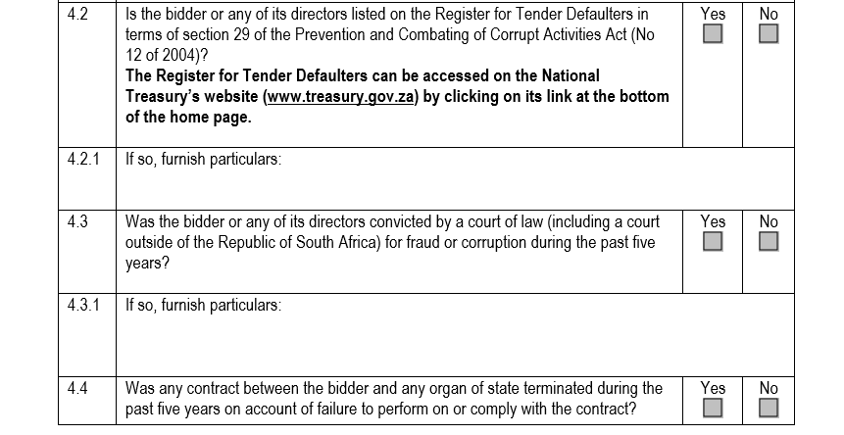
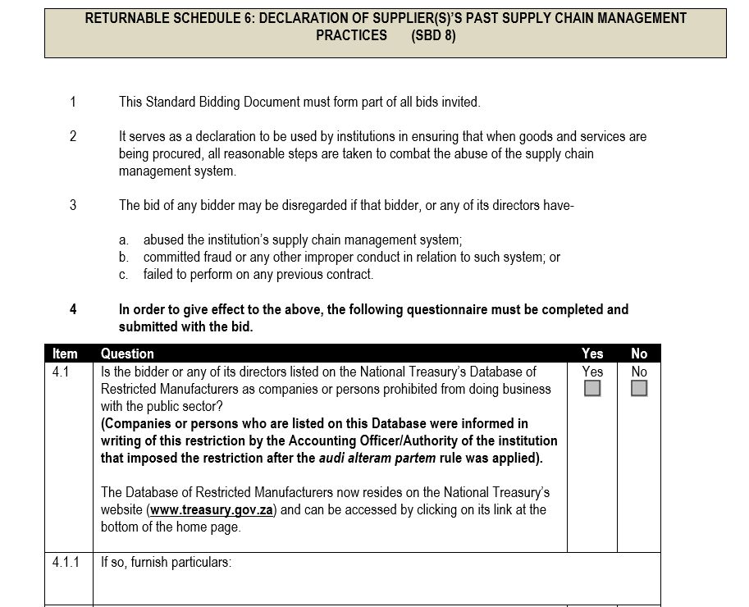




RETURNABLE SCHEDULE 7: CERTIFICATE OF INDEPENDENT BID DETERMINATION (SBD 9)

- This Standard Bidding Document (SBD) must form part of all bids¹ invited.

2 Section 4 (1) (b) (iii) of the Competition Act No. 89 of 1998, as amended, prohibits an agreement between, or concerted practice by, firms, or a decision by an association of firms, if it is between parties in a horizontal relationship and if it involves collusive bidding (or bid rigging).² Collusive bidding is a pe se prohibition meaning that it cannot be justified under any grounds.
3 Treasury Regulation 16A9 prescribes that accounting officers and accounting authorities
must take all reasonable steps to prevent abuse of the supply chain management
system and authorizes accounting officers and accounting authorities to:

a. disregard the bid of any bidder if that bidder, or any of its directors have abused the institution’s supply chain management system and or committed fraud or any other improper conduct in relation to such system.

b. cancel a contract awarded to a Supplier(s) of goods and services if the Supplier(s) committed any corrupt or fraudulent act during the bidding process or the execution of that contract.

4 This SBD serves as a certificate of declaration that would be used by institutions to ensure that, when bids are considered, reasonable steps are taken to prevent any form of bid-rigging.

5 In order to give effect to the above, the attached Certificate of Bid Determination (SBD 9) must be completed and submitted with the bid:

¹ Includes price quotations, advertised competitive bids, limited bids and proposals.

² Bid rigging (or collusive bidding) occurs when businesses, that would otherwise be expected to compete, secretly conspire to raise prices or lower the quality of goods and / or services for purchasers who wish to acquire goods and / or services through a bidding process. Bid rigging is, therefore, an agreement between competitors not to compete.

SBD 9

SBD 9 :- CERTIFICATE OF INDEPENDENT BID DETERMINATION

I, the undersigned, in submitting the accompanying bid:
________________________________________________________________________
(Bid Number and Description)

in response to the invitation for the bid made by:
______________________________________________________________________________
(Name of Institution)

do hereby make the following statements that I certify to be true and complete in every respect:

I certify, on behalf of:_______________________________________________________that:
(Name of Bidder)

1. I have read and I understand the contents of this Certificate;
2. I understand that the accompanying bid will be disqualified if this Certificate is found not to be true and complete in every respect;
3. I am authorized by the bidder to sign this Certificate, and to submit the accompanying bid, on behalf of the bidder;
4. Each person whose signature appears on the accompanying bid has been authorized by the bidder to determine the terms of, and to sign the bid, on behalf of the bidder;
5. For the purposes of this Certificate and the accompanying bid, I understand that the word “competitor” shall include any individual or organization, other than the bidder, whether or not affiliated with the bidder, who:

(a) has been requested to submit a bid in response to this bid invitation;
(b) could potentially submit a bid in response to this bid invitation, based on their qualifications, abilities or experience; and
(c) provides the same goods and services as the bidder and/or is in the same line of business as the bidder

6. The bidder has arrived at the accompanying bid independently from, and without consultation, communication, agreement or arrangement with any competitor. However communication between partners in a joint venture or consortium³ will not be construed as collusive bidding.
7. In particular, without limiting the generality of paragraphs 6 above, there has been no consultation, communication, agreement or arrangement with any competitor regarding:
(a) prices;
(b) geographical area where product or service will be rendered (market allocation)
(c) methods, factors or formulas used to calculate prices;
(d) the intention or decision to submit or not to submit, a bid;
(e) the submission of a bid which does not meet the specifications and conditions of the bid; or
(f) bidding with the intention not to win the bid.
8. In addition, there have been no consultations, communications, agreements or arrangements with any competitor regarding the quality, quantity, specifications and conditions or delivery particulars of the products or services to which this bid invitation relates.
- The terms of the accompanying bid have not been, and will not be, disclosed by the bidder, directly or indirectly, to any competitor, prior to the date and time of the official bid opening or of the awarding of the contract.

³ Joint venture or Consortium means an association of persons for the purpose of combining their expertise, property, capital, efforts, skill
and knowledge in an activity for the execution of a contract.

10. I am aware that, in addition and without prejudice to any other remedy provided to combat any restrictive practices related to bids and contracts, bids that are suspicious will be reported to the Competition Commission for investigation and possible imposition of administrative penalties in terms of section 59 of the Competition Act No 89 of 1998 and or may be reported to the National Prosecuting Authority (NPA) for criminal investigation and or may be restricted from conducting business with the public sector for a period not exceeding ten (10) years in terms of the Prevention and Combating of Corrupt Activities Act No 12 of 2004 or any other applicable legislation.

………………………………………………… …………………………………
Signature Date

…………………………………………………. …………………………………
Position Name of Bidder

