Weather proof shed with air vents for medical waste storage.
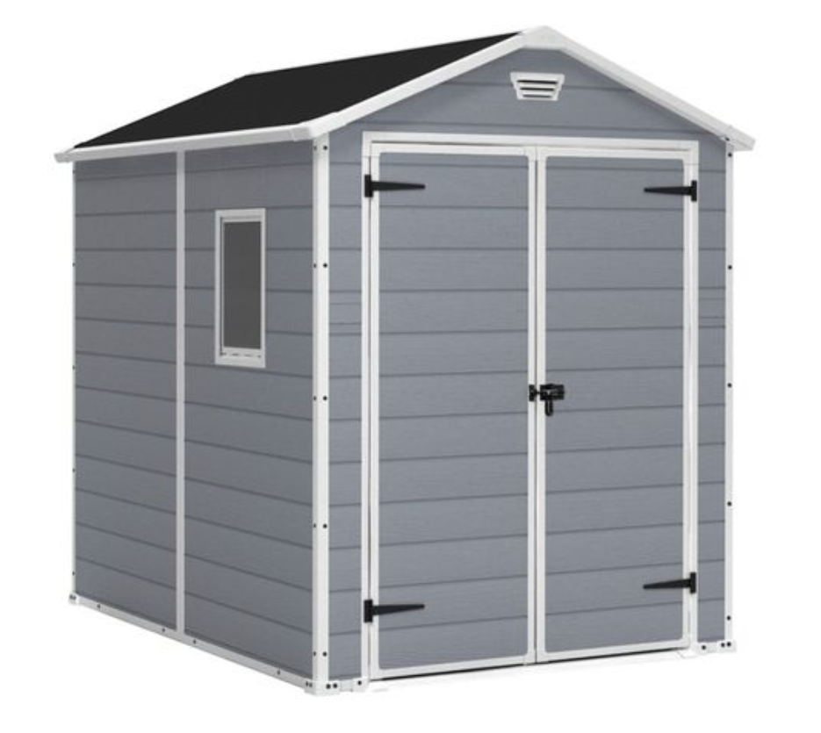
product
6 x 8 Shed (2367mm length x 1823mm width x 2438mm height)
door type
Double door
skylight
No
no of windows
1
air vents
Yes
Assembly required
Yes
material
Plastic
Features
• Wood-look resin walls are durably constructed to withstand all weather conditions, and preventing rust and rot.
• Double doors feature easy access within, plus they are lockable for added security (lock not included).
• Bottom floor panels
• Fixed window lets in natural light easily and provides plenty of airflow.
• 8-Foot high ceiling provides ample room to move around inside the shed.
• Storage unit is easy to assemble with common household tools.
Dimensions
length
2367
width
1823
height
2438
SKU weight
71.5
shipping weight
71.5

