Multichannel:
BIOPETTE PLUS AUTOCLAVABLE 20-200UL 8-CHANNEL PIPETTE FROM LABNET
20-200 UL 8-Channel pipette
Fully autoclavable
360º for comfortable pipetting in any direction
Precision designed tip cones provide leak-proof tip fit
Continuously adjustable volume selection with thumbwheel or push-button
Curved ejector bar reduces ejection force
Large Capacity Multichannel Pipete

Comfortable Multi-directional Pipetting
The BioPette™ Plus Multichannel pipettes offer reduced pipetting forces. The manifold rotates 360º for comfortable pipetting in any direction. An individual piston suspension system allows even sealing of tips across all channels without rocking the pipette. The curved ejector design pushes the tips off in steps, thus requiring minimal force to operate. Each channel has an independent, precision piston assembly to ensure accuracy and reproducibility from one pipetting series to the next as well as between channels. Four volume ranges are available as both 8 and 12 channel models. Each large capacity multichannel pipette is individually tested and supplied with a certificate of quality and a calibration key. The BioPette™ Plus multichannel pipettes are fully autoclavable.
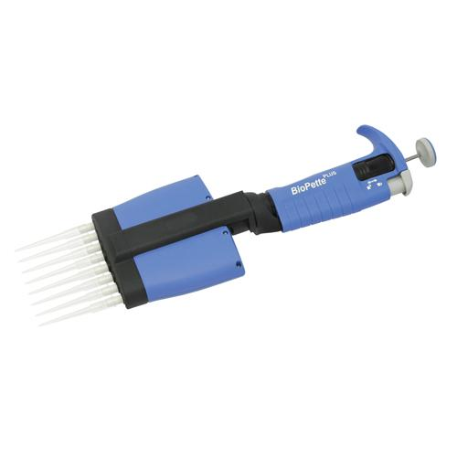

Plate washer specifications:
96 Well plates ELx 405
Dimensions: 17”D X 114” W X 10” H (43.2 cm x 35.6 cm x 25.4 cm), 13.5 kg
Electrical: Voltage range (100-240 ~ V at 50-60Hz, ≤8.0 A), Accessory outlet: (≤5.0 A, used for vacuum pump)
Other: Waste bottle volume 10L, Supply volume 3.7 L, User interface: (2 x line 24 character LCD display, 25 alphanumeric keys)

