

BID NO: SCMU10CHR-25/26-0001
TO : DEPUTY DIRECTOR – TECHNICAL MR S. FIKENI
FROM : OFFICE OF THE DISTRICT ROADS ENGINEER
DATE : 05 APRIL 2022
SUBJECT : REQUEST FOR ACCOMMODATION FOR MR F. PONCO IN EAST LONDON

FOR

SUPPLY, DELIVERY AND PLACING OF PARKHOME STRUCTURES IN CALA, BIRCH (KOMANI), WHITTLESEA, TARKASTAD AND CRADOCK WITHIN THE CHRIS HANI DISTRICT.

BID DOCUMENT

ISSUED BY:
DEPARTMENT OF TRANSPORT
Supply Chain Management Unit
Department of Transport
Private Bag X7185
KOMANI
5320

NAME OF BIDDER:

For ease of reference, Bidders shall enter their Price in the space provided below:

Bid Sum (amount in words) ……………………………………………........................

……………………………………………………………………………………………..

………………………………………………………………..…………inclusive of VAT

Bid Sum (amount in figures) R………………………………….inclusive of VAT

NAME OF BIDDER: …………………………………………………………………….

SIGNED ON BEHALF OF THE BIDDER: …………………………………………….

CONTENTS

1. BID NOTICE
2. BID CONDITIONS
3. GENERAL CONDITIONS OF CONTRACT
4. PROJECT SPECIFICATION / TERMS OF REFERENCE
5. FORMS TO BE COMPLETED BY THE BIDDER

SECTION 1: BID NOTICE
BID NOTICE NO.: SCMU10CHR-25/26-0001
Bids are hereby invited for the SUPPLY, DELIVERY AND PLACING OF PARKHOME STRUCTURES IN CALA, BIRCH (KOMANI), WHITTLESEA, TARKASTAD AND CRADOCK WITHIN THE CHRIS HANI DISTRICT.
Bid documents will be available as from 07 NOVEMBER 2025 from the Departmental website (www.ectransport.gov.za) and E-portal on the following website: www.e-tenders.gov.za.
The completed Bid documents must be placed in a sealed envelope, clearly marked: SCMU10CHR-25/26-0001 SUPPLY,DELIVERY AND PLACING OF PARKHOME STRUCTURES IN CALA, BIRCH (KOMANI), WHITTLESEA, TARKASTAD AND CRADOCK WITHIN THE CHRIS HANI DISTRICT and be deposited in the Bid Box situated at Department of Transport at 1st Floor No. 92 Cathcart Road ,Sanlam Building ,Komani not later than 11h00, 19 DECEMBER 2025 where tenders will be opened in public.
There will be a compulsory briefing on Thursday 27th of November 2025 at 11h00 at the Department of Transport, Traffic station No.1 Creamery Road, Kings Park, Komani.
NB: Failure to attend the briefing will result in the bidder being non-responsive.
Bidders must take particular note of the following:
• Bids will be evaluated based on the 80/20 preference point system in terms of the Preferential Procurement Policy Framework Act (Act 5 of 2000) and 2012 Regulations thereto and points for Specific Goals
• Bidders must submit a Centralized Suppliers Database (CSD) Registration Report with the Bid as proof of being registered on the Database, and failure to do so will render the bid non-responsive, and will be disqualified
Bidders must also submit a Tax Compliance Status PIN code in order to verify their tax status with SARS No late, posted, telephonic, or faxed bids/proposals will be considered.
The lowest/any bid will not necessarily be accepted. Enquiries should be directed to:
TECHNICAL ENQUIRIES ADMIN ENQUIRIES
Mr. Solomzi Lunika or Ms. Nontembeko Kolo
Telephone Number: 071 490 8558 Telephone Number: 082 0831348
Email: Solomzi.Lunika@ectransport.gov.za Email: Nontembeko.Kolo@ectransport.gov.za

Furthermore
• Bidders are required to be registered with Central Supplier Database (CSD) prior to submitting this bid (see https://secure.csd.gov.za/).
• The tenderer is in good standing with SARS as verified on the Central Supplier Database.
• The tenderer or any its directors or shareholders is not listed on the register of tender defaulters in terms of the prevention and compacting of corrupt activities Act of 2004 as a person prohibited from doing business within the public sector.
• The tenderer has not abused the employers Supply Chain Management System or failed to perform on any previous contract and has been given written notice to this effect.

SECTION 2: BID CONDITIONS
1. GENERAL CONDITIONS OF CONTRACT
The General Conditions of Contract given in Section 3 and the Department’s Policy on Supply Chain Management shall apply to this contract.
2. BID FORM
All bids shall be made on the bid forms incorporated in this document.
3. EVIDENCE OF EXPERIENCE OF BIDDERS
Bidders shall give satisfactory evidence of actual experience in the class of work being bid for, incorporating the following details:
Recommendation / reference letter with letter head from previous work completed
Employer for whom the work was performed, and Nature of work.
Value of work; and Year completed.
Contact details and stamped with signatures
Failure to complete this statement may prejudice the bid as being submitted by an inexperienced Bidder and it may be rejected for such reasons.
4. COMPLETION OF BIDS
The Bidder shall complete all forms in black ink.
Mistakes made by the Bidder in the completion of the forms shall not be erased. A line shall be drawn through the incorrect entry and the correct entry shall be written above and the correction initialled by the Bidder. Failure to observe this rule may lead to the bid being disqualified.
Bids shall be ineligible for consideration unless submitted on the forms bound in this document.
A bid shall not be considered if alterations have been made to the bid from, unless such alterations have been duly authenticated by the Bidder, or of any particulars required therein have not been completed in all respects.
No unauthorized amendment shall be made to the bid form or to any other part of the bid document. If any such amendments are made, the bid may be rejected.
Bids submitted in accordance with this bid document shall not have any qualifications. Any point of difficulty of interpretation shall be cleared with the Eastern Cape Department of Transport as early as possible during the bid period. Should any query be found to be of significance, The Eastern Cape Department of Transport will inform all Bidders accordingly as early as possible.
5. SUBMISSION OF BIDS
Each Bidder is required to return the complete set of bid documents with all the required information and complete in all respects.
Bidders shall not tamper with the bid documents which shall be submitted as issued. Any bid documents found to have been unbound and rebound could be deemed to be unacceptable.
Bids, in sealed envelope clearly marked
“Bid No: SCMU10CHR-25/26-0001 SUPPLY, DELIVERY AND PLACING OF PARKHOME STRUCTURES IN CALA, BIRCH (KOMANI), WHITTLESEA, TARKASTAD AND CRADOCK WITHIN THE CHRIS HANI DISTRICT.
and the Bidder’s name and address, shall be deposited in the Bid Box situated at Department of Transport, 1st Floor No. 92 Cathcart Road, Sanlam Building, Komani not later than 11H00 on 19 December 2025 Bids may not be faxed or e-mailed. Bids shall be opened in public shortly thereafter. Late bids shall be rejected.
6. DATA TO BE FURNISHED AT BID STAGE
Bidders shall submit with their bids the information that is applicable and as may be required in terms of the specifications. The Employer reserves the right, in the event of such details being insufficient, to call for further information. The Bidder shall furnish such additional information within seven (7) days of being called upon to do so.
7. WITHDRAWAL OF BIDS
A Bidder may, without incurring any liability, withdraw his bid. This will be a written advice and received before the date and time of closure of this bid. The notice must be received by the Eastern Cape Department of Transport, before the closure of this bid.
8. COSTS WHICH DEFAULTING BIDDERS MAY BE CALLED UPON TO PAY
Should the Service Provider, after he has been notified of the acceptance of his bid, fail to enter into a contract when called upon to do so, within the period stipulated in the conditions of bid or within such extended period as the Employer may allow, the Service Provider holds himself liable for any additional expense which may incur in having to call for bids afresh and/or in having to accept any less favourable bid and that if he purports to withdraw his bid within the period for which he has agreed that it shall remain open for acceptance.
The Service Provider shall indemnify the specified from any claim capable of being made against him either under the statute of common law in respect of any damage to any person or property arising out of the execution of this contract.

09. ACCEPTANCE OR REJECTION OF BIDS
Bids may be rejected if they show any additional items not originally included in the bid document. Conditional or incomplete offers, irregularities of any kind in the bid forms, or if the bid rates and amounts are obviously unbalanced and the Bidder, after having been called upon to adjust same in a reasonable manner, fails to do so within a period of seven (7) days having received notification to that effect.
The Employer does not bind itself to accept the lowest or any bid and reserves the right to accept the whole or any part of a bid as it may deem expedient, nor will it assign any reason for the acceptance or rejection of any bid, be it the whole or part of a bid.
10. SITE INSPECTION/BIDDERS MEETING
See co-ordinates below for delivery areas.
Birch Camp (Komani) : 31°57'19.93"S 26°58'13.08"E
Whittlesea Camp (Whittlesea) : 32°10'19.83"S 26°48'08.59"E
Tarkastad (Tarkastad) : 32°00'38.60"S 26°15'30.60"E
Cradock (Cradock) : 32°09'51.07"S 25°36'17.87"E
Cala Camp (Cala) : 31°31'32.20"S 27°41'58.00"E
12. FAILURE TO RETURN BID DOCUMENTS
A Bidder who does not submit a bid does not have to return the bid documents after the closing date for the receipt of bids.

13. TAXES AND LEVIES
Bidders shall include Value Added Tax (VAT) in their bid rates.
14. EVALUATION OF BIDS
Bids will be evaluated based on Functionality and Price based on the 80/20 preference point system in terms of the Preferential Procurement Policy Framework Act (Act 5 of 2000) and 2022 Regulations thereto.
PRICE
80 points will be awarded to the bidder submitting the lowest price (all other bidders will receive points proportionately thereto):
CALCULATION OF POINTS FOR SPECIFIC GOALS
The tenderer will be allocated points based on the goals stated in table 1 below as may be supported by proof/ documentation stated in the conditions of this tender.
PREFERENTIAL SPECIFIC GOALS POINTS TABLE
The specific goals allocated points in terms of this tender | Number of points allocated (80/20 system) (To be completed by the organ of state) | Number of points claimed (80/20 system)  (To be completed by the tenderer)
Historically Disadvantaged Individuals Ownership
Black ownership | 4
Women ownership | 6
Youth ownership | 6
Disabled people ownership | 4

The points for specific goals will be distributed as per the table below.
To Score points for Black Ownership the following formula will be used to calculate the points out of 4 points Max.
SGP= Specific goals points
MHDI= Maximum points for Historical disadvantaged individuals
BOE = Black Ownership Equity
PREFERENTIAL SPECIFIC GOALS POINTS TABLE
The specific goals allocated points in terms of this tender | Number of points allocated (80/20 system) (To be completed by the organ of state) | Number of points claimed (80/20 system)  (To be completed by the tenderer)
Historically Disadvantaged Individuals Ownership
Black ownership | 4
Women ownership | 6
Youth ownership | 6
Disabled people ownership | 4

Historically Disadvantaged Individual (HDI): Black Ownership
Means a South African Citizen: who, due to the apartheid policy that had been in place, had no franchise in national elections.
Central Supplier Database (CSD) report will be used.
It is the onus of the bidder to provide proof of ownership equity status
Locality:
Locality shall mean' Fully functional office within the Province of the Eastern Cape. Satellite shall mean an office with minimum staff of not more than 3 personnel running the office on fulltime.
Locality Points will be allocated for proof of local office operations in Eastern Cape. The primary address on CSD and proof of ownership under the bidding company will be used for choice of Locality.
15. BID VALIDITY PERIOD
Bids must remain valid for a period of NINETY (90) days from the closing date of the bid.
16. ACCEPTANCE OF BID
The Department does not bind itself to accept the lowest or any bid received and reserves the right to accept the whole or part of the bid.
17. PENALTIES
If the Contractor fails to produce registers as specified in Chapter 4 “Project Specification”, the Employer may deduct 5% of the invoice amount.

SECTION 3: GENERAL CONDITIONS OF CONTRACT
GENERAL CONDITIONS OF CONTRACT
• The latest General Conditions of Contract [GCC] and Contract Law shall be applicable to this Quotation and obtainable by visiting the National Treasury website at www.treasury.gov.za
• Bidders must familiarize themselves with these GCCs

SECTION 4: TERMS OF REFERENCE
SUPPLY, DELIVERY AND PLACING OF PARKHOME STRUCTURES IN CALA, BIRCH (KOMANI), WHITTLESEA, TARKASTAD AND CRADOCK WITHIN THE CHRIS HANI DISTRICT.
1. Purpose
SUPPLY, DELIVERY AND PLACING PARKHOME STRUCTURES IN CALA, BIRCH (KOMANI), WHITTLESEA, TARKASTAD AND CRADOCK WITHIN THE CHRIS HANI DISTRICT. The purpose of the project is to ensure that the condition of the existing structures is upgraded, and thus improving the conditions of DoT personnel live in.
2. Proposed upgrade measures
- Supply and Delivery of Parkhome Structures for Dormitory, Storage, Kitchen and Ablution usage.
TO BE DONE BY THE DEPARTMENT OF TRANSPORT
- Clearing and grubbing (ground preparation for platforms).
- Connecting to the existing water line (500m) including all related items.
- Construction of septic tank (6000L) including related items.
- Sewer connection to septic tank including related items.
- Electrical Connection

3. Standard specification
Model Preambles for Trades 2008 shall be adhered to at all times.
The JBCC Preliminaries Code 2103, May 2005 edition for use with the JBCC Principal Building Agreement Edition 4.1, Code 2101, March 2005 is taken to be incorporated under Pricing Schedule

SPECIFICATION

ITEM NO | DISCRIPTION | QTN
Birch Camp (Queenstown)
1 | 12m x 3m Insulated four rooms, and doors park home unit with fitted electrical plugs and built in cupboard. | 02
2 | 6m x 3m Insulated Ablution Park home unit with bathroom, 2 x toilets and 2 x showers with a sink. Showers to have connections for hot and cold water. | 02
3 | 4,2m x 2,4 Insulated ablution (kitchen) park home Unit with single sink basin and connections for hot and cold water, electrical plugs, plumbing inlets and outlets. | 01
Whittlesea
4 | 12m x 3m Insulated four rooms, and doors park home unit with fitted electrical plugs and built in cupboard. | 01
5 | 6m x 3m Insulated Ablution Park home unit with bathroom, 2 x toilets and 2 x showers with a sink. Showers to have connections for hot and cold water. | 01
Cradock
6 | 6m x 3m Insulated Ablution Park home unit (Toilets only) with 6x toilets and 2 x sink basins with hot and cold water connections. | 02
Traffic Station (Cala)
7 | 6m x 6m Insulated Park home Unit with electrical plugs, lighting and connections. | 01
8 | 12m x 3m Insulated four rooms, and doors park home unit with fitted electrical plugs and built in cupboard. | 01
9 | 4,15m x 2,4m Storage unit with shelves on two sides of the unit. | 01

NB: INTERNAL FITTINGS AND PLUMBING MUST COME AS COMPLETE.
4. Breach and termination
4.1 Bidders are referred to General Conditions of Contract (GCC) relating to failure to comply with conditions of this contract and delayed execution.
5. Loss and Damage
5.1 Contractor hereby indemnifies the State/Employer/Institution and will hold the State harmless/Employer/institution, against any loss or damages which the State may suffer, or any claims lodged against the State by any third party arising out of or relating to any loss that the State or such third party may suffer as a result of, or arising out of any act or omission of any personnel of contractor or the failure of contractor to provide the Services in accordance with the provisions of the contract.

6. Transfer Management
6.1 Upon termination of the contract for whatever reason contractor shall assist the Employer to transfer the Services to the Employer, or to another service provider designated by the Employer. Without detracting from the generality of this obligation, contractor shall, to the extent required by the Employer, provide the Employer or the third-party service provider with all information and documentation required to enable the Employer or such service provider to provide the Services, it being recorded that this obligation shall not oblige contractor to deliver any documentation which is proprietary or confidential to contractor.
7. Sub-Contractors
7.1 The contractor may only sub-contract its obligations under the contract with the prior written consent of the Employer (or any other authorized authority) and then only to a person and to the extent approved by the Employer or such authority and upon such terms and conditions as the Employer or such authority require. It is recorded that where such consent is given the contractor shall remain liable to Employer for the performance of the Services.
8. Strikes
8.1 The Contractor undertakes that strikes by his personnel will not influence the rendering of the implementation service.
9. Insurance and Indemnity
9.1 The Contractor agrees and hereby undertakes to indemnify, defend and save harmless, the Employer, its officers, employees and agents from and against any and all liability, damages, claims, thefts, losses, suits and actions (including but not limited to, any and all costs and expenses related thereto) brought or alleged against the Employer, its officers, employees and agents on account of allegations of or actual false arrest, violation of applicable security regulations, searches, liable, slander, theft or injury to or death of any person or damage to or destruction of any property of any party, directly or indirectly, arising out of or in any way
related to or resulting from the negligent act or omission pursuant to this Agreement, excepting, however, such liability damages, claims, penalties, thefts, fines, losses, suits and action that are caused by a negligent act or omission of the Employer, its officers, employees and agents. The Contractor’s liability under this indemnity shall be limited to the Public and Product Liability insurance coverage.
9.2 The Employer agrees that it will give to the Contractor prompt and timely notice of any claim made or suit instituted which in any way, directly or indirectly, continently or otherwise, affects or might affect the Contractor and the Contractor shall have the right to participate in the defence of the same to the extent of its own interest.
10. Professional Indemnity, all Risks, Insurances, Warranties, guarantees, Licensing& on-site support
10.1 All warranties and license entitlements must be registered by the Vendor and provided to the Department in paper form and electronically.
11. Minimum Requirements
11.1 The company must have performed a minimum of one (1) projects of the similar nature (Supply of Park homes) to the value of R1 million and above, in South Africa in the last 72 months.
NB: Failure to meet any of the above minimum requirements may render the bidder non- responsive and will not be considered.

12. Monitoring and Reporting
12.1 Establishment of the Project Team to comprise of, End User, Service Provider and any other stake holder relevant to the project
12.2 A Project Team will be established to amongst other, monitor performance and certify invoices prior to payment.
13. Duration of The Project
13.1 All equipment must be delivered within stipulated estimated time of arrival of 6 -8 weeks upon receipt of an official works order and all deliverables determined in the scope of work are satisfied.
14 Validity of BID
• The validity of the offer is ninety (90) days.
15 General conditions of Contract
• The latest general conditions of contract law will apply.
• Where special conditions of the contract are in conflict with these general conditions, the special conditions shall apply.

16 Special Conditions of Contract
a. Conditions of Contract
• The service provider awarded the contract is expected to charge fees at the rates not higher than those issued by the Department of Labour
• The ceiling price of the bid to be completed on the Pricing Schedule form must reflect all costs including VAT and disbursements.
• No late, faxed, electronically transmitted, photocopied, incomplete, copies or unsigned bids will be accepted. Only original bids fully completed and filled in black ink will be accepted.
• It is critical for service providers to fully present the credentials of key personnel to be assigned to projects.
• The Department shall not enter into a contract where a company has directors, partners or employees who are employed by the state where permission has not been granted by the Executive Authority.
• All documents submitted and/or produced shall become the property of the DOT.
• The service provider undertakes to provide the professional resources required to attain the project objectives.
• Service Providers who have entered into a consortium / Joint Venture must attach signed agreements by all partners and each party thereto must comply with all the bidding requirements.
• Bidders are requested to submit one envelope marked on the outside indicating the name of the bidding company (Bidder) and the bid number;
• The overall price must be in Rand and must be inclusive of VAT where applicable;
• The selected service provider will have to sign a Service Level Agreement and SBD 7.2 contract form with the Department of Transport immediately upon acceptance of the bid.
• The service provider undertakes to act as an independent contractor in respect of all work to be done.
• The service provider shall exercise all reasonable skill, care and diligence in the execution of the work and shall carry out all its obligations.
• The service provider shall, in all professional matters, act as a faithful adviser to the DOT and, in so far as any of its duties being discretionary, act fairly between DOT and third parties;
• The service provider shall execute and complete the work strictly in accordance with this contract to the satisfaction of the DOT;
• The service provider shall be deemed to have satisfied itself as to the correctness and sufficiency of the rates and prices set out in the contract for the work to be rendered;
• The service provider shall not have the power or authority to enter into any contract or otherwise to bind or incur any liability on behalf of the DOT;
• The service provider must be registered in the Centralised Supplier Database
(CSD);The CSD registration report must have been printed at least ten (10) days prior the closing date of the bid.
• It’s the responsibility of every bidder to provide the Department with a SARS “PIN” to verify the tax compliance status at any time prior to the award of the bid.
• DOT will not be liable to reimburse any costs incurred by any service provider during the proposal /bidding process;
• The service provider shall attend meetings with officials whenever required to do so by the representative for the purpose of obtaining information or advice in regard to the work and assignments or any matters arising thereof;
• Replacement of candidates for this assignment will not be allowed except in extreme cases and the new candidates must possess the same educational and training qualifications or higher than that of the predecessor which will be agreed upon in writing between the service provider and the Department.
• All the submitted documents must be completed in full and signed where necessary.
• In cases where two or more bidders attain equal number of points in all aspects of evaluation, the bidder who has the highest points for specific goals will be the preferred bidder.
• If functionality is part of the evaluation process and two or more bidders attain equal number of points and preference points for specific goals, the bidder who has the highest points for functionality will be the preferred bidder.
• In cases where there is a tie in all aspects of evaluation then the award must be decided by the drawing of lots.
• Failure to submit the documentation as prescribed may lead to the bid being considered non- responsive and subsequently rejected / not considered.

17 EVALUATION CRITERIA
• Bids will be evaluated on a 80/20 point system within the ambit of the Preferential Procurement Policy Framework Act(PPPFA) No.5 of 2000 and section 38(1)(a)(iii) of the Public Finance.
Management Act 1 of 1999 as amended by Act NO.29 of 1999 and Preference Procurement Regulations 2022;
• The evaluation will be carried out in three phases, namely, Compliance, “functionality” and “price”. Bidders are requested to submit one envelope.
• Functionality will be evaluated separately to determine the responsiveness of the bids. The minimum qualifying percentage that will be accepted for functionality is 70%. A bidder who does not obtain a minimum of 70% will be disqualified;
• The final score will be obtained by adding points obtained for price to the preference points; NB: Points score will be rounded to the nearest two (2) decimals.

BIDDERS SHALL TAKE NOTE OF THE FOLLOWING BID CONDITIONS AND STAGES OF EVALUATION:

Stage 1 - Compliance
Stage 2 - Functionality
Stage 3 - The 80/20 or 90/10 preference point systems

STAGE 1 - COMPLIANCE

NB. Please note, bidders who do not comply with the following requirements will not be moving to the second stage.
MINIMUM REQUIREMENTS | PROOF REQUIRED
1. Proof of experience in  Supply and Delivery of Park homes. | Written contactable references from previous  contracts/employers. The bidder must attach Reference/testimonial Letters and must be in the client’s letter heads, incorporating the following details: Customer; Nature of work/ Description; Rand value of contract; Year completed; Customer contact, Customer contact number  All references will be checked by the Department. (Tenderers must have completed at least 1 relevant project)

STAGE 2 - FUNCTIONALITY
Ps = So * Ap
Ms
Where
Ps = Points scored for functionality by bid/proposal under consideration So = Score of the bid under consideration
Ms = Maximum possible scored.
Ap = Percentage allocated for functionality.
- Bidders score on functionality will not be included in the final points scored but determined to establish functionality abilities.
- The percentages allocated by all panel members must be added together and divided by the number of panel members to establish the average percentage obtained by each individual bidder for functionality;
- The minimum qualifying percentage that will be accepted for functionality is 70%;
- Bids/proposal that do not score the specified minimum percentage for functionality will be disqualified.
STAGE 3 - PRICE
The 80/20 preference points system:
• Ps=80(1-Pt-Pmin)
Where
• Ps = Points scored for price by bid under consideration
• Pmin = Lowest acceptable consideration
• Pt = Price of bid under consideration
NB: - The department is user no obligation to award the bid to the bidder scoring the highest or lowest points.
The department reserves its own discretion to reject any bid on the basis of the bidder’s inadequate performance of previous contracts.
The following information for functionality and weights will be considered in the evaluation of all
applications received.
1: Poor, 2: Acceptable, 3: Good, 4: Very Good, 5: Excellent

18 AWARDING OF POINTS FOR FUNCTIONALITY AND PRICE
Functionality
- Bid offers will only be considered responsive if a minimum Functionality requirement of 70% is achieved.
Functionality (Max =60points)

Bidders are required to demonstrate their ability to undertake the work and provide proof of previous experience and expertise to undertake a project of this nature. Bidders are therefore required to meet a minimum Functionality Score of 70% (42 points out of 60 points) based on the criteria listed below. A score of less than 42 out of 60 points for Functionality will render the BID non responsive. The onus rests with the Bidder to supply sufficient information to allow for evaluation and award of points detailed below.
If insufficient information is provided, zero points will be awarded for that particular item.
Note that functionality points are only used to determine responsiveness and will not be used further in the evaluation.

Locality : 40 points _{max}

 | Points Allocated
- If the office is within the Province of the Eastern Cape. (As per the preferred address on the CSD registration report within the last 3 years ) | 40 points
- Offices outside the Eastern Cape (As per the preferred address in the CSD registration report within the last 3 years) | 30 points

Contractors Past Experience: 20 points _{max}

The Bidder should have a proven track record in the supply, delivery, and placement of Parkhome Structures or related. Points of at least 1(one) relevant completed project. Points will be awarded as follows:

Projects of the value/combined value of R 2 000 000.00 and above 20 points
Projects of value between R 100 000.00 to R 2 000 000.00 10 points

The bidder is expected to score at least 42 points out of the total functionality points of 60 to be able to move to the next stage.
Tenderer must provide a signed copy of award letter and Practical/Completion certificates to claim Functionality points.
19 PREFERENTIAL CLAIMS
Points scored for specified goals as contemplated by the PPPFA and its regulations are then calculated separately and added to the points scored for price to obtain the final score.
20 SPECIFIED GOALS
Calculation of points for Preferential Points – specific goals will be allocated in the following manner
• The tenderer will be allocated points based on the goals stated in table 1 below as may be supported by proof/ documentation stated in the conditions of this tender

PREFERENTIAL SPECIFIC GOALS POINTS TABLE
The specific goals allocated points in terms of this tender | Number of points allocated (80/20 system) (To be completed by the organ of state) | Number of points claimed (80/20 system)  (To be completed by the tenderer)
Historically Disadvantaged Individuals Ownership
Black ownership | 4
Women ownership | 6
Youth ownership | 6
Disabled people ownership | 4

In the event that two or more bids are equal in all respects, the successful bidder will be the one with the highest functionality percentage and the last option will be the drawing of lots.
Submitted documents must be composed of the following:
Tender check list
• SBD 1 - Invitation to Bid
• SBD 3.1 - Pricing Schedule
• SBD 4 - Declaration of interest
• SBD 6.1 - Preference Points Claim Form
• SBD 7.2 - Contract Form for Services
• Tax Compliance Status PIN / CSD registration report
• Letters of reference from previous clients (Must be in logo of that particular institution) with office telephone details.
21 BID ENQUIRIES
Please refer all enquiries to the following personnel:
TECHNICAL ENQUIRIES SCM ENQUIRIES
Mr. Solomzi Lunika or Ms. Nontembeko Kolo
Telephone Number: 071 490 8558 Telephone Number: 082 0831348
Email:Solomzi.Lunika@ectransport.gov.za Email: Ntontembeko.Kolo@ectransport.gov.za

SECTION 5: FORMS TO BE COMPLETED BY THE BIDDER

BID FORM
CLOSING TIME AND DATE: 11H00 - 19 DECEMBER 2025
BID NO: SCMU10CHR-25/26-0001
This bid shall remain binding for a period of 90 days calculated from the closing date of the bid
I/We the *undersigned hereby offer to the Eastern Cape Department of Transport herein represented by the Accounting Officer (hereinafter referred to as the “Chief Executive”, to provide Parkhomes and accessories at Chris Hani District – Department of Transport in execution of the abovementioned Contract in accordance with the Specifications, Conditions of Contract and subject to the Bid Conditions, to the entire satisfaction of the Accounting Officer for the Bid Price (including VAT) of:
BID PRICE: R………………..
15% VAT R………………………..
TOTAL R………………………..
Full Trading Name:……………………………………………………………………………………………….
Address (Business):……………………………………………………………………………………………….
…………………………………………………………………………………………………………………………. Telephone No (Business):……………………………………………………………………………………..
Telex-/Fax No:………………………………………………………………………………………………….
Bankers (specify branch and telephone No):………………………………………………………….
Registration number at EC Treasury:…………………………………………………
I/We acknowledge that I/we am/are fully acquainted with the contents of the Bid Conditions and that I/we accept the conditions in all respects.
I/We agree that the laws of the Republic of South Africa shall be applicable to the contract resulting from the acceptance of my/our bid and that I/we elect domicilum citandi et executandi in the Republic at:
…………………………………………………………………………………………………………………………
…………………………………………………………………………………………………………………………
Has the declaration of interest (ECBD4) been duly completed? and included with the other bid forms? YES/NO
Any bid received which does not include unit prices, itemized prices or any relevant information as requested in the specification may be rejected.
………………………………………………………… ………………………………………………………
WITNESS PLACE

SIGNATURE OF BIDDER

SIGNATURE OF BIDDER
…………………………………………………………

………….………………………………………..…..
NAME OF BIDDER

………………………………………………
CAPACITY

………………………………………………
DATE

SBD1
PART A

INVITATION TO BID

YOU ARE HEREBY INVITED TO BID FOR REQUIREMENTS OF THE DEPARTMENT OF TRANSPORT
BID NUMBER: | SCMU10CHR-25/26-0001 |  |  | CLOSING DATE:….19/12/2025 |  |  |  | CLOSING TIME: |  |  | 11H00
DESCRIPTION | SUPPLY, DELIVERY AND PLACING OF PARKHOME STRUCTURES IN CALA, BIRCH (KOMANI), WHITTLESEA, TARKASTAD AND CRADOCK WITHIN THE CHRIS HANI DISTRICT.
BID RESPONSE DOCUMENTS MAY BE DEPOSITED IN THE BID BOX SITUATED AT (STREET ADDRESS)
DEPARTMENT OF TRANSPORT
Supply Chain Management Unit
No 92 Cathcart Road
Sanlam Building
KOMANI
5320
BIDDING PROCEDURE ENQUIRIES MAY BE DIRECTED TO |  |  |  |  | TECHNICAL ENQUIRIES MAY BE DIRECTED TO:
CONTACT PERSON |  |  | Ms. Nontembeko Kolo |  | CONTACT PERSON |  |  |  | Mr. Solomzi Lunika
TELEPHONE NUMBER |  |  | 082 0831348 |  | TELEPHONE NUMBER |  |  |  | 071 490 8558
FACSIMILE NUMBER |  |  | N/A |  | FACSIMILE NUMBER |  |  |  | N/A
E-MAIL ADDRESS |  |  | Nontembeko.Kolo@ectransport.gov.za |  | E-MAIL ADDRESS |  |  |  | Solomzi.Lunika@ectransport.gov.za
SUPPLIER INFORMATION
NAME OF BIDDER
POSTAL ADDRESS
STREET ADDRESS
TELEPHONE NUMBER |  | CODE |  |  |  | NUMBER
CELLPHONE NUMBER
FACSIMILE NUMBER |  | CODE |  |  |  | NUMBER
E-MAIL ADDRESS
VAT REGISTRATION NUMBER
SUPPLIER COMPLIANCE STATUS |  | TAX COMPLIANCE SYSTEM PIN: |  |  | OR |  | CENTRAL SUPPLIER DATABASE No: |  |  | MAAA
ARE YOU THE ACCREDITED REPRESENTATIVE IN SOUTH AFRICA FOR THE GOODS /SERVICES OFFERED? |  | Yes No  [IF YES ENCLOSE PROOF] |  |  | ARE YOU A FOREIGN BASED SUPPLIER FOR THE GOODS /SERVICES OFFERED? |  |  | Yes No  [IF YES, ANSWER THE QUESTIONNAIRE BELOW]
QUESTIONNAIRE TO BIDDING FOREIGN SUPPLIERS
IS THE ENTITY A RESIDENT OF THE REPUBLIC OF SOUTH AFRICA (RSA)? YES NO
DOES THE ENTITY HAVE A BRANCH IN THE RSA? YES NO

DOES THE ENTITY HAVE A PERMANENT ESTABLISHMENT IN THE RSA? YES NO

DOES THE ENTITY HAVE ANY SOURCE OF INCOME IN THE RSA? YES NO

IS THE ENTITY LIABLE IN THE RSA FOR ANY FORM OF TAXATION? YES NO

IF THE ANSWER IS “NO” TO ALL OF THE ABOVE, THEN IT IS NOT A REQUIREMENT TO REGISTER FOR A TAX COMPLIANCE STATUS SYSTEM PIN CODE FROM THE SOUTH AFRICAN REVENUE SERVICE (SARS) AND IF NOT REGISTER AS PER 2.3 BELOW.

PART B
TERMS AND CONDITIONS FOR BIDDING
- BID SUBMISSION:
  - BIDS MUST BE DELIVERED BY THE STIPULATED TIME TO THE CORRECT ADDRESS. LATE BIDS WILL NOT BE ACCEPTED FOR CONSIDERATION.
  - ALL BIDS MUST BE SUBMITTED ON THE OFFICIAL FORMS PROVIDED (NOT TO BE RE-TYPED) OR IN THE MANNER PRESCRIBED IN THE BID DOCUMENT.
  - THIS BID IS SUBJECT TO THE PREFERENTIAL PROCUREMENT POLICY FRAMEWORK ACT, 2000 AND THE PREFERENTIAL PROCUREMENT REGULATIONS, THE GENERAL CONDITIONS OF CONTRACT (GCC) AND, IF APPLICABLE, ANY OTHER SPECIAL CONDITIONS OF CONTRACT.
  - THE SUCCESSFUL BIDDER WILL BE REQUIRED TO FILL IN AND SIGN A WRITTEN CONTRACT FORM (SBD7).

- TAX COMPLIANCE REQUIREMENTS
- BIDDERS MUST ENSURE COMPLIANCE WITH THEIR TAX OBLIGATIONS.
- BIDDERS ARE REQUIRED TO SUBMIT THEIR UNIQUE PERSONAL IDENTIFICATION NUMBER (PIN) ISSUED BY SARS TO ENABLE THE ORGAN OF STATE TO VERIFY THE TAXPAYER’S PROFILE AND TAX STATUS.
- APPLICATION FOR TAX COMPLIANCE STATUS (TCS) PIN MAY BE MADE VIA E-FILING THROUGH THE SARS WEBSITE WWW.SARS.GOV.ZA
- BIDDERS MAY ALSO SUBMIT A PRINTED TCS CERTIFICATE TOGETHER WITH THE BID.
- IN BIDS WHERE CONSORTIA / JOINT VENTURES / SUB-CONTRACTORS ARE INVOLVED; EACH PARTY MUST SUBMIT A SEPARATE TCS CERTIFICATE / PIN / CSD NUMBER.
- WHERE NO TCS PIN IS AVAILABLE BUT THE BIDDER IS REGISTERED ON THE CENTRAL SUPPLIER DATABASE (CSD), A CSD NUMBER MUST BE PROVIDED.
- NO BIDS WILL BE CONSIDERED FROM PERSONS IN THE SERVICE OF THE STATE, COMPANIES WITH DIRECTORS WHO ARE PERSONS IN THE SERVICE OF THE STATE, OR CLOSE CORPORATIONS WITH MEMBERS PERSONS IN THE SERVICE OF THE STATE.”

NB: FAILURE TO PROVIDE / OR COMPLY WITH ANY OF THE ABOVE PARTICULARS MAY RENDER THE BID INVALID.

SIGNATURE OF THE BIDDER: …………………………………………………

CAPACITY UNDER WHICH THIS BID IS SIGNED:

…………………………………………………
(Proof of authority must be submitted e.g. company resolution)

DATE:

SBD 3.1

PRICING SCHEDULE – FIRM PRICES
(PURCHASES)

NOTE: ONLY FIRM PRICES WILL BE ACCEPTED. NON-FIRM PRICES (INCLUDING PRICES SUBJECT TO RATES OF EXCHANGE VARIATIONS) WILL NOT BE CONSIDERED

IN CASES WHERE DIFFERENT DELIVERY POINTS INFLUENCE THE PRICING, A SEPARATE PRICING SCHEDULE MUST BE SUBMITTED FOR EACH DELIVERY POINT

Name of bidder…………………………………… Bid number: SCMU10CHR-25/26-0001

Closing Time 11:00 Closing date…19/12/2025

OFFER TO BE VALID FOR………DAYS FROM THE CLOSING DATE OF BID.
__________________________________________________________________________
ITEM NO. | QUANTITY | DESCRIPTION | BID PRICE IN RSA CURRENCY  **(ALL APPLICABLE TAXES INCLUDED)

- Required by: ………………………………….

- At: ………………………………….

…………………………………

- Brand and model ………………………………….

- Country of origin ………………………………….

- Does the offer comply with the specification(s)? *YES/NO

- If not to specification, indicate deviation(s) ………………………………….

- Period required for delivery ………………………………….
*Delivery: Firm/not firm

- Delivery basis ……………………………………

Note: All delivery costs must be included in the bid price, for delivery at the prescribed destination.

** “all applicable taxes” includes value- added tax, pay as you earn, income tax, unemployment insurance fund contributions and skills development levies.
*Delete if not applicable
SBD 4
BIDDER’S DISCLOSURE

- PURPOSE OF THE FORM

Any person (natural or juristic) may make an offer or offers in terms of this invitation to bid. In line with the principles of transparency, accountability, impartiality, and ethics as enshrined in the Constitution of the Republic of South Africa and further expressed in various pieces of legislation, it is required for the bidder to make this declaration in respect of the details required hereunder.

Where a person/s are listed in the Register for Tender Defaulters and / or the List of Restricted Suppliers, that person will automatically be disqualified from the bid process.

- Bidder’s declaration
2.1 Is the bidder, or any of its directors / trustees / shareholders / members / partners or any person having a controlling interest in the enterprise, employed by the state? YES/NO
2.1.1 If so, furnish particulars of the names, individual identity numbers, and, if applicable, state employee numbers of sole proprietor/ directors / trustees / shareholders / members/ partners or any person having a controlling interest in the enterprise, in table below.
Full Name | Identity Number | Name of State institution

2.2 Do you, or any person connected with the bidder, have a relationship with any person who is employed by the procuring institution? YES/NO
2.2.1 If so, furnish particulars:
……………………………………………………………………………………
……………………………………………………………………………………

2.3 Does the bidder or any of its directors / trustees / shareholders / members / partners or any person having a controlling interest in the enterprise have any interest in any other related enterprise whether or not they are bidding for this contract? YES/NO

    - If so, furnish particulars:
………………………………………………………………………………….
…………………………………………………………………………….

- DECLARATION

I, the undersigned, (name)……………………………………………………………………. in submitting the accompanying bid, do hereby make the following statements that I certify to be true and complete in every respect:

3.1 I have read and I understand the contents of this disclosure;

3.2 I understand that the accompanying bid will be disqualified if this disclosure is found not to be true and complete in every respect;

  - The bidder has arrived at the accompanying bid independently from, and without consultation, communication, agreement or arrangement with any competitor. However, communication between partners in a joint venture or consortium will not be construed as collusive bidding.

  - In addition, there have been no consultations, communications, agreements or arrangements with any competitor regarding the quality, quantity, specifications, prices, including methods, factors or formulas used to calculate prices, market allocation, the intention or decision to submit or not to submit the bid, bidding with the intention not to win the bid and conditions or delivery particulars of the products or services to which this bid invitation relates.

3.5 The terms of the accompanying bid have not been, and will not be, disclosed by the bidder, directly or indirectly, to any competitor, prior to the date and time of the official bid opening or of the awarding of the contract.

3.6 There have been no consultations, communications, agreements or arrangements made by the bidder with any official of the procuring institution in relation to this procurement process prior to and during the bidding process except to provide clarification on the bid submitted where so required by the institution; and the bidder was not involved in the drafting of the specifications or terms of reference for this bid.

  - I am aware that, in addition and without prejudice to any other remedy provided to combat any restrictive practices related to bids and contracts, bids that are suspicious will be reported to the Competition Commission for investigation and possible imposition of administrative penalties in terms of section 59 of the Competition Act No 89 of 1998 and or may be reported to the National Prosecuting Authority (NPA) for criminal investigation and or may be restricted from conducting business with the public sector for a period not exceeding ten (10) years in terms of the Prevention and Combating of Corrupt Activities Act No 12 of 2004 or any other applicable legislation.

I CERTIFY THAT THE INFORMATION FURNISHED IN PARAGRAPHS 1, 2 and 3 ABOVE IS CORRECT.
I ACCEPT THAT THE STATE MAY REJECT THE BID OR ACT AGAINST ME IN TERMS OF PARAGRAPH 6 OF PFMA SCM INSTRUCTION 03 OF 2021/22 ON ENHANCING COMPLIANCE, TRANSPARENCY AND ACCOUNTABILITY IN SUPPLY CHAIN MANAGEMENT SHOULD THIS DECLARATION PROVE TO BE FALSE.

……………………………… ..……………………………………………
Signature Date

……………………………… ………………………………………………
Position Name of bidder

DECLARATION OF EMPLOYEES OF THE STATE OR OTHER STATE INSTITUTIONS

This form must be included additional to the SBD.4

1. In terms of section 30 of the Public Service Act;
No employee shall perform or engage himself or herself to perform remunerative work outside his or her employment in the relevant department, except with the written permission of the executive authority of the department.

2.
Yes/No
Are any of the shareholders/ directors of your company employed by the State?

- 3. “State” means –

  - Any national or provincial department, national or provincial public entity or constitutional institution within the meaning of the Public Finance Management Act, 1999 (Act No. 1 of 1999);
  - Any municipality or municipal entity;
  - Any provincial legislature;
  - national Assembly or the national Council of provinces; or
  - Parliament.
  - Any Parastatal (A company or agency owned or controlled wholly or partly by the government).

- Should you indicate “yes” above, please provide the following details:

No | NAME & SURNAME OF DIRECTOR | STATE INSTITUTION WHERE EMPLOYED | ID NUMBER | EMPLOYEE/ PERSAL NUMBER
1
2
3
4

5. Please note: The “state” is clearly defined in paragraph 3 above. In the event that “no” is selected and subsequently any false declaration are detected, the non-disclosure of such “state employment” will be deemed as “fraud”. Therefore the state may reject the bid and in addition may proceed with further action s
hould this declaration prove to be false.

6. DECLARATION
I, (NAME & SURNAME)……………………………………………ID NUMBER……………………………….
CERTIFY THAT THE INFORMATION FURNISHED IN PARAGRAPHS 2 AND 4 ABOVE IS CORRECT.
Signature Date
………………………………….…………………… ……………………………………….
Position Name of bidder

……………………………………………………… ……………………………………….

SBD 6.1

PREFERENCE POINTS CLAIM FORM IN TERMS OF THE PREFERENTIAL PROCUREMENT REGULATIONS 2022

This preference form must form part of all tenders invited. It contains general information and serves as a claim form for preference points for specific goals.

NB: BEFORE COMPLETING THIS FORM, TENDERERS MUST STUDY THE GENERAL CONDITIONS, DEFINITIONS AND DIRECTIVES APPLICABLE IN RESPECT OF THE TENDER AND PREFERENTIAL PROCUREMENT REGULATIONS, 2022

- GENERAL CONDITIONS
  - The following preference point systems are applicable to invitations to tender:
    - the 80/20 system for requirements with a Rand value of up to R50 000 000 (all applicable taxes included); and
    - the 90/10 system for requirements with a Rand value above R50 000 000 (all applicable taxes included).

  - To be completed by the organ of state
(delete whichever is not applicable for this tender).

- The applicable preference point system for this tender is the 80/20 preference point system.

- Either the 90/10 or 80/20 preference point system will be applicable in this tender. The lowest/ highest acceptable tender will be used to determine the accurate system once tenders are received.

  - Points for this tender (even in the case of a tender for income-generating contracts) shall be awarded for:
- Price; and
- Specific Goals.

  - To be completed by the organ of state:
The maximum points for this tender are allocated as follows:

 | POINTS
PRICE | 80
SPECIFIC GOALS | 20
Total points for Price and SPECIFIC GOALS | 100

  - Failure on the part of a tenderer to submit proof or documentation required in terms of this tender to claim points for specific goals with the tender, will be interpreted to mean that preference points for specific goals are not claimed.
  - The organ of state reserves the right to require of a tenderer, either before a tender is adjudicated or at any time subsequently, to substantiate any claim in regard to preferences, in any manner required by the organ of state.

- DEFINITIONS
“tender” means
a written offer in the form determined by an organ of state in response to an invitation to provide goods or services through price quotations, competitive tendering process or any other method envisaged in legislation;
- “price” means an amount of money tendered for goods or services, and includes all applicable taxes less all unconditional discounts;
- “rand value” means the total estimated value of a contract in Rand, calculated at the time of bid invitation, and includes all applicable taxes;
- “tender for income-generating contracts” means a written offer in the form determined by an organ of state in response to an invitation for the origination of income-generating contracts through any method envisaged in legislation that will result in a legal agreement between the organ of state and a third party that produces revenue for the organ of state, and includes, but is not limited to, leasing and disposal of assets and concession contracts, excluding direct sales and disposal of assets through public auctions; and
- “the Act” means the Preferential Procurement Policy Framework Act, 2000 (Act No. 5 of 2000).

- FORMULAE FOR PROCUREMENT OF GOODS AND SERVICES

  - POINTS AWARDED FOR PRICE

    - THE 80/20 OR 90/10 PREFERENCE POINT SYSTEMS
A maximum of 80 or 90 points is allocated for price on the following basis:

80/20 or 90/10

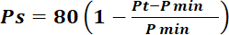 or 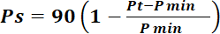
Where
Ps | = | Points scored for price of tender under consideration
Pt | = | Price of tender under consideration
Pmin | = | Price of lowest acceptable tender
  - FORMULAE FOR DISPOSAL OR LEASING OF STATE ASSETS AND INCOME GENERATING PROCUREMENT
3.2.1. POINTS AWARDED FOR PRICE

A maximum of 80 or 90 points is allocated for price on the following basis:

80/20 or 90/10
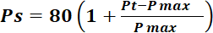 or 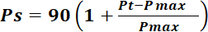

Where
 | Ps | = | Points scored for price of tender under consideration
 | Pt | = | Price of tender under consideration
 | Pmax | = | Price of highest acceptable tender

- POINTS AWARDED FOR SPECIFIC GOALS
  - In terms of Regulation 4(2); 5(2); 6(2) and 7(2) of the Preferential Procurement Regulations, preference points must be awarded for specific goals stated in the tender. For the purposes of this tender the tenderer will be allocated points based on the goals stated in table 1 below as may be supported by proof/ documentation stated in the conditions of this tender:
  - In cases where organs of state intend to use Regulation 3(2) of the Regulations, which states that, if it is unclear whether the 80/20 or 90/10 preference point system applies, an organ of state must, in the tender documents, stipulate in the case of—
    - an invitation for tender for income-generating contracts, that either the 80/20 or 90/10 preference point system will apply and that the highest acceptable tender will be used to determine the applicable preference point system; or

    - any other invitation for tender, that either the 80/20 or 90/10 preference point system will apply and that the lowest acceptable tender will be used to determine the applicable preference point system,
then the organ of state must indicate the points allocated for specific goals for both the 90/10 and 80/20 preference point system.

FORMULAE FOR CALCULATION OF POINTS

To Score points for Equity Ownership / Disability/ Locality the following formula will be used to calculate the points out of 5 points Max.

(e.g)
Where,
SGP= Specific goals points
OE = Ownership Equity
MOE= Maximum points for Equity Ownership

Table 1: Specific goals for the tender and points claimed are indicated per the table below.
(Note to organs of state: Where either the 90/10 or 80/20 preference point system is applicable, corresponding points must also be indicated as such.
Note to tenderers: The tenderer must indicate how they claim points for each preference point system.)

PREFERENTIAL SPECIFIC GOALS POINTS TABLE
The specific goals allocated points in terms of this tender | Number of points allocated (80/20 system) (To be completed by the organ of state) | Number of points claimed (80/20 system)  (To be completed by the tenderer)
Historically Disadvantaged Individuals Ownership
Black ownership | 4
Women ownership | 6
Youth ownership | 6
Disabled people ownership | 4

DECLARATION WITH REGARD TO COMPANY/FIRM

4.3. Name of company/firm…………………………………………………………………….
4.4. Company registration number:
…………………………………………………………...
  - TYPE OF COMPANY/ FIRM
    - Partnership/Joint Venture / Consortium
    - One-person business/sole propriety
    - Close corporation
    - Public Company
    - Personal Liability Company
    - (Pty) Limited
    - Non-Profit Company
    - State Owned Company

  - I, the undersigned, who is duly authorised to do so on behalf of the company/firm, certify that the points claimed, based on the specific goals as advised in the tender, qualifies the company/ firm for the preference(s) shown and I acknowledge that:
- The information furnished is true and correct;
- The preference points claimed are in accordance with the General Conditions as indicated in paragraph 1 of this form;
- In the event of a contract being awarded as a result of points claimed as shown in paragraphs 1.4 and 4.2, the contractor may be required to furnish documentary proof to the satisfaction of the organ of state that the claims are correct;
- If the specific goals have been claimed or obtained on a fraudulent basis or any of the conditions of contract have not been fulfilled, the organ of state may, in addition to any other remedy it may have –

  - disqualify the person from the tendering process;
  - recover costs, losses or damages it has incurred or suffered as a result of that person’s conduct;
  - cancel the contract and claim any damages which it has suffered as a result of having to make less favourable arrangements due to such cancellation;
  - recommend that the tenderer or contractor, its shareholders and directors, or only the shareholders and directors who acted on a fraudulent basis, be restricted from obtaining business from any organ of state for a period not exceeding 10 years, after the audi alteram partem (hear the other side) rule has been applied; and
  - forward the matter for criminal prosecution, if deemed necessary.

……………………………………….
SIGNATURE(S) OF TENDERER(S)

SURNAME AND NAME: ……………………………………………………….
DATE: ………………………………………………………
ADDRESS: ………………………………………………………
………………………………………………………
………………………………………………………
………………………………………………………

SBD 7.2

CONTRACT FORM - PURCHASE OF GOODS/WORKS

THIS FORM MUST BE FILLED IN DUPLICATE BY BOTH THE SUCCESSFUL BIDDER (PART 1) AND THE PURCHASER (PART 2). BOTH FORMS MUST BE SIGNED IN THE ORIGINAL SO THAT THE SUCCESSFUL BIDDER AND THE PURCHASER WOULD BE IN POSSESSION OF ORIGINALLY SIGNED CONTRACTS FOR THEIR RESPECTIVE RECORDS.

PART 1 (TO BE FILLED IN BY THE BIDDER)

- I hereby undertake to supply all or any of the goods and/or works described in the attached bidding documents to (name of institution)………..…………………………. in accordance with the requirements and specifications stipulated in bid number………..……….. at the price/s quoted. My offer/s remain binding upon me and open for acceptance by the purchaser during the validity period indicated and calculated from the closing time of bid.

- The following documents shall be deemed to form and be read and construed as part of this agreement:

- Bidding documents, viz
- Invitation to bid;
- Proof of tax compliance status;
- Pricing schedule(s);
- Technical Specification(s);
- Preference claim form for Preferential Procurement in terms of the Preferential Procurement Regulations;
- Bidder’s Disclosure form;
- Special Conditions of Contract;
- General Conditions of Contract; and
- Other (specify)

- I confirm that I have satisfied myself as to the correctness and validity of my bid; that the price(s) and rate(s) quoted cover all the goods and/or works specified in the bidding documents; that the price(s) and rate(s) cover all my obligations and I accept that any mistakes regarding price(s) and rate(s) and calculations will be at my own risk.

- I accept full responsibility for the proper execution and fulfilment of all obligations and conditions devolving on me under this agreement as the principal liable for the due fulfillment of this contract.

- I declare that I have no participation in any collusive practices with any bidder or any other person regarding this or any other bid.

- I confirm that I am duly authorised to sign this contract.
WITNESSES
1…….……………………

2……………………………

DATE: ……………………

NAME (PRINT) ………………………………………….
CAPACITY ………………………………………….
SIGNATURE ………………………………………….
NAME OF FIRM ………………………………………….
DATE …………………………………………..
SBD 7.2

CONTRACT FORM - PURCHASE OF GOODS/WORKS

PART 2 (TO BE FILLED IN BY THE PURCHASER)

- I……………………………………………. in my capacity as…………………………………………………...….. accept your bid under reference number ………………… …….dated………………………for the supply of goods/works indicated hereunder and/or further specified in the annexure(s).

- An official order indicating delivery instructions is forthcoming.

- I undertake to make payment for the goods/works delivered in accordance with the terms and conditions of the contract, within 30 (thirty) days after receipt of an invoice accompanied by the delivery note.

ITEM  NO. | PRICE (ALL APPLICABLE TAXES INCLUDED) | BRAND | DELIVERY PERIOD | TOTAL PREFERENCE POINTS CLAIMED | POINTS CLAIMED FOR EACH SPECIFIC GOAL

4. I confirm that I am duly authorised to sign this contract.

SIGNED AT ………………………………………ON………………………………..

NAME (PRINT) …………………………………….

SIGNATURE …………………………………….
WITNESSES
- ……………………….

- ……………………….

DATE ……………………….

OFFICIAL STAMP

BID PRICING FORM

For ease of reference, Bidders shall enter their Bid Price, copied from the Pricing Schedule, in the space provided below. Should there be any discrepancy, then the sum calculated from the Pricing Schedule, subject to any arithmetic correction, shall hold precedence.

Total Price (amount in words)…………………...…….……………………………………………………….………………

……………………………………………………………………………………………………………

……………………………………………………………………………………………, inclusive of VAT

Total Price (amount in figures) R…………………………………………………., inclusive of VAT

NAME OF BIDDER:

……………………………….….…….………………………………………………………………………

SIGNED ON BEHALF OF THE BIDDER:

…………………………………………………………………………………………….

BILL OF QUANTITIES
DRAWINGS
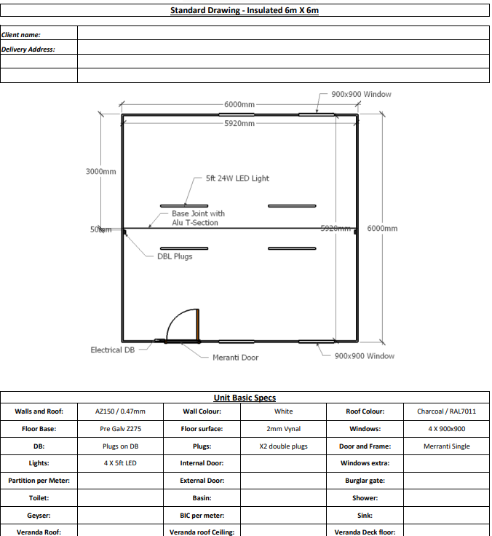
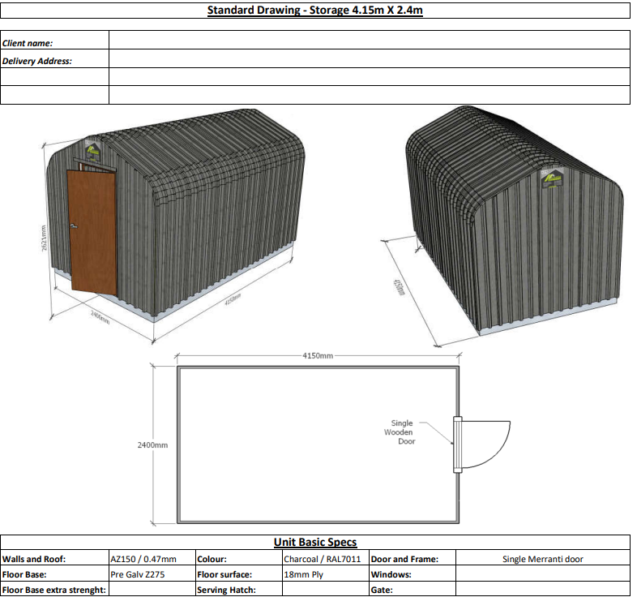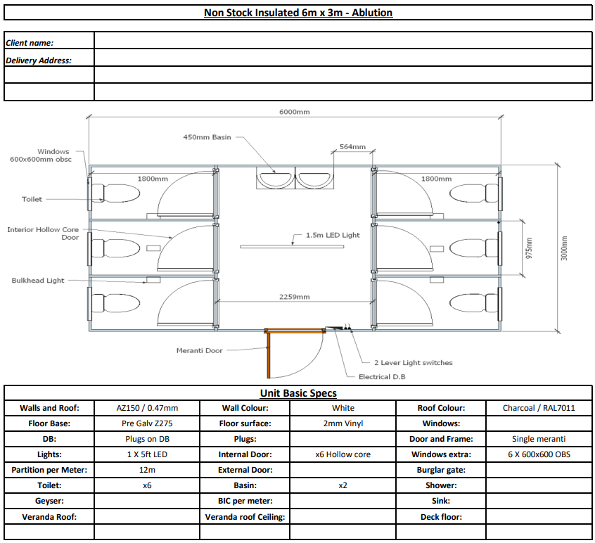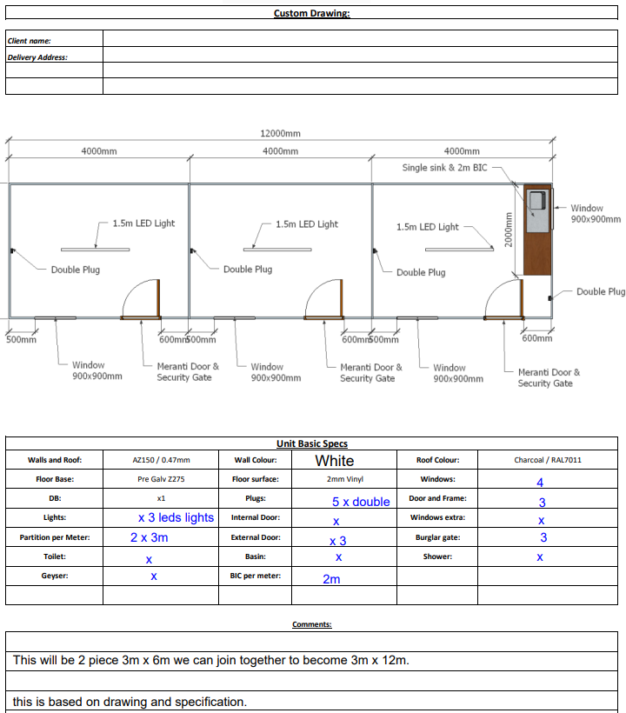

the power, by one person or a group of persons holding the majority of the equity of an enterprise, alternatively, the person/s having the deciding vote or power to influence or to direct the course and decisions of the enterprise.
Joint venture or Consortium means an association of persons for the purpose of combining their expertise, property, capital, efforts, skill and knowledge in an activity for the execution of a contract.

