Arrangement of Waterways

1. Delivery Tunnel
The Design of the 38 km long Delivery Tunnel was based on a "valveless" control system, i.e. upstream control by way of the Muela Intake up to drown out, thereafter tunnel control (“conductance”). The tunnel will remain full of water at all times. To achieve this without downstream closure capability the vertical alignment everywhere upstream of the Ash Outfall Crump Weir control is below the level of that control.

2. Basic Project Parameters
The following basic project parameters are relevant:

- Muela Tail pond:
- Operating levels (Phase I) 1773,5 masl
- Full supply (spillway level) 1775,0 masl
- PMF level 1777,5 masl

- Tunnel Output:
- Nominal yield (Phase IA) 18,0 m³/s
- Nominal yield (Phase I) 29,6 m³/s
- Nominal yield (Phase II) 42,0 m³/s
- Design flow (Phase I) 32,6 m³/s (theoretically fully aged tunnel)
- Maximum capacity 38,0 m³/s (calculated on basis of last set of ageing data)

- Little Caledon Bypass:
- Tunnel take-off level 1734,0 masl
- Outlet Level 1715,0 masl
- Nominal yield (Phase I) 20,0 m³/s

- Ash Outfall:
- Outfall Crump Weir level 1734,0 masl
- Maximum capacity 48,0 m³/s (confirmed during 1998 flow testing)

The layout of the Delivery Tunnel and a long section showing the design HGL are included in Appendix A.

3. Delivery Tunnel North Access
Access to the tunnel is gained as follows:

Table 1: Tunnel Access Points and Modes.
Access Point Description | Tunnel Chainage (m) | Interval  (m) | Tunnel Invert Level (masl) | Adit Length  (m) | Remarks
Caledon North Adit | 16 418 | 736 | 1 666,563 | 232 m to BH⁽²⁾ | Vehicular access
Little Caledon Tunnel Bypass | 25 105 | 8 687 | 1 715,610 | 1,5 m MH⁽²⁾  Bypass Shaft Off-take 154m US | On foot access
Little Caledon South Adit | 25 308 | 203 | 1 714,771 | 7 m to BH⁽²⁾ | Vehicular access
Little Caledon North Adit | 25 909 | 601 | 1 716,373 | 7 m to BH⁽²⁾ | Vehicular access
Ash Outfall | 37 013 | 11 104 | 1 731,250 | Portal | Vehicular access
Notes:
1. GS = Gate Shaft.
2. BH = Tunnel Bulkhead in Access Adit.
3. MH = Access Manhole in pipework in Valve Chamber.

4. Delivery Tunnel North Ventilation
The tunnel is ventilated as follows:

Table 2: Tunnel Ventilation Points.
Ventilation Point Description | Tunnel Chainage (m) | Interval  (m) | Tunnel Invert Level (masl) | Opening Size  (m) | Remarks
VS No. 5 | 15 081 | 5 732 | 1 728,272 | 0,23 m | 124 m Deep HDPE pipe
Caledon South Adit | 15 682 | 601 | 1 668,315 | 3,4 m | Vehicular access
Caledon North Adit | 16 418 | 736 | 1 666,563 | 3,4 m | Vehicular access
VS No. 6A | 17 042 | 624 | 1 726,055 | 0,23 m | 73 m Deep HDPE pipe
Little Caledon Tunnel Bypass | 25 105 | 8 063 | 1 715,610 | 3 m | 31 m Deep RC shaft
Little Caledon South Adit | 25 308 | 203 | 1 714,771 | 3,4 m | Vehicular access
Air Valve South | 25 329 | 21 | 1 714,648 | 0,15 m | 8 m S/S pipe and air valve
Little Caledon North Adit | 25 909 | 580 | 1 716,373 | 3,4 m | Vehicular access
Air Valve North | 25 916 | 7 | 1 716,556 | 0,15 m | 8 m S/S pipe and air valve
Ash Outfall | 37 013 | 11 097 | 1 731,250 | 4,6m | Vehicular access
Notes:
1. GS = Gate Shaft.
2. BH = Tunnel Bulkhead in Access Adit.
3. MH = Access Manhole in pipework in Valve Chamber.

5. Delivery Tunnel North Linings
Two different types of tunnel lining designs were employed along Delivery Tunnel.

Table 3: Tunnel Diameter and Lining Types.
Lining Type | Diameter (m) | Length  (m) | Start⁽¹⁾ Chainage  (m) | Remarks
Concrete | 4,5 | 589 |  | Caledon VS5 Drive
Steel | 3,0 | 20 | 15 682 | Caledon South Adit Bulkhead
Concrete | 4,5 | 111 |  | Caledon River Crossing South
Steel | 3,4 | 495 |  | Caledon River Crossing Steel Liner
Concrete | 4,5 | 223 |  | Caledon River Crossing North
Steel | 3,0 | 20 | 16 418 | Caledon North Adit Bulkhead
Concrete | 5,662 | 570 |  | Caledon VS6A Drive
Segment Lining | 4,6 | 7 040 |  | Caledon Drive
Steel | 3,4 | 215 |  | Low Cover Section
Segment Lining | 4,6 | 788 |  | Caledon Tunnel Drive
Concrete | 5,662 | 203 |  | Little Caledon South Drive
Concrete | 2,4 | 55 |  | Little Caledon Tunnel Bypass Off-take
Steel | 1,6 | 128 |  | Little Caledon Tunnel Bypass Off-take
Steel | 3,0 | 10 | 25 308 | Little Caledon South Adit Bulkhead
Concrete | 4,5 | 652 |  | Little Caledon Siphon
Steel | 3,0 | 10 | 25 909 | Little Caledon North Adit Bulkhead
Concrete | 5,662 | 91 |  | Little Caledon North Drive
Segment Lining | 4,6 | 10 981 |  | Ash Tunnel Drive
Concrete | 4,6 | 10 | 37 013 | Ash Outfall
Notes:
1. Measured from closest point of access.

6. Delivery Tunnel North Geometric Sections
The Delivery Tunnel may be divided into four Geometric Sections, within each of which there is a dewatering facility:

- Caledon, consisting only of the Caledon river crossing bounded by Ventilation Shaft No 5 and Ventilation Shaft No 6A, and

- Little Caledon, consisting of the Caledon and Ash Tunnels and the Little Caledon river crossing bounded by Ventilation Shaft No 6A and the Ash Outfall.

Table 4: Water Volumes per Tunnel Section (Delivery Tunnel)
Description of Geometric Section | Volume drained by Gravity  (m³) | Volume drained by Pumping  (m³) | Total Volume  (m³)
Caledon | 28,701.0 | 9,734.2 | 33,435.7
Little Caledon | 328,839.0 | 3,086.8 | 333,925.6
TOTAL | 357,540.0 | 12,921.0 | 366,361.3

Also refer to the Delivery Tunnel long section included in Appendix A.

7. Dewatering Shafts
The Tunnel is dewatered by means of two dewatering shafts located, one each, in the four river crossings traversed by the Tunnel. Details of the shafts are as follows.

Table 5: Dewatering Shaft Details.
Description of Section | Diameter  (mm) | Control Valve (CV) | Outlet Level  (masl)
Caledon | 250 & 600 | Fixed Cone Sleeve Valve | 1,670.000
Little Caledon | 700 & 900 | Butterfly Valve | 1,710.300

These were designed and built as dry shafts with internal pipe and control work. Discharge coefficients for the dewatering shafts are shown in Table 10 below.

Table 6: Dewatering Shaft Discharge Coefficients (C_{v})
Dewatering | % Open
Shaft | 100 | 75 | 50 | 25
Caledon | 0,137 | 0,103 | 0,069 | 0,034
Little Caledon | 1,083 | 0,889 | 0,563 | 0,302

with,

8. Little Caledon Tunnel Bypass
The Tunnel Bypass arrangement is designed such that

(i) The tunnel will remain full of water at all times,
(ii) At full valve opening the hydraulic resistance of the bypass works is approximately the same as that of the downstream tunnel to the Ash Outfall. With the bypass fully open the Delivery Tunnel flow will therefore be shared approximately equally between the Ash and Little Caledon rivers,
(iii) The off-take from the Delivery Tunnel has an invert sill level of 1734,0 masl placing it at the same level as the Outfall level control and therefore making it impossible for air to be drawn into the tunnel,
(iii) The 900 mm φ FCSV and 1600 mm φ Butterfly valves closure rates are limited to minimise pressure transients in the tunnel,
(iv) The off-take is via a shaft to atmosphere with an overflow level marginally above the full flow hydraulic grade line in the tunnel thus providing, by overflow, positive assurance that tunnel design pressures cannot be exceeded by mal-operation of valves or Intake Gates.

The effect of bypass operation will be to increase the flow in the DT because of a reduction in the overall hydraulic resistance of the tunnel. For example, the design flow rate through Delivery Tunnel will increase from 32,6 m³/s to 39,5 m³/s with the Bypass open.

9. Ash River Outfall
The Ash Outfall Works principally comprises an open rectangular channel with an upstream transition to the tunnel and equipped with a Crump Weir. The Crump Weir serves a dual purpose of a hydraulic control for the operation of the tunnel and as a flow measurement device. In the latter respect it serves as a back up to the flow measurement facility at the Ngoajane River Crossing in Lesotho.

The Crump Weir level is at 1734,0 masl and is 9 m wide.

RELEVANT DRAWINGS

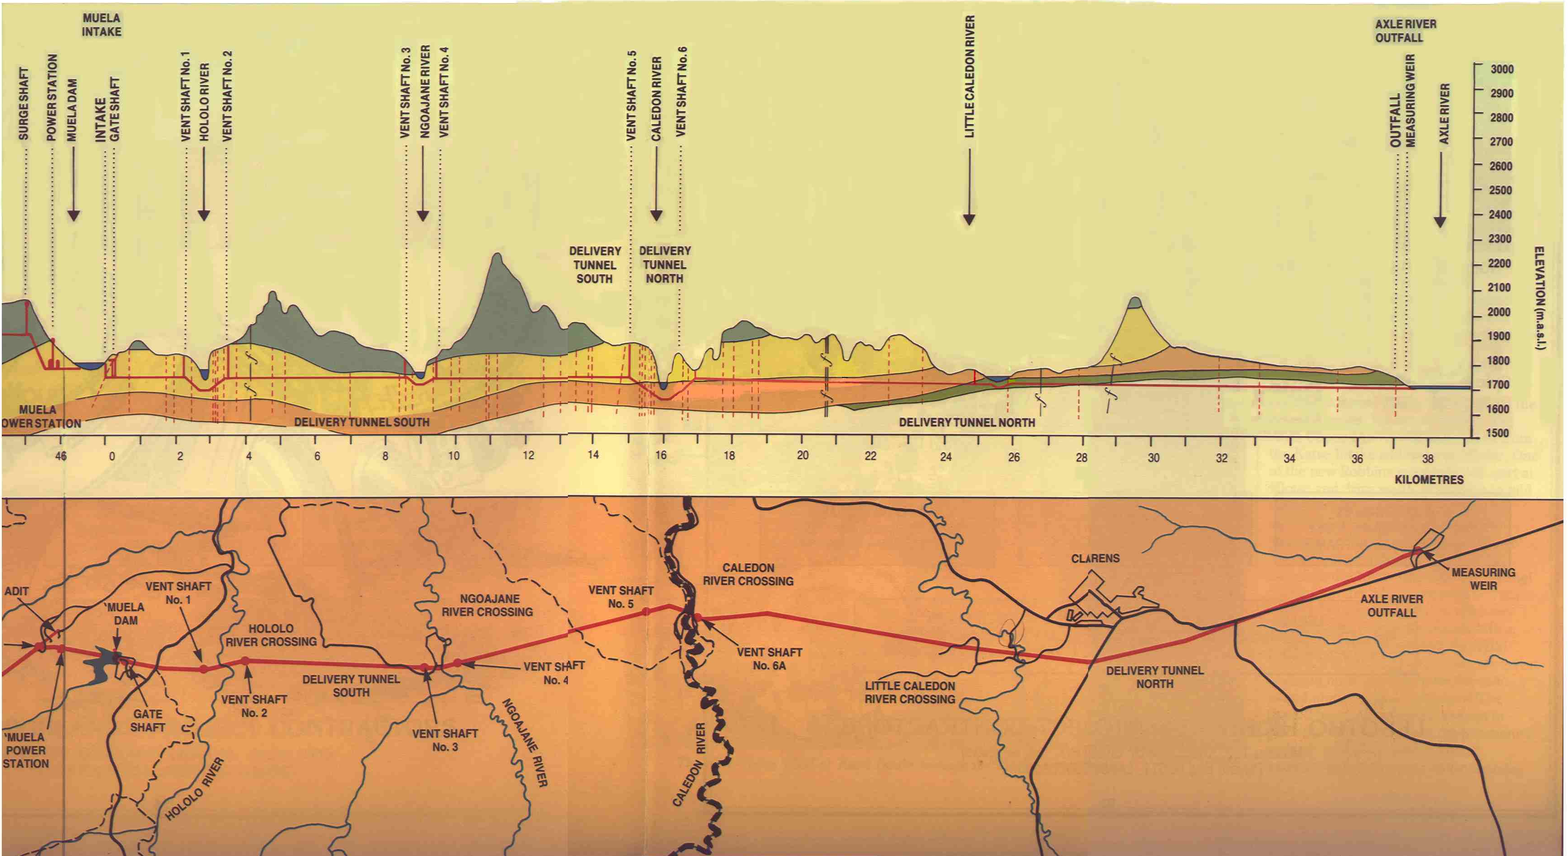
Delivery Tunnel lay out

Delivery Tunnel long section
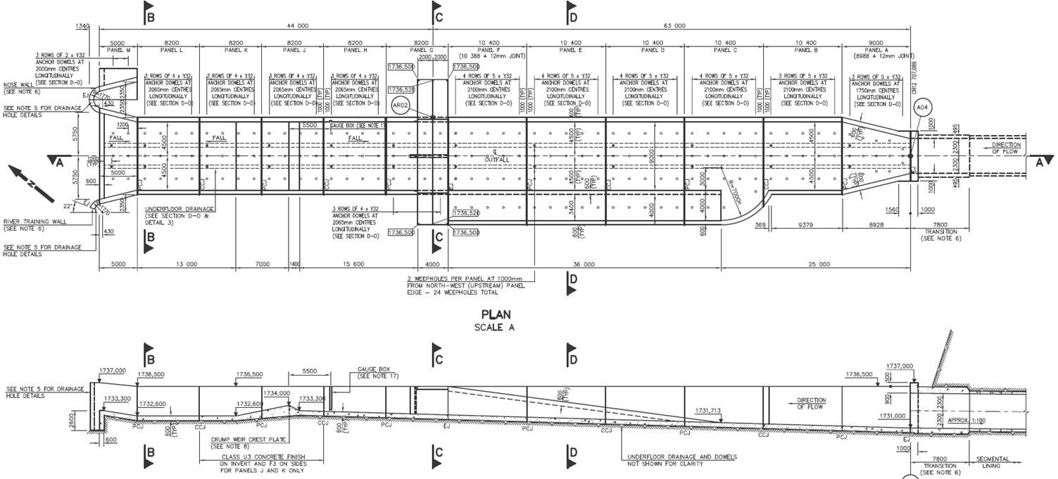
Ash Outfall

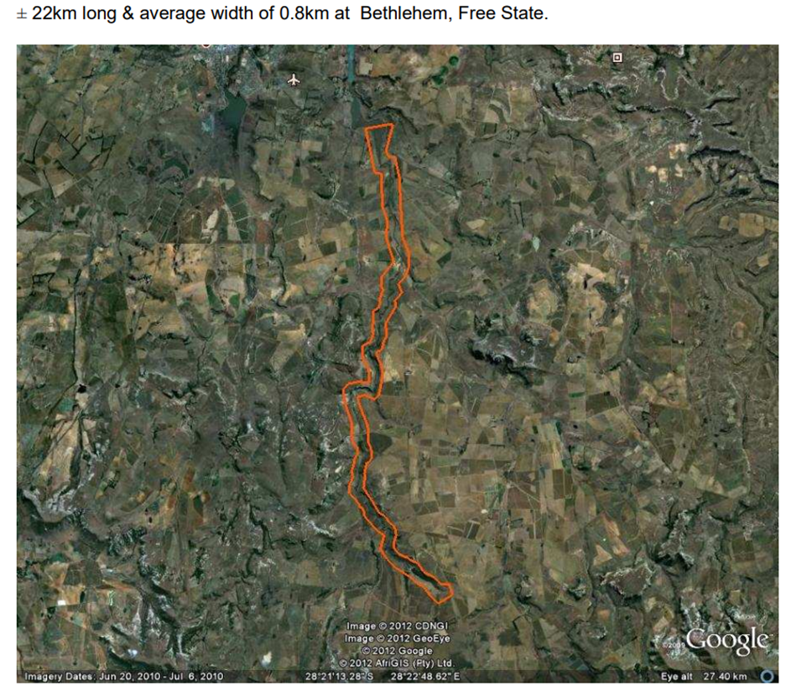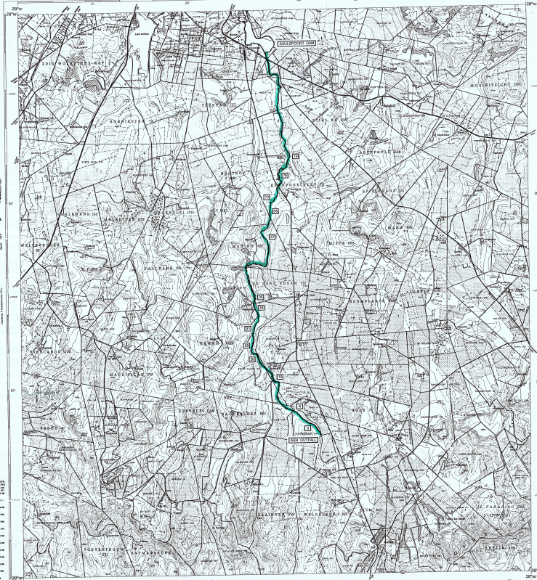
Ash river layout
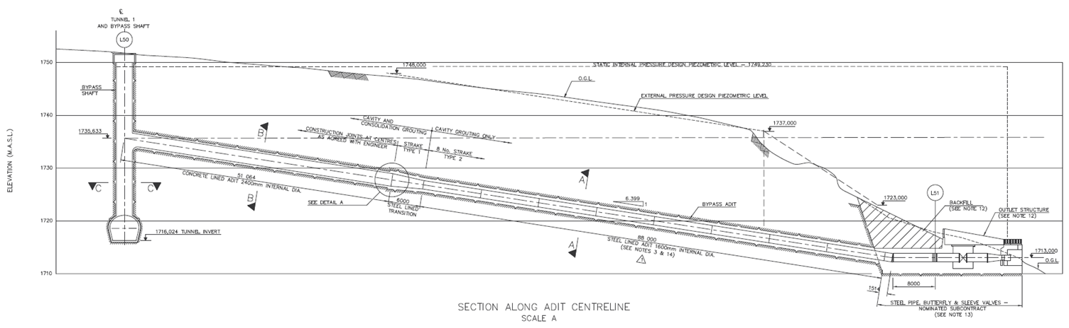
Tunnel By Pass off-take

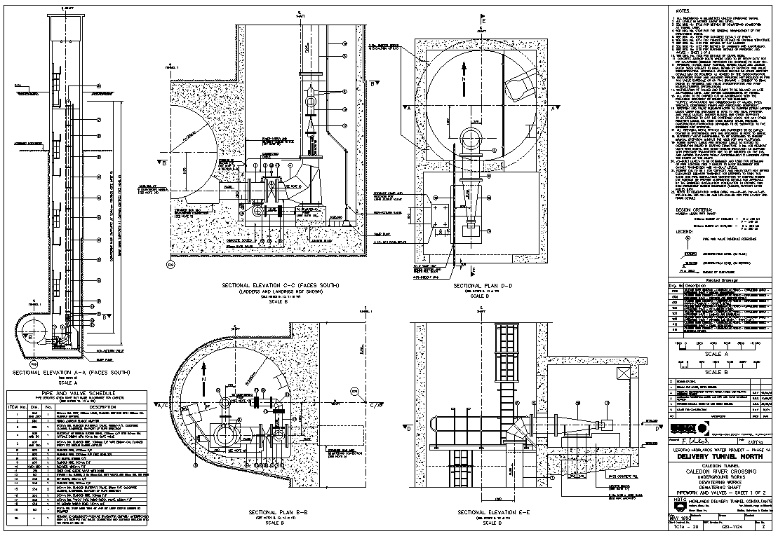
Caledon Dewatering Shaft
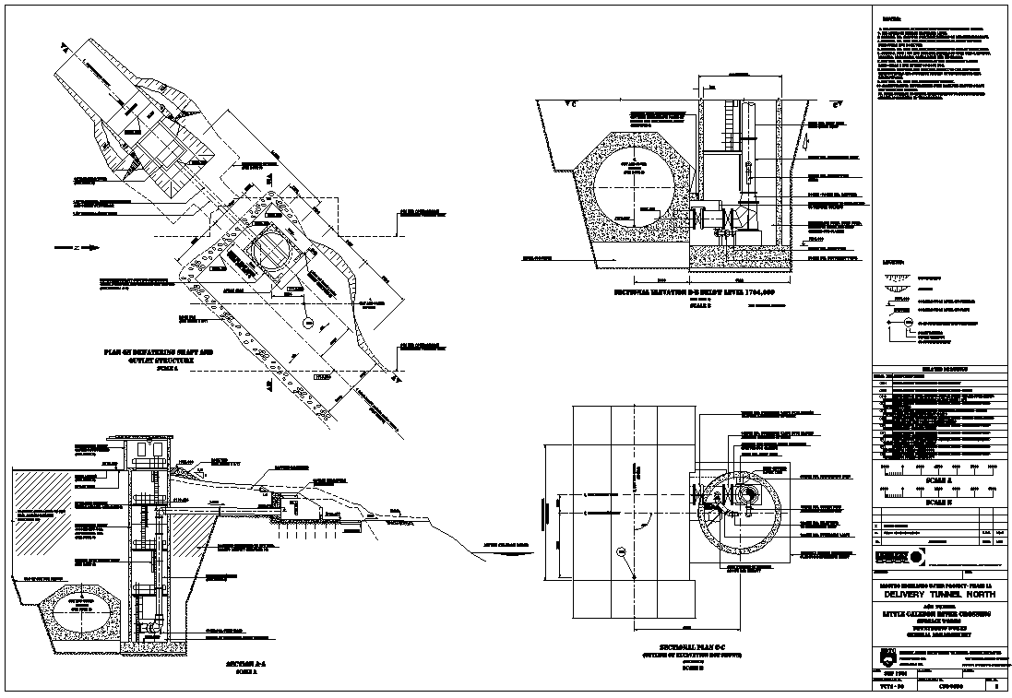
Little Caledon Dewatering Shaft

