 | Section/division | Supply Chain Management | Form Number: CA 183-515
 | REQUEST FOR QUOTES (RFQ)

Description of Goods/ Service required | Audio Visual and Decor Services in Gauteng (An airport either in Lanseria/Centurion/Midrand will be confirmed) for the Young Aviation Professionals Assembly
SPECIFICATIONS/ DESCRIPTION
ITEM/ SERVICE |  | QUANTITY
DÉCOR, FURNITURE AND RENTAL EQUIPMENT REQUIREMENTS

Event details:

Set up time: 22 June 2023 from 10:00
Break up: 23 June from 17:00

Rental Equipment

- 800 sqm Navy Floor tile carpeting installation and removal
- 10 x Outdoor Patio Heaters with plugs and extensions necessary to be placed around the venue.
- Power source – Generator (3-phase or any suitable power for a seamless audio-visual production) – The venue does will not be providing have power.

Furniture and Décor:

Tables and Chairs

- 280 pax Round Tables and Chairs with white tablecloths, minimal centrepieces, water bottles for each individual and mints
- Halfmoon roundtable seating
Stage Furniture and Decor

6 x ottomans in white (see pic below for the an idea on how they will be placed)
1 x youthful coffee table
5 x Giant size Marquee letters (estimated size: 1100mm L x 760mm H) spelling
#YAPA should be placed in front /on the side/at the bottom of the stage.

AUDIO VISUAL EQUIPMENT REQUIREMENTS:

Built in Stage (Stage Renders/layout should be submitted with the quote)
Guidelines:
- Two areas in one stage: First an area with a podium with a screen background and a conversation area for a maximum of 6 people.
- Size of the stage
- All Audio-visual equipment necessary for good quality sound
- Include a teleprompter.
- Include Autocue screen/s for the Programme Director and Presenters
- 6 lapel mics, 2 mics with stand to be placed on the stage, 2 roving mics for audience engagement.

Stage design samples to consider:
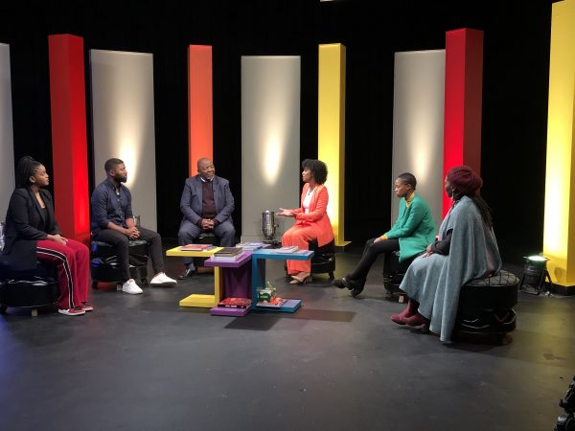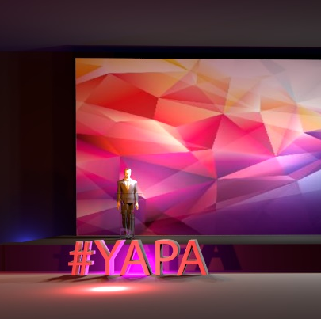
GENERAL/ COMMENTS:
Deliver and set up to be included

