ARC INFRUITEC - NIETVOORBIJ

Private Bag/Private X5026, Stellenbosch, 7599, South Africa
Tel: (021) 809 3093. Fax: (021) 809 3400/3592

Office of the Supply Chain Management

1.1 Description of Service: Servicing of 2 steam boilers

Background: Used in multiple pilot plant processors

PURPOSE : Used in processing of agro processing techniques

SCOPE OF WORK: Minimise post-harvest losses through processing

SPECIFICATION | Comply with specification. Please indicate (Yes or No)
 | Yes | No | If no, indicate deviation
Servicing of steam boilers in Pilot Plant (See pictures attached for reference) and all items necessary to ensure boilers are operating correctly more details will be discussed on the compulsory site inspection for viewing of the boilers

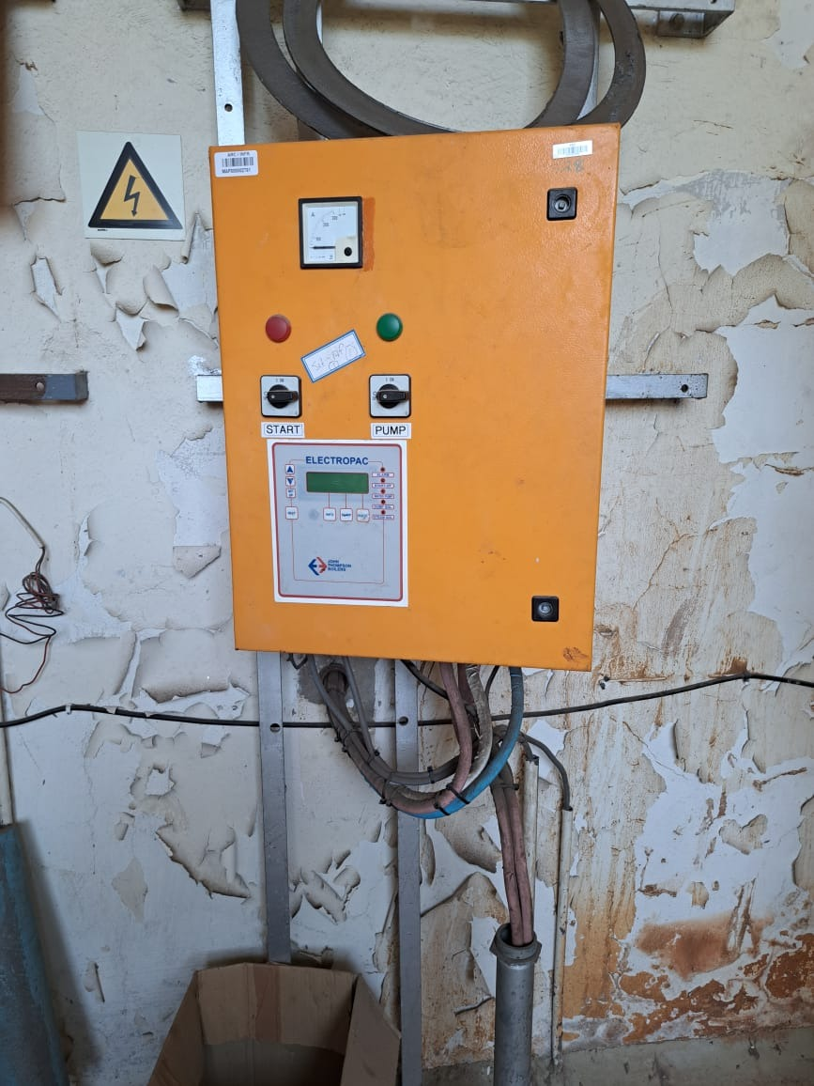
Control unit

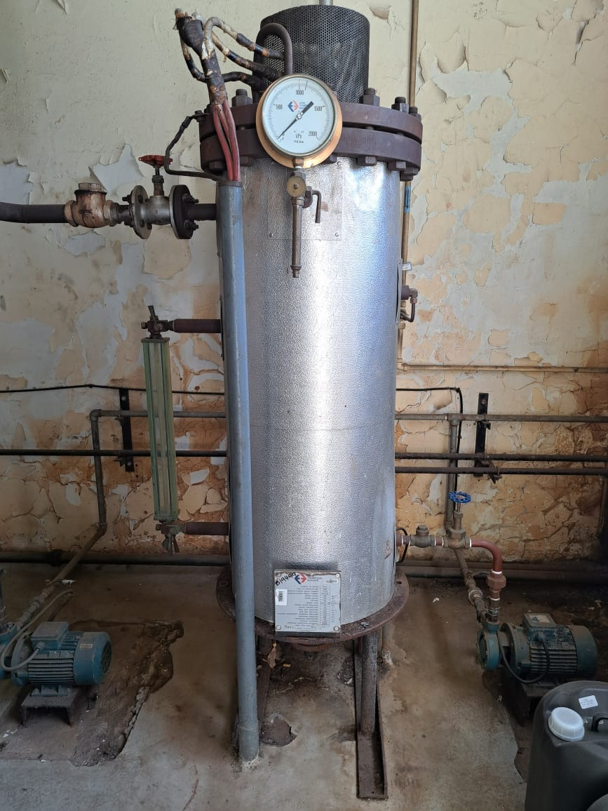
Steam Boiler
After service the boiler must be tested and be operational, and all the electricaland infrastructure must still be working
Supplier must have Electrical Certicate issued by the Department of Labour
Installation by a qualified Electrician – Trade Test Certificate must be supplied.

Issue C.O.C compliance certificate
Compulsosry site inspection, scheduled for 14/11/2022 at 11:00 am Closing date and time 16/11/2022 @ 11:00 am
GENERAL CONDITIONS FOR THE PURCHASE ORDER AGREEMENT

1.2 PRICING SCHEDULE Servicing of 2 steam boilers

Item description | QTY | Unit price | Total Price
- Servicing of Steam Boilers in Pilot Plant (and all items necessary to ensure boilers are operating correctly) | 2
Other: Delivery
SUBTOTAL
VAT
GRANDTOTAL

1. The specification prepared by ………..

Name …Feroza October…………

Date…04 November 2022…

Signature……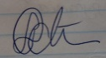……………

2. The specification approved by commodity specialist ………..

Name …Feroza October…………

Date…04 November 2022…

Signature…………………

EVALUATION PROCESS & CRITERIA STAGE ONE FOR Servicing of 2 steam boilers
ADMINISTRATIVE COMPLIANCE EVALUATION OF ALL PROPOSALS
 | Comply with specification. Please indicate (Yes or No)
 | Yes | No | If no, indicate deviation
EVALUATION PROCESS: NB: It must be noted that ARC reserve the rights to request for clarification if all the below questions are not answered properly.
STAGE ONE: ADMINISTRATION COMPLIANCE
All suppliers are duly lodged will be examined to determine compliance with quoting requirements and conditions. Quotes with obvious deviations from the requirements/conditions, will be eliminated or disqualified from further adjudication.
          - Mandatory
Quotes will only be compliant if supplier has submitted the following documents:
Administrative documents
- According to National Treasury SCM Instruction number 4 of 2016/2017, only suppliers who are registered on Central Supplier Database (CSD) may be appointed. Suppliers is therefore encourage to register their entities on CSD, www.csd.gov.za and such information will be verified through Central Supply Database (CSD);
- All SBD documents must be submitted and completed;
- The supplier must comply with all the specification
- Contact Details, VAT number, Company registration number, Bank details must be appended on the supplier quote.
          - Non-Mandatory
- Valid B-BBEE certificate or sworn affidavit certify by commissioner of oaths.

Delivery Address: ARC Infruitec Nietvoorbij, Helshoogte Road, Stellenbosch
Supplier’s Details:
Company Name: ……………………………………………………………………….
Contact person: …………………………………………………………………………
Contact number & Email: …………………………………………………………….
Date & Signature: ………………………………………………………………………
Arc Contact: Name ……………., email……………………. Tel, ………………………….
ANNEXURE B



BIDDER’S DISCLOSURE

- PURPOSE OF THE FORM
Any person (natural or juristic) may make an offer or offers in terms of this invitation to bid. In line with the principles of transparency, accountability, impartiality, and ethics as enshrined in the Constitution of the Republic of South Africa and further expressed in various pieces of legislation, it is required for the bidder to make this declaration in respect of the details required hereunder.

Where a person/s are listed in the Register for Tender Defaulters and / or the List of Restricted Suppliers, that person will automatically be disqualified from the bid process.

- Bidder’s declaration
2.1 Is the bidder, or any of its directors / trustees / shareholders / members / partners or any person having a controlling interest in the enterprise,
employed by the state? YES/NO
2.1.1 If so, furnish particulars of the names, individual identity numbers, and, if applicable, state employee numbers of sole proprietor/ directors / trustees / shareholders / members/ partners or any person having a controlling interest in the enterprise, in table below.

Full Name | Identity Number | Name of State institution

2.2 Do you, or any person connected with the bidder, have a relationship with any person who is employed by the procuring institution? YES/NO
2.2.1 If so, furnish particulars:
……………………………………………………………………………………
……………………………………………………………………………………

2.3 Does the bidder or any of its directors / trustees / shareholders / members / partners or any person having a controlling interest in the enterprise have any interest in any other related enterprise whether or not they are bidding for this contract? YES/NO

    - If so, furnish particulars:
…………………………………………………………………………….
…………………………………………………………………………….

- DECLARATION

I, the undersigned, (Name)………………………………………………..
in submitting the accompanying bid, do hereby make the following statements that I certify to be true and complete in every respect:

3.1 I have read and I understand the contents of this disclosure;
3.2 I understand that the accompanying bid will be disqualified if this disclosure is found not to be true and complete in every respect;
3.3 The bidder has arrived at the accompanying bid independently from, and without consultation, communication, agreement or arrangement with any competitor. However, communication between partners in a joint venture or consortium will not be construed as collusive bidding.
3.4 In addition, there have been no consultations, communications, agreements or arrangements with any competitor regarding the quality, quantity, specifications, prices, including methods, factors or formulas used to calculate prices, market allocation, the intention or decision to submit or not to submit the bid, bidding with the intention not to win the bid and conditions or delivery particulars of the products or services to which this bid invitation relates.
3.4 The terms of the accompanying bid have not been, and will not be, disclosed by the bidder, directly or indirectly, to any competitor, prior to the date and time of the official bid opening or of the awarding of the contract.

3.5 There have been no consultations, communications, agreements or arrangements made by the bidder with any official of the procuring institution in relation to this procurement process prior to and during the bidding process except to provide clarification on the bid submitted where so required by the institution; and the bidder was not involved in the drafting of the specifications or terms of reference for this bid.

  - I am aware that, in addition and without prejudice to any other remedy provided to combat any restrictive practices related to bids and contracts, bids that are suspicious will be reported to the Competition Commission for investigation and possible imposition of administrative penalties in terms of section 59 of the Competition Act No 89 of 1998 and or may be reported to the National Prosecuting Authority (NPA) for criminal investigation and or may be restricted from conducting business with the public sector for a period not exceeding ten (10) years in terms of the Prevention and Combating of Corrupt Activities Act No 12 of 2004 or any other applicable legislation.

I CERTIFY THAT THE INFORMATION FURNISHED IN PARAGRAPHS 1, 2 and 3 ABOVE IS CORRECT.
I ACCEPT THAT THE STATE MAY REJECT THE BID OR ACT AGAINST ME IN TERMS OF PARAGRAPH 6 OF PFMA SCM INSTRUCTION 03 OF 2021/22 ON PREVENTING AND COMBATING ABUSE IN THE SUPPLY CHAIN MANAGEMENT SYSTEM SHOULD THIS DECLARATION PROVE TO BE FALSE.

……………………………… ..……………………………………………
Signature Date

……………………………… ………………………………………………
Position Name of bidder

November 2011



SBD 6.1
PREFERENCE POINTS CLAIM FORM IN TERMS OF THE PREFERENTIAL PROCUREMENT REGULATIONS 2017

This preference form must form part of all bids invited. It contains general information and serves as a claim form for preference points for Broad-Based Black Economic Empowerment (B-BBEE) Status Level of Contribution

NB: BEFORE COMPLETING THIS FORM, BIDDERS MUST STUDY THE GENERAL CONDITIONS, DEFINITIONS AND DIRECTIVES APPLICABLE IN RESPECT OF B-BBEE, AS PRESCRIBED IN THE PREFERENTIAL PROCUREMENT REGULATIONS, 2017.

- GENERAL CONDITIONS
  - The following preference point systems are applicable to all bids:
- the 80/20 system for requirements with a Rand value of up to R50 000 000 (all applicable taxes included); and
- the 90/10 system for requirements with a Rand value above R50 000 000 (all applicable taxes included).

a) The value of this bid is estimated to not exceed R50 000 000 (all applicable taxes included) and therefore the 80/20 preference point system shall be applicable; or
b) Either the 80/20 or 90/10 preference point system will be applicable to this tender (delete whichever is not applicable for this tender).

  - Points for this bid shall be awarded for:
- Price; and
- B-BBEE Status Level of Contributor.
  - The maximum points for this bid are allocated as follows:
 | POINTS
PRICE | 80
B-BBEE STATUS LEVEL OF CONTRIBUTOR | 20
Total points for Price and B-BBEE must not exceed | 100

  - Failure on the part of a bidder to submit proof of B-BBEE Status level of contributor together with the bid, will be interpreted to mean that preference points for B-BBEE status level of contribution are not claimed.
  - The purchaser reserves the right to require of a bidder, either before a bid is adjudicated or at any time subsequently, to substantiate any claim in regard to preferences, in any manner required by the purchaser.

- DEFINITIONS
- “B-BBEE” means broad-based black economic empowerment as defined in section 1 of the Broad-Based Black Economic Empowerment Act;
- “B-BBEE status level of contributor” means the B-BBEE status of an entity in terms of a code of good practice on black economic empowerment, issued in terms of section 9(1) of the Broad-Based Black Economic Empowerment Act;
- “bid” means a written offer in a prescribed or stipulated form in response to an invitation by an organ of state for the provision of goods or services, through price quotations, advertised competitive bidding processes or proposals;
- “Broad-Based Black Economic Empowerment Act” means the Broad-Based Black Economic Empowerment Act, 2003 (Act No. 53 of 2003);
- “EME” means an Exempted Micro Enterprise in terms of a code of good practice on black economic empowerment issued in terms of section 9 (1) of the Broad-Based Black Economic Empowerment Act;
- “functionality” means the ability of a tenderer to provide goods or services in accordance with specifications as set out in the tender documents.
- “prices” includes all applicable taxes less all unconditional discounts;
- “proof of B-BBEE status level of contributor” means:
B-BBEE Status level certificate issued by an authorized body or person;
A sworn affidavit as prescribed by the B-BBEE Codes of Good Practice;
Any other requirement prescribed in terms of the B-BBEE Act;
- “QSE” means a qualifying small business enterprise in terms of a code of good practice on black economic empowerment issued in terms of section 9 (1) of the Broad-Based Black Economic Empowerment Act;

- “rand value” means the total estimated value of a contract in Rand, calculated at the time of bid invitation, and includes all applicable taxes;

- POINTS AWARDED FOR PRICE
  - THE 80/20 OR 90/10 PREFERENCE POINT SYSTEMS
A maximum of 80 or 90 points is allocated for price on the following basis:

80/20 or 90/10

or
Where
Ps = Points scored for price of bid under consideration
Pt = Price of bid under consideration
Pmin = Price of lowest acceptable bid

- POINTS AWARDED FOR B-BBEE STATUS LEVEL OF CONTRIBUTOR
  - In terms of Regulation 6 (2) and 7 (2) of the Preferential Procurement Regulations, preference points must be awarded to a bidder for attaining the B-BBEE status level of contribution in accordance with the table below:
B-BBEE Status Level of Contributor | Number of points  (90/10 system) | Number of points  (80/20 system)
1 | 10 | 20
2 | 9 | 18
3 | 6 | 14
4 | 5 | 12
5 | 4 | 8
6 | 3 | 6
7 | 2 | 4
8 | 1 | 2
Non-compliant contributor | 0 | 0

- BID DECLARATION
  - Bidders who claim points in respect of B-BBEE Status Level of Contribution must complete the following:
- B-BBEE STATUS LEVEL OF CONTRIBUTOR CLAIMED IN TERMS OF PARAGRAPHS 1.4 AND 4.1
  - B-BBEE Status Level of Contributor: . = ………(maximum of 10 or 20 points)
(Points claimed in respect of paragraph 7.1 must be in accordance with the table reflected in paragraph 4.1 and must be substantiated by relevant proof of B-BBEE status level of contributor.
- SUB-CONTRACTING
  - Will any portion of the contract be sub-contracted?
(Tick applicable box)

YES |  | NO

    - If yes, indicate:
- What percentage of the contract will be subcontracted............…………….…………%
- The name of the sub-contractor…………………………………………………………..
- The B-BBEE status level of the sub-contractor......................................……………..
- Whether the sub-contractor is an EME or QSE
(Tick applicable box)
YES |  | NO
- Specify, by ticking the appropriate box, if subcontracting with an enterprise in terms of Preferential Procurement Regulations,2017:

Designated Group: An EME or QSE which is at last 51% owned by: | EME  √ | QSE  √
Black people
Black people who are youth
Black people who are women
Black people with disabilities
Black people living in rural or underdeveloped areas or townships
Cooperative owned by black people
Black people who are military veterans
OR
Any EME
Any QSE

- DECLARATION WITH REGARD TO COMPANY/FIRM
  - Name of company/firm:…………………………………………………………………………….
  - VAT registration number:……………………………………….…………………………………
  - Company registration number:…………….……………………….…………………………….
  - TYPE OF COMPANY/ FIRM
Partnership/Joint Venture / Consortium
One person business/sole propriety
Close corporation
Company
(Pty) Limited
[Tick applicable box]
  - DESCRIBE PRINCIPAL BUSINESS ACTIVITIES
…………………………………………………………………………………………………………………………………………………………………………………………………………………………………………………………………………………………………………………………………………………………………………………………………………………………..
  - COMPANY CLASSIFICATION
Manufacturer
Supplier
Professional service provider
Other service providers, e.g. transporter, etc.
[Tick applicable box]

  - Total number of years the company/firm has been in business:……………………………
  - I/we, the undersigned, who is / are duly authorised to do so on behalf of the company/firm, certify that the points claimed, based on the B-BBE status level of contributor indicated in paragraphs 1.4 and 6.1 of the foregoing certificate, qualifies the company/ firm for the preference(s) shown and I / we acknowledge that:
- The information furnished is true and correct;
- The preference points claimed are in accordance with the General Conditions as indicated in paragraph 1 of this form;
- In the event of a contract being awarded as a result of points claimed as shown in paragraphs 1.4 and 6.1, the contractor may be required to furnish documentary proof to the satisfaction of the purchaser that the claims are correct;
- If the B-BBEE status level of contributor has been claimed or obtained on a fraudulent basis or any of the conditions of contract have not been fulfilled, the purchaser may, in addition to any other remedy it may have –

  - disqualify the person from the bidding process;
  - recover costs, losses or damages it has incurred or suffered as a result of that person’s conduct;
  - cancel the contract and claim any damages which it has suffered as a result of having to make less favourable arrangements due to such cancellation;
  - recommend that the bidder or contractor, its shareholders and directors, or only the shareholders and directors who acted on a fraudulent basis, be restricted by the National Treasury from obtaining business from any organ of state for a period not exceeding 10 years, after the audi alteram partem (hear the other side) rule has been applied; and
  - forward the matter for criminal prosecution

……………………………………….
SIGNATURE(S) OF BIDDERS(S)

DATE: …………………………………..
ADDRESS …………………………………..
…………………………………..
…………………………………..

WITNESSES

- ……………………………………..
- …………………………………….

the power, by one person or a group of persons holding the majority of the equity of an enterprise, alternatively, the person/s having the deciding vote or power to influence or to direct the course and decisions of the enterprise.
Joint venture or Consortium means an association of persons for the purpose of combining their expertise, property, capital, efforts, skill and knowledge in an activity for the executaion of a contract.

