TOOL NAME | SPECIFICATION |  | PICTURE | Comment
Voltage Transducer | LTC 1000-S/SP1  Ratio: 1/4000  Power Supply: +/- 15 to 24V  DTR 0000042433  Supply: TRANSNET |  | 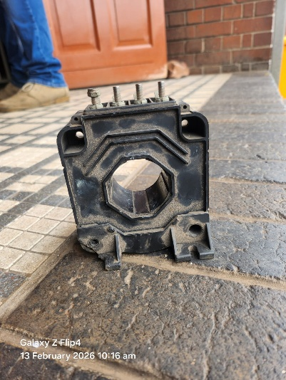 | It is an 18E electronic component. It monitors voltage on the locomotive
Voltage Regulator (VR) for MA/ME |  |  | 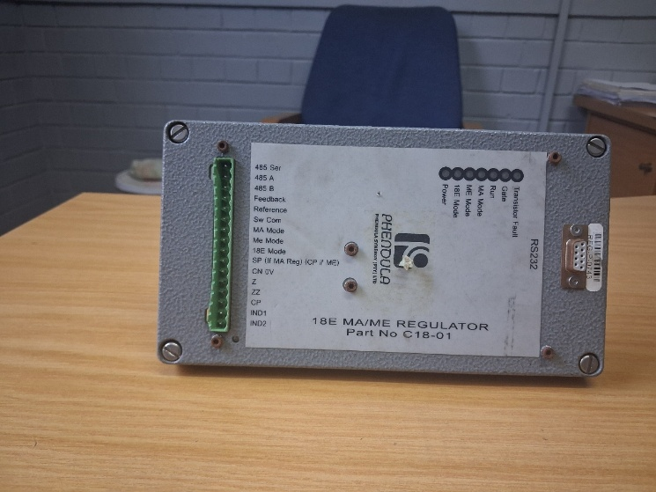 | It is an 18E locomotive electronic component. It regulates low tension voltage on the 18E locomotive.
Voltage Regulator (VR) for MA/ME | Supplier: Pendula
Voltage Regulator (VR) for MA/ME | Part number: C18-01
Voltage Regulator (VR) for MA/ME | RS 232
LEM (power Supply) | SN: 0V  CP: 110V  Red light: 110V ok  Up green light: -20 V ok  Lower green light: +20V ok  Supplier: TRANSNET |  | 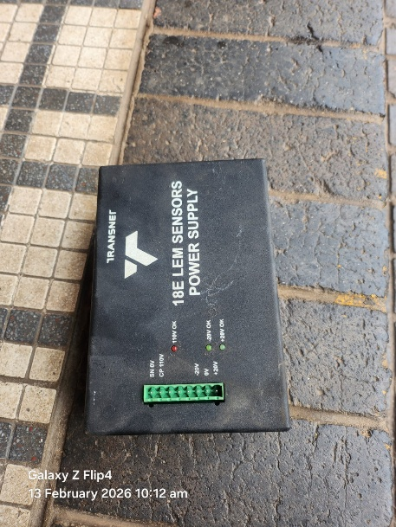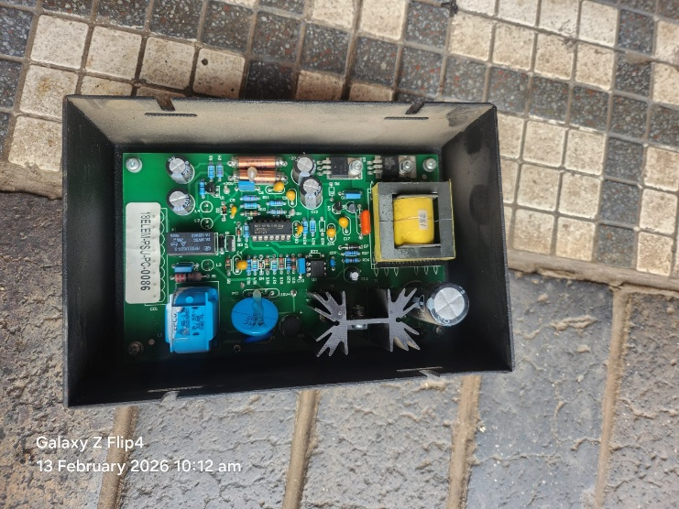 | It is an 18E locomotive electrical component. It detects voltage from the pantograph and it sends signal to MPU.
MPU (Main Processor Unit) | Supplier: ALSTOM  TRVP037944000  Slow Speed MOD  AGATE LINK  TRV: 037944000  MPHT1:10 |  | 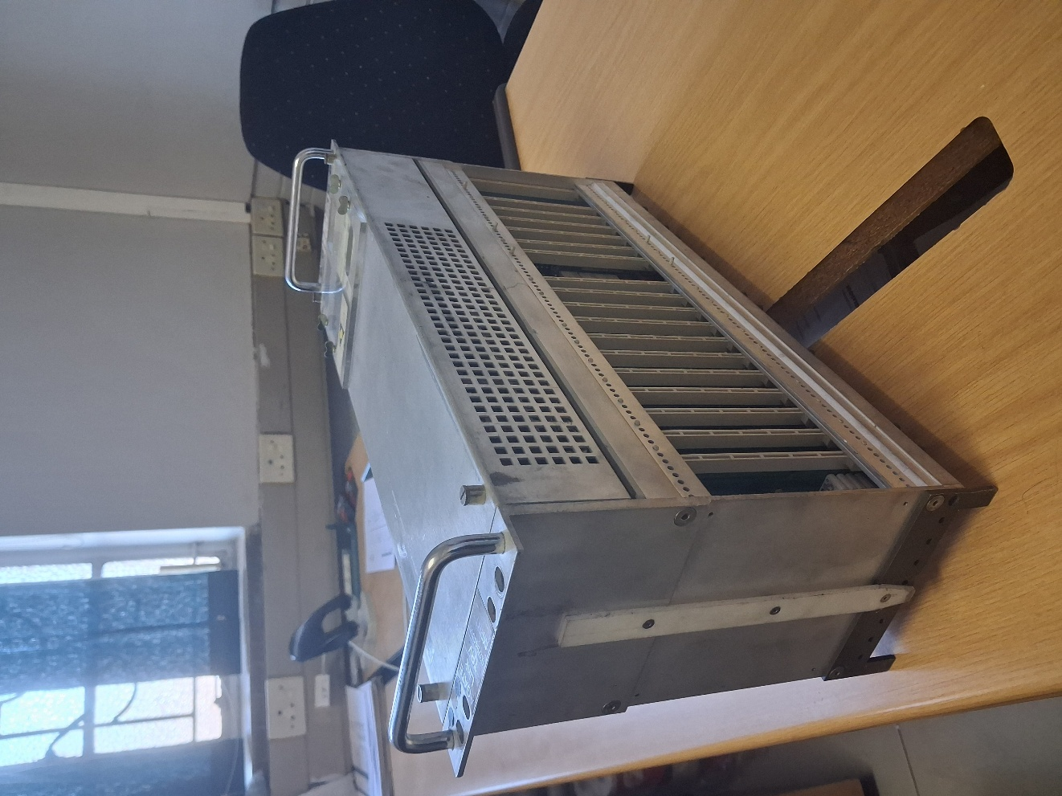 | It is an 18E electronic component. It monitors all the electronic components and protects them from current surges. It is the brain of the locomotives
LT Riom | No Specification  Supplier: TRANSNET |  | 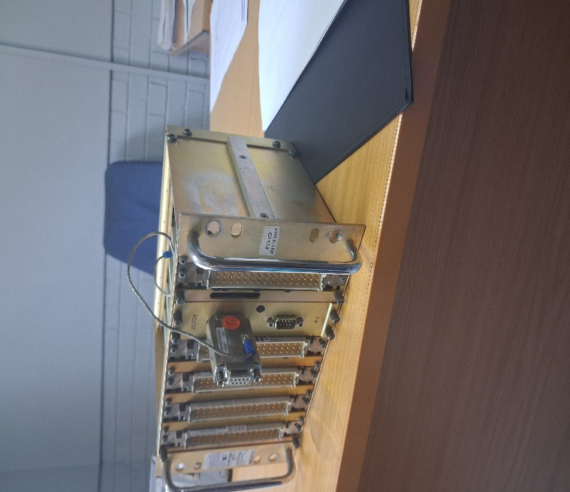 | It is an 18E locomotive electrical component. It gives signal to MPU.
Invertor Box |  |  | No picture | It is an electrical component used on the 18E locomotive. It runs Blower motors
Feedback Box | Supplier: TRANSNET |  | 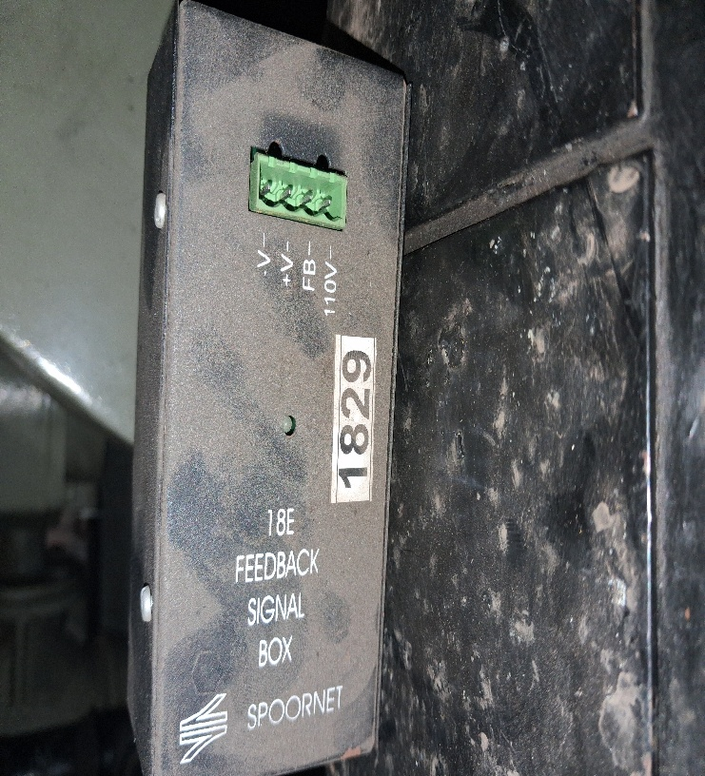 | It is an 18E electric component. When the compressor is starting the feedback box gives MPU signal that the compressor or exhauster is running.
Wheel Sleep Box | Supplier: TRANSNET  C18E-Speed-V2 |  | 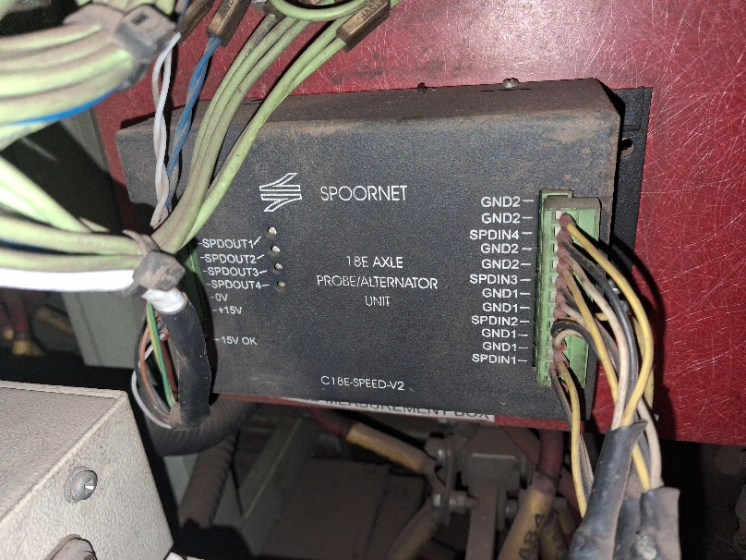 | It is an 18E electric component. It gets signal from the probes and sends to the MPU.
Econo Box |  |  | 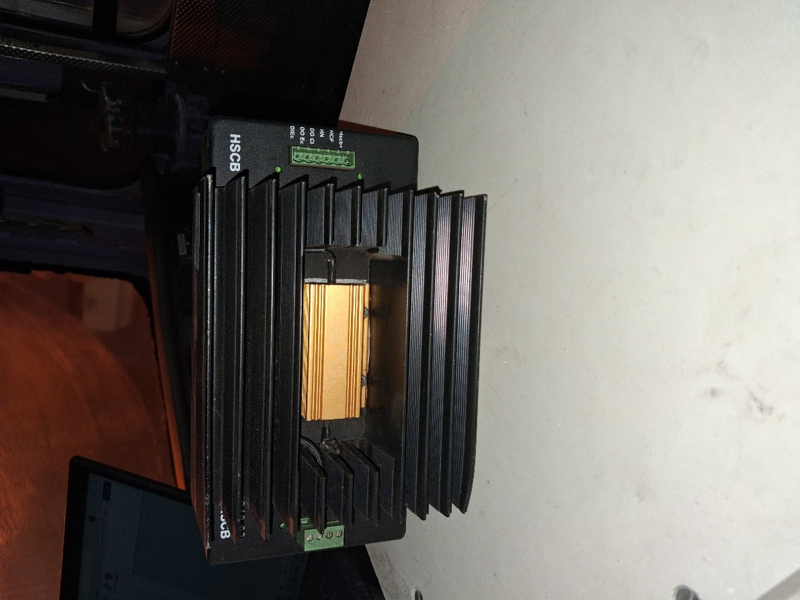 | It is an 18E electrical component. It closes the high-speed circuit breaker.
Cab Riom | Supplier: ALSTOM  TRVS33917/4010  MESD80-40  HT2  0728/A326 |  | 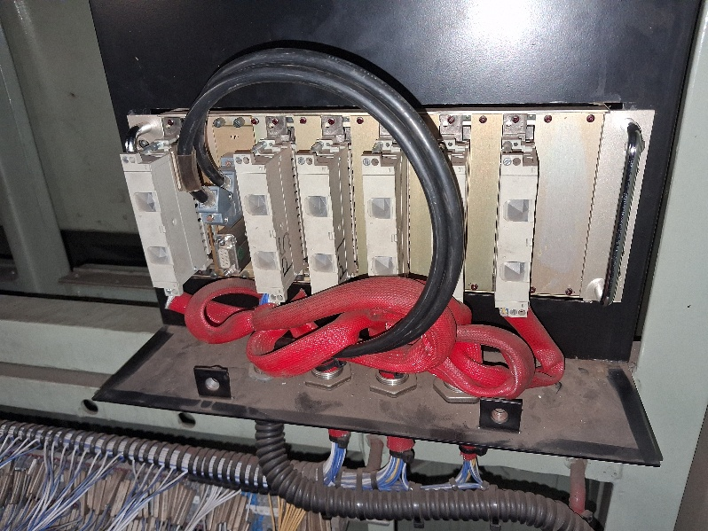 | It is an 18E electrical component. It gives signal to MPU
DDU (Drivers Display Unit) | Supplier: ALSTOM |  | 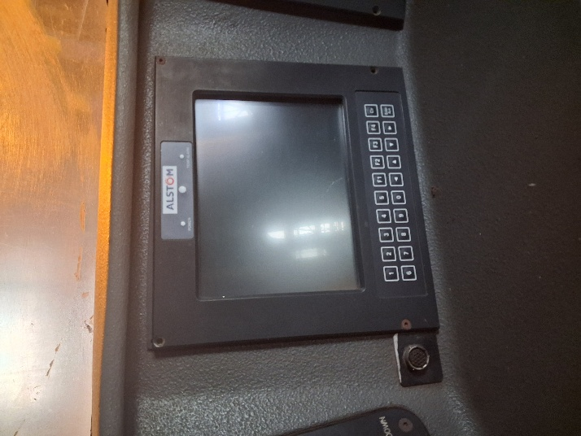 | It is an 18E electrical Component. It is on the driver’s cab monitoring all the activities.

