Credenza 1200x600 roller door (Cherry veneer)

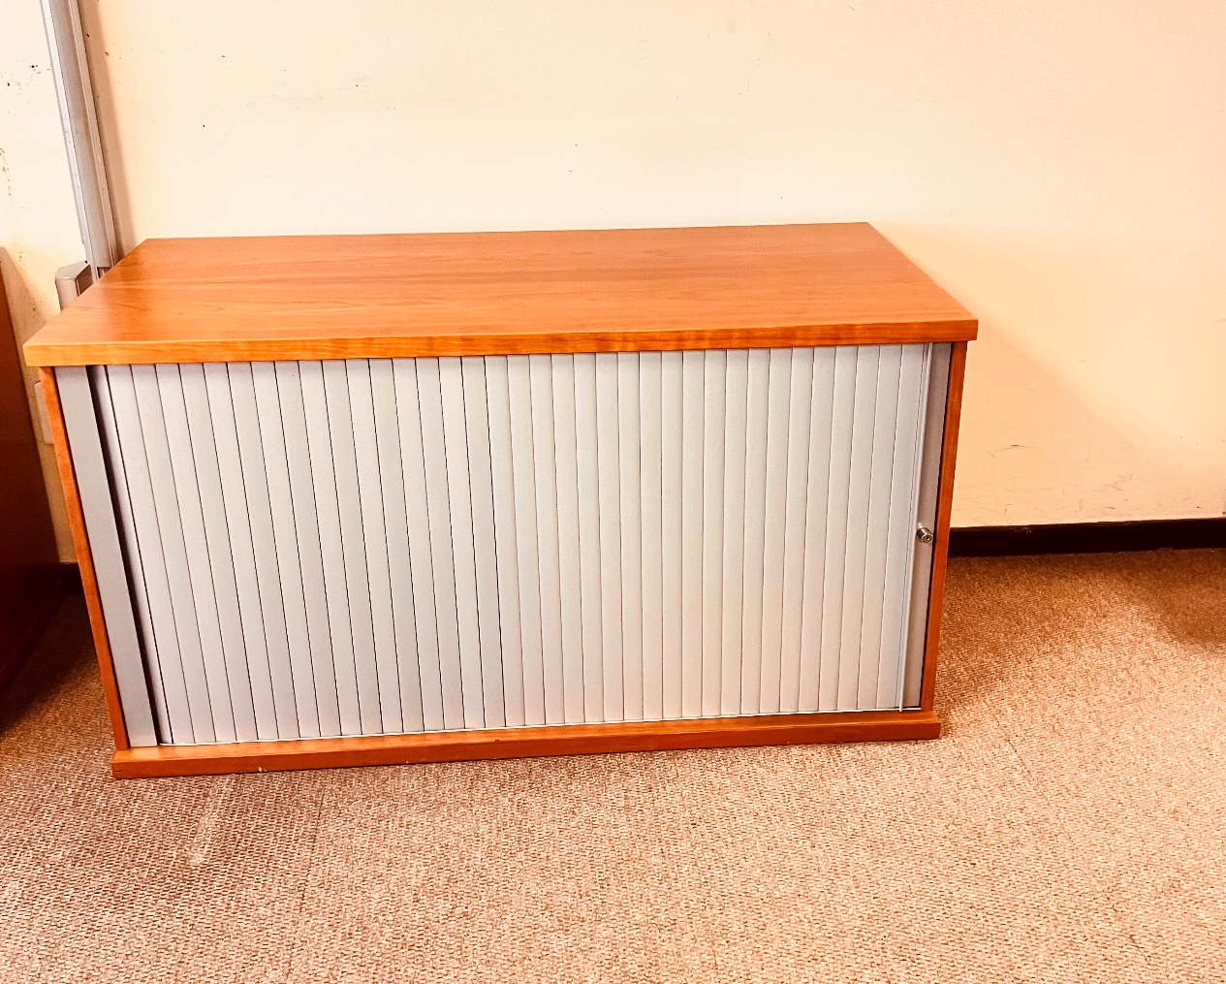

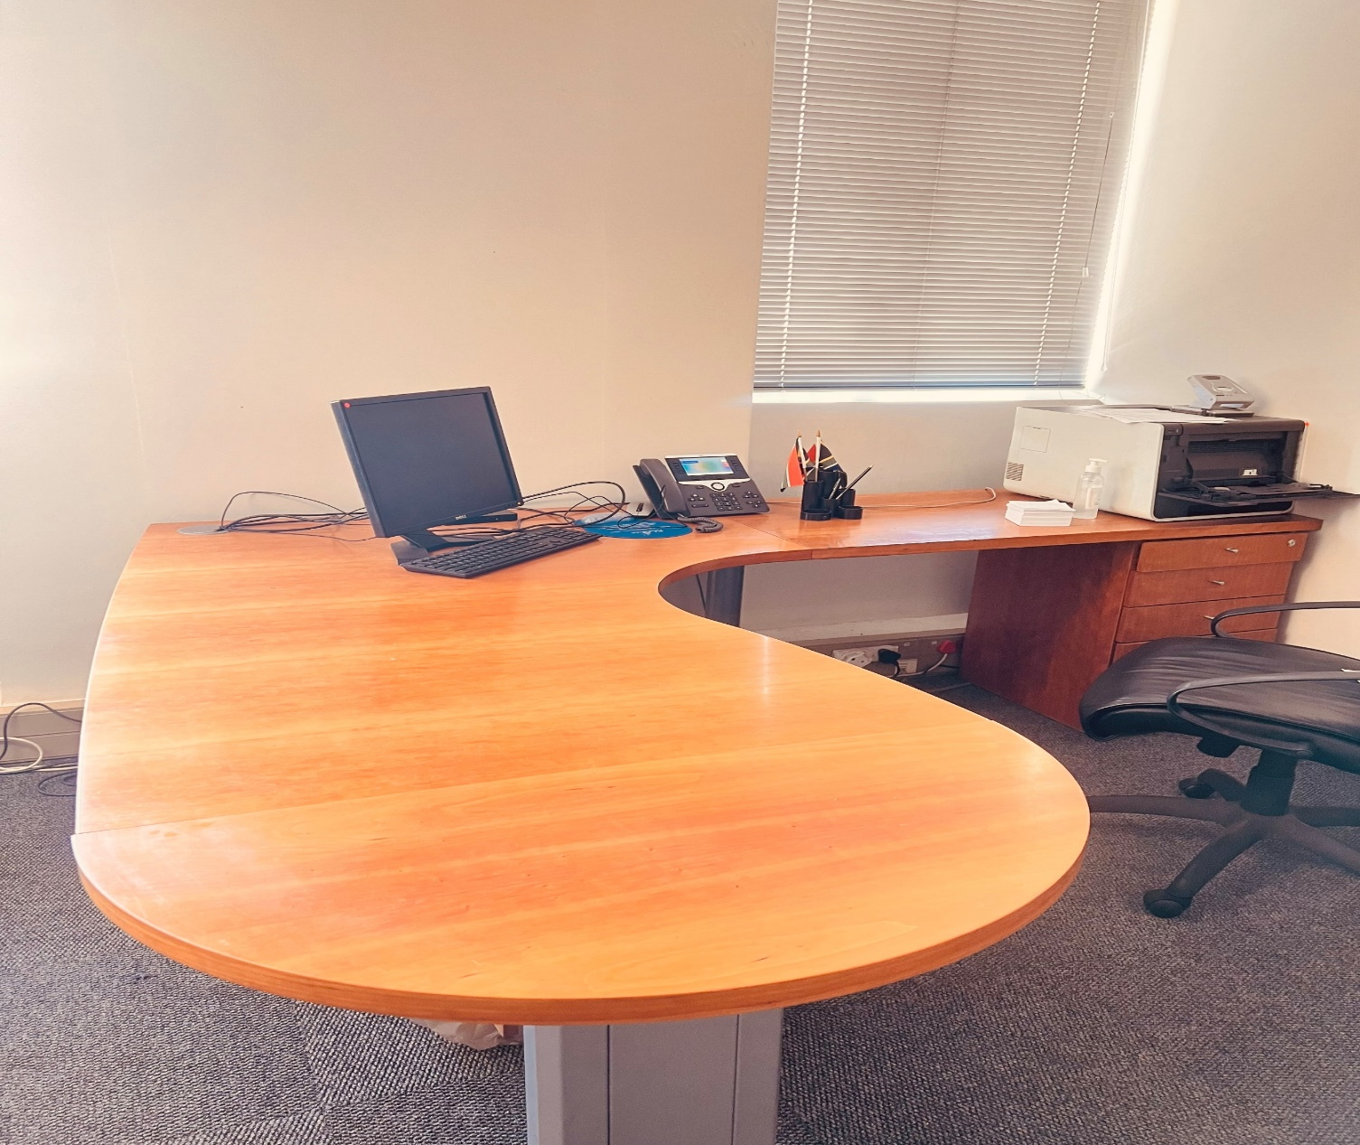
Desk 2038x2400mm with wooden modesty panel (Cherry veneer)
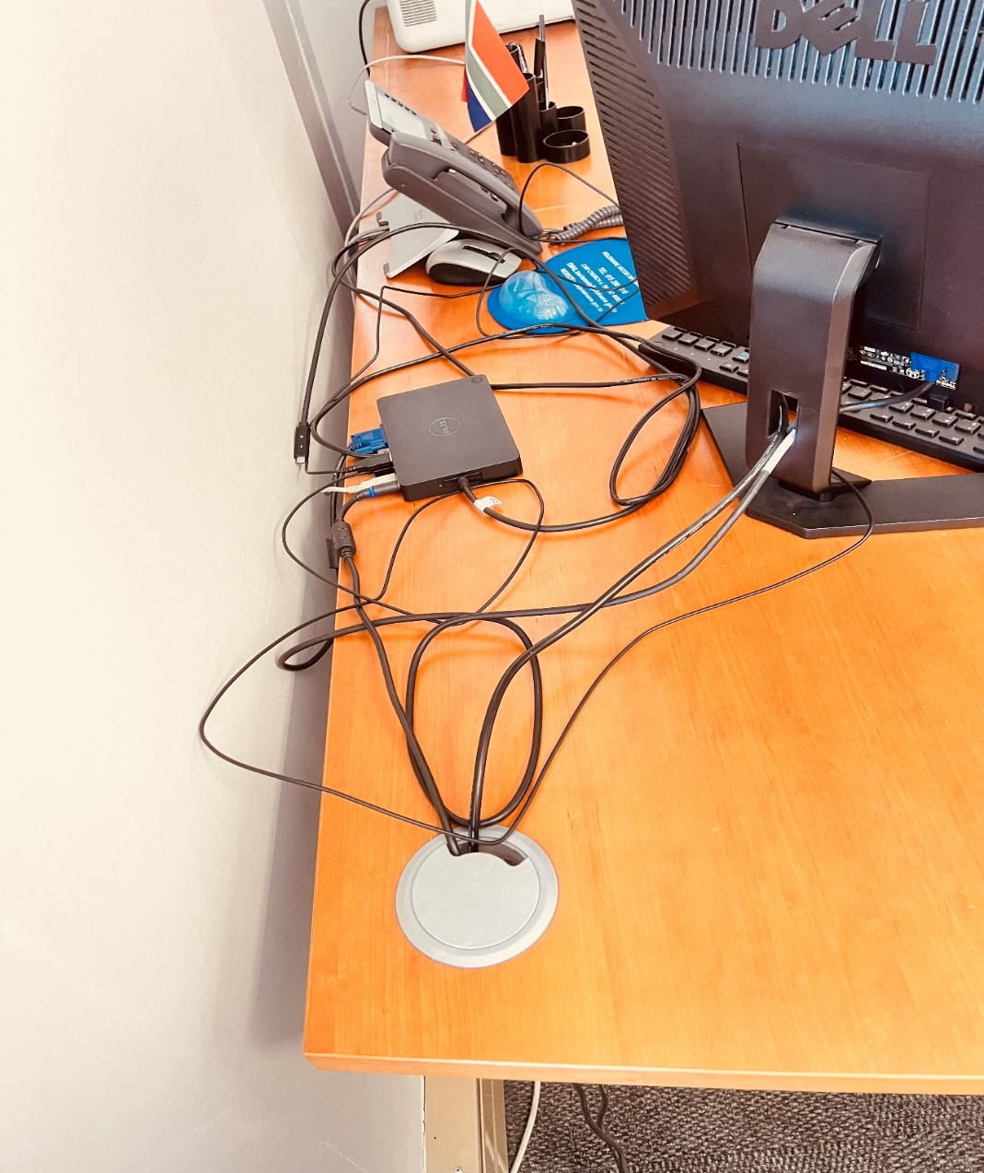
Corner of the desk
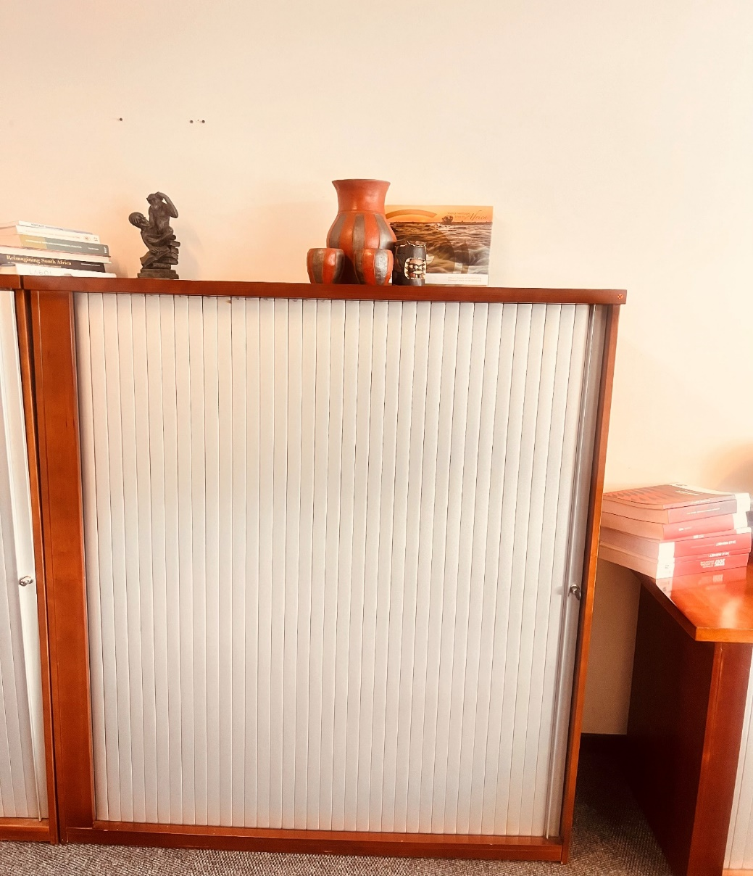
Cabinet system roller door 1500x1200 with four legs (Cherry veneer)

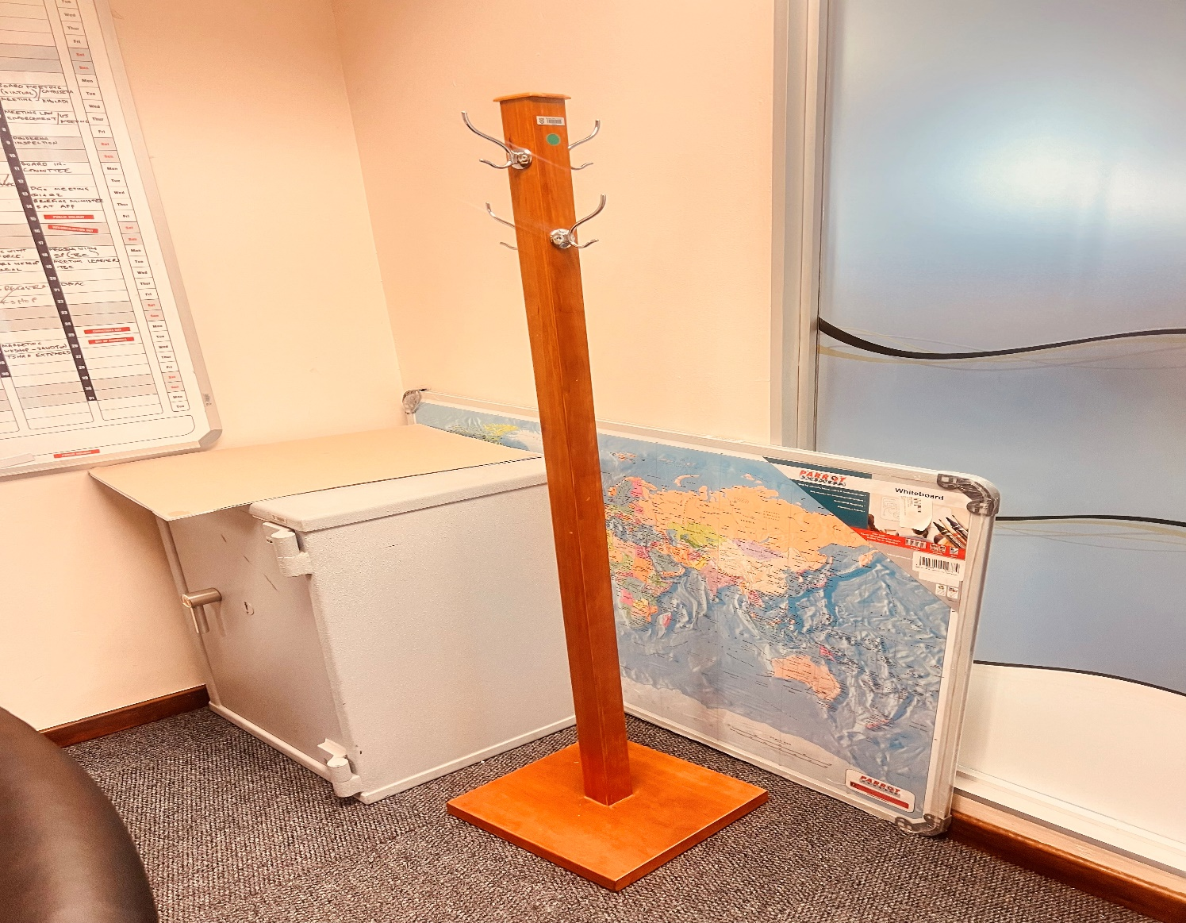

Hat and coat stand (Cherry Veneer)
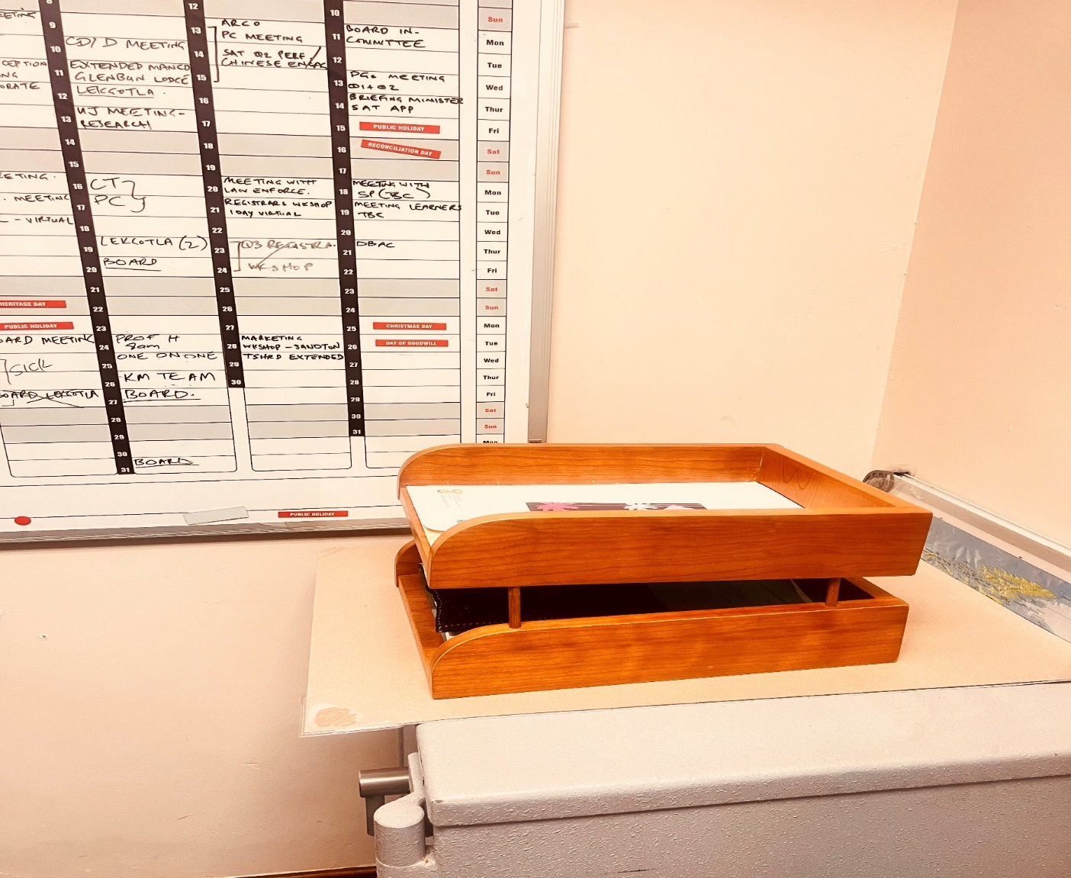
Desk Tray (Letter) 2 Tier (Cherry Veneer)

