Item | Section | Questions | Answers
QA4-1. | 2.1.1. Professional / Managed Services | Please clarify our understanding. The scope listed for the below listed items is to be priced as a rate card for specific roles that are required to execute as and when required and Eskom is not looking for a fixed cost quotation for these activities.  i. Cloud Architecture (including solution, data, security, integration)  ii. Develop overall multi-cloud architecture designs  iii. Develop all other architectural artifacts required to support the multi-cloud environment.  iv. Cloud Operations (including day-to-day management of operations, improvement operations and availability of infrastructure and services, data management)  v. Cloud Security, Risk and Compliance (identification and implementation of the security strategy requirements for effective governance, risk and compliance process management)  vi. Platform Services (management of Hyperscalers and Private cloud environments)  vii. Configuration of applications in the CMP tool once they have been migrated into the prescribed Hyperscalers environments.  viii. Refine the existing Application assessment (6R’s) and based on the current workload determine the best Hyperscaler to move the system to and to determine the best deployment options for the workload migration. If this can be done with the use of a tool, then then tool needs to be included in the proposal.  ix. Assist with workload migration to the cloud. | Yes, your understanding is correct based on the Tender Scope of Work document.  The listed items (i to ix) fall under Professional / Managed Services and are explicitly described as non-committal and to be used on an "as and when required" basis.  Our expectation is that the resources available on professional services must have the required knowledge and experience to assist Eskom in the various tasks.  Eskom does not request a fixed cost for these activities.  You are required to submit a rate card for the roles involved (e.g., Cloud Architect, Security Architect, etc.).  The roles will be engaged as needed, and pricing will be based on the resource level (Senior, Intermediate, Junior).
QA4-2 | 2.1.1. Professional / Managed Services | If the answer to the question above is Yes, please confirm if we are correct in understanding that Discovery & assessment for new workload migration from on-premises to cloud will be taken care of by Eskom Cloud COE and the Suppliers responsibility would only be to provide resources as required/requested by Eskom. | Based on the tender document, your understanding is partially correct.  - Eskom has an initial assessment framework/baseline.  - However, the supplier is expected together with Eskom, to refine and apply this assessment.  - Should the supplier have a tool, this must also be included in the proposal.
QA4-3 | 2.1.2. Provision of a cloud management tool(s) | Solution Analysis and Design  Solution Build  Solution Integration  Testing of the solution  Solution Deployment  We understand that this portion of the scope is only limited to the implementation of the CMP tool and does not apply to Managed Services asks from Eskom. Please confirm if correct. | Based on the tender documentation, your understanding is correct.
QA4-4 | 2.1.2. Provision of a cloud management tool(s) | We request to kindly provide the number of PaaS DB and IaaS DB for each cloud provider (AWS/AZURE/GCP/OTHERS).  We require this information for sizing the CMP tool. | Eskom currently has only AZURE.  List is not available due to limited implementation.  Database question previously answered.
QA4-5 | 2.1.2. Provision of a cloud management tool(s) | We request to kindly share the inventory split details for AWS, Azure, GCP environment like Dev, QAS & Prod environment? | Eskom currently has only AZURE.  Split details are not available.
QA4-6 | 2.1.2. Provision of a cloud management tool(s) | Request if you could please provide detailed inventory of machines including the application details which are hosted inside your current Azure/AWS/GCP.  We would only need a high level/ballpark figure for sizing. | Eskom currently has only AZURE.
QA4-7 | 3. Service Level Agreement requirements | To leverage the benefit of multiple time zones, we would like to know if Eskom would be open to an Onsite-Offshore hybrid model of delivery for 24X7 support.  Please note that we shall do this split with considerations to Local Procurement Content in the SD&LI requirements and shall keep that in mind while sizing the efforts. | The hosting of the tool must be within the borders of South Africa as per the Key Requirements specified.  For CMP tool(s) application support this can be considered.  For professional services the resources must be able to occasionally visit to Eskom sites in Gauteng.  Therefore, a 100% offshore model will not align with Eskom’s preferences.
QA4-8 | Generic | Please advise on the approximate/ballpark cloud services spends for the services deployed in Azure, AWS and GCP regions. | Eskom currently has only AZURE.  The spend details are not available.
QA4-9 | Generic | We would like to understand the current risks and pain areas in the current cloud environment to tailor our solution to address any risks or pain areas that you may currently be facing. If we could get a bit of details on this. | Eskom’s cloud environment is limited and with most applications on premise. The risks are very low.
QA4-10 | Generic | Are there any other monitoring tools used today in the environment apart from Azure Monitor and Cloud Watch? | At this stage, only AZURE Monitor is used.
QA4-11 | Generic | How are the ITSM events like incidents, change, problem etc. logged today for the cloud environment in Eskom? | Service Desk, using Helix
QA4-12 | Generic | Would it be possible to advise on the number of audits (External/Internal) does the service provider needs to support in a year and if we could please get a list of expected or usual audits. | No, Eskom does not have predetermined number of audits, ad hoc audits are conducted. However, SOC 1 and SOC 2 Type II are conducted annually.
QA4-13 | Generic | Please share the number of disaster recovery testing requests to be performed in a year. | At least once a year
QA4-14 | Generic | Could you please help us understand the Current DR/Backup Plan with the presentation policies? What is the frequency of DR Drill & Backup Audit? | At least once a year
QA4-15 | Generic | How long do the back ups need to be retained? | This will be determined in the design phase.
QA4-16 | Generic | What is the frequency of current OS patch and updates? | Depends on the OEM release frequency.
QA4-17 | Generic | Do all the cloud resources have tagging in place in the current cloud environment? | No, tagging will be defined and executed during implementation.
QA4-18 | Generic | Is there a current knowledge management solution that would be utilized for the Azure/AWS/GCP environment/hosted application? If you could please explain this a bit. | No
QA4-19 | Generic | Please advise if cloud batch jobs are being utilized. If yes, how many batches are being executed in each cloud? | Future requirement, but currently no batch jobs.
QA4-20 | Generic | We would need to get a comprehensive view of the current environment and would request kindly to share any architectural topology diagram that could help us understand the current AZURE/AWS/GCP environment. | Only AZURE in use.  Below is the planned state.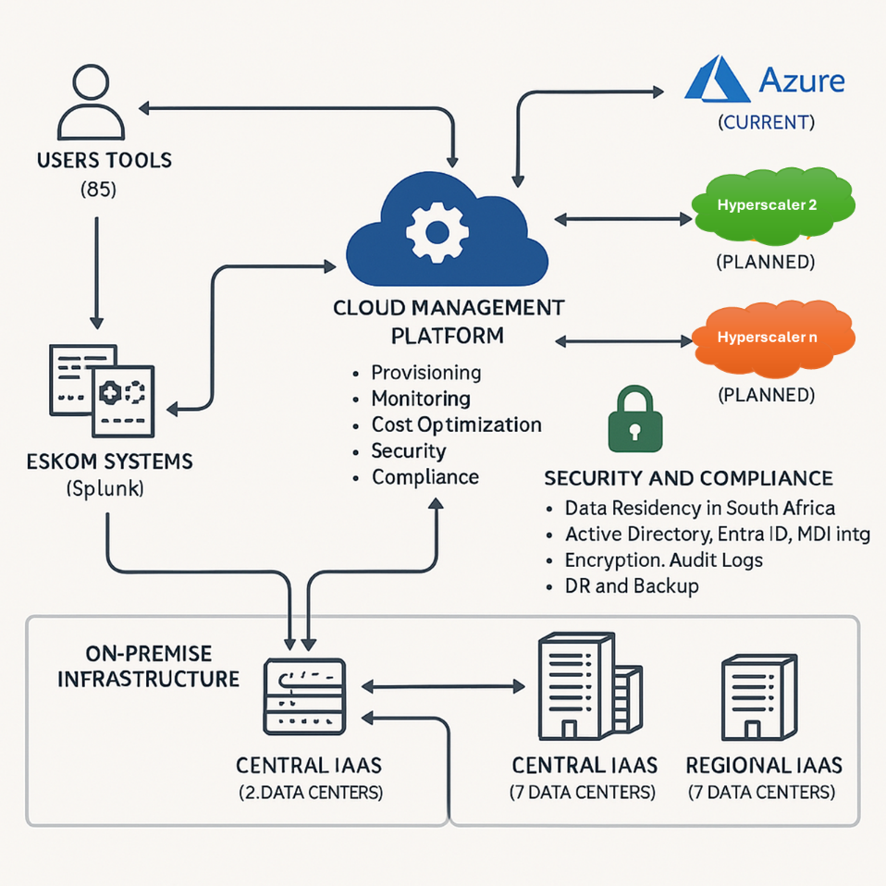
QA4-21 | Generic | Please provide us the expected % yr on yr growth in the Azure/AWS/GCP environment | Only AZURE in use.  Growth will be determined once the migration strategy has been defined.
QA4-22 | Generic | Please share details of all Compliance and Data Protection requirements that are required for the Azure/AWS/GCP Environments | Additional information and copies of policies will be shared with the successful bidder.  Some of the requirements include but not limited to:  - Information Security Policy  - Information Security Logical Access Control Standard  - Information Security – System Classification Standard  - Information Security – Asset and Information Classification Procedure  - Standard for records retention periods  - Eskom Cloud Security Standard  - Protection of Personal Information (POPI) Act, 2013  - Eskom Cloud Policy
QA4-23 | Generic | Request to kindly share the ticket dump or an expected number of incident/problem tickets. | Please clarify the relevance of this request.
QA4-24 | Generic | Please advise if any marketplace applications/solutions would need to be supported as part of scope. | Marketplace applications are not part of the scope.
QA4-25 | FN2.8 - Monitoring and observability | Please provide a list of existing monitoring & Observability tools to check compatibility with CMP.  Also please share existing tools list like backup, Patching, , Backup, DR, Automation, any management tools, DevOps, Network, Security to be integrated with CMP solution. | At this stage, only AZURE Monitor is used.  Please clarify the relevance of the question.
QA4-26 | FN2.9 - Provisioning and orchestration | Please confirm existing infrastructure provisioning process is manual or automated using tools (Please specify which tools if yes). What is the Percentage of requests deployed via Automation ? Can we get report / volumetrics on the number of provisioning requests in a month across Cloud and the DC environment. | Currently manual process used  Zero % as no automation currently  CMP solution required to automate the current provisioning process.
QA4-27 | FN2.13- Data storage | Pls provide brief requirements about data storage rollback and extraction from CMP SaaS tool  These involve tasks to replicate data to migrate workloads, implement business continuity (BC) or disaster recovery (DR) architectures, or protect data against accidental deletion or malicious activity. This functionality also includes application dependency mapping. | The tenderer is required to demonstrate how the proposed tool meets the specified capabilities with respect to the following required functionalities, including, but not limited to:  - Functionality to define and enforce backup policies for objects stored in the object storage service of the cloud platform.  - Functionality to define and enforce backup policies for block storage volumes  - Functionality to define and enforce backup policies for compute instances
QA4-28 | FN2.20- Network | Pls clarify: Leverages network technologies like software-defined wide area networks and over-the-top monitoring to ensure the optimal performance of the solution." | Requirement is for the tenderer to explain their tool’s capability to be flexible to leverage the different network technologies.
QA4-29 | Generic | Please share the catalogues that would need to be created in CMP across all the environments. | Please propose aligned with best practices.
QA4-30 | Generic | Please share any IAC tool is being used in the environment Like Ansible or terraform. | No IAC tools currently used
QA4-31 | Generic | How many blueprints and category we are looking to integrate with CMP. | Please propose aligned with best practices.
QA4-32 | Generic | Is the CMP platform required to be integrated to on premise Datacenter? | Yes
QA4-33 | Generic | Could you please advise on the intended users of the CMP tool ex: Operations, DevOps Engineers, Developers, Business Users?  Could you please help in elaborating the expectations from each of these personas with regards to the CMP platform. | This will form part of the design phase.
QA4-34 | Generic | Can the CMP Platform be deployed in a Self-Hosted environment either in DC or in Cloud? | Yes
QA4-35 | Generic | Please confirm if IBM Power servers also need to be part of CMP platform? | It needs to be monitored/managed as part of the CMP Tool(s)

