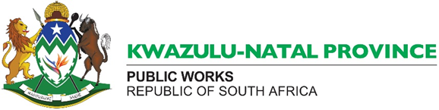
KZN PUBLIC WORKS: HEAD OFFICE – INVITES BIDS FOR THE FOLLOWING SERVICE
No. | Tender No. | Facility | Tender Description | Project Leaders | Compulsory Pre-Tender Meeting | Closing Date | Collection Of Tender Document
1. | Wims 072617 | Addington Hospital | The appointment of a multidisciplinary entity to provide professional services: Maintenance Package 1: renovations to ablutions, dining hall and nutrition center  The team is to have the following disciplines:  Architect, Mechanical Engineer, Electrical Engineer, Civil/ Structural Engineer | Technical Enquiries:  Mr B Ntselemane  033 355 5421  SCM Enquiries:  scm@enquiries.gov.za  033 260 3740 | Date: Tuesday 04 October 2022  Time: 11h00  Venue: Addington Hospital, Main Dining Hall , 16 Erskine Terrance South Beach, Durban | 14 October 2022 at 11h00 | At no cost from the KZN Departmental of Public Works website under the section: Bids and Quotations.  Link:  https://www.kznworks.gov.za/index.php/tenders/quotations/bids-and-quotations-2022.  Bidders to note:  Interested bidders are requested to download bid document prior to the briefing date as no bidders will be allowed in the meeting without a document

