SPECIFICATION OF MATERIAL

Pictures | Description | Quantity
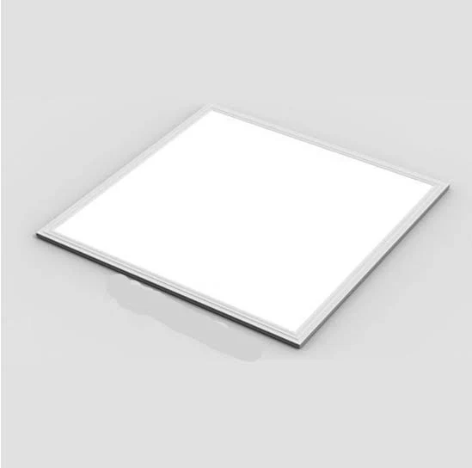 | -Smart LED lights 600/600 48watts (3000k-4000k-6000k) | 200
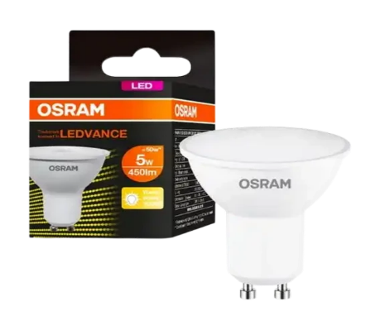 | -LED GU10 down lights | 70
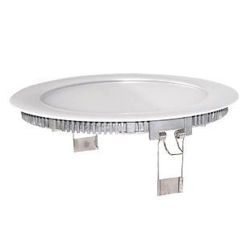 | -Mesmerize Meta D/L RCD LED 24w 6500k 2300LM  -200mm ML-MT-R200-24w-65k | 50
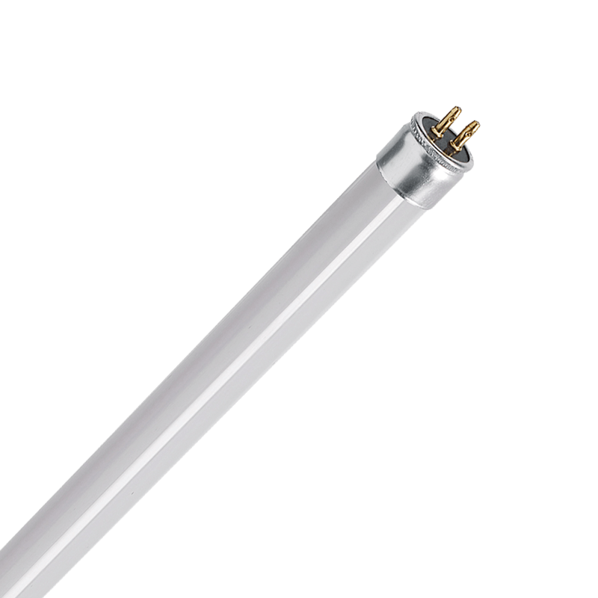 | -PIOLED LIGHTING  -T5 4FT 18w LED Tube  -1600LM 6000k 2411W2 | 200

